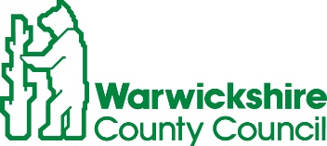
ROAD TRAFFIC REGULATION ACT 1984, SECTION 14
TEMPORARY CLOSURE OF D5223 BROOK END DRIVE & D5226 STATION ROAD, HENLEY IN ARDEN
Warwickshire County Council has made a Temporary Traffic Order details as indicated below:
Effect of Order | Roads closed to vehicular traffic as indicated below:  Brook End Drive closed between its junctions with New Road and Station Road,  Station Road closed between its junctions with Brook End Drive and Mayfield Drive.
Reason for Order | Footway reconstruction and associated works,  08.00-17.00hrs week days only.
Order Effective from: 5 September 2022 for up to 18 months or until works are completed, whichever is the sooner.
Anticipated Completion Date: 26 October 2022.
Access & Diversion: An alternative route will be signed and is available via: Station Road, Birmingham Road, High Street, New Road and vice versa.
Access/Egress to St. Johns Close, Yew Tree Gardens and Brook End Gardens may be restricted whilst works are in progress. Vehicular access & egress will be maintained where possible.
Access/Egress to Train Station will be maintained at all times.
Contractor: Balfour Beatty Tel: 03452 415 302.
To report any problems with these works or for further details of our current & planned roadworks visit our website www.warwickshire.gov.uk/roadworksmap or call us 01926 412515.
S Duxbury, Assistant Director of Governance & Policy,
Shire Hall, Warwick, CV34 4RL. 1 September 2022

