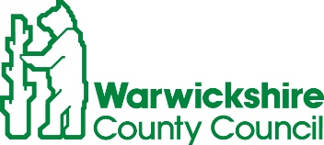
ROAD TRAFFIC REGULATION ACT 1984, SECTION 14
TEMPORARY CLOSURE OF STATION ROAD, HENLEY IN ARDEN
Warwickshire County Council has made a Temporary Traffic Order details as indicated below:
Effect of Order | Station Road closed to vehicular traffic between its junctions with Bear Lane and Birmingham Road.
Reason for Order | To enable works for pipe renewal.
Order Effective from: 23 September 2024 for up to 18 months or until works are completed, whichever is the sooner.
Anticipated Completion Date: 26 September 2024.
Access & Diversion: An alternative route will be signed and is available via: Station Road, Birmingham Road, High Street, New Road, Brook End Drive and vice versa.
Vehicular access & egress will be maintained where possible.
Contractor: For STW, Chevron TM Ltd Tel: 0330 008 0820.

To report any problems with these works or for further details of our current & planned roadworks visit our website www.warwickshire.gov.uk/roadworksmap or call us 01926 412515.
S Duxbury, Assistant Director of Governance & Policy,
Shire Hall, Warwick, CV34 4RL.
20 September 2024

