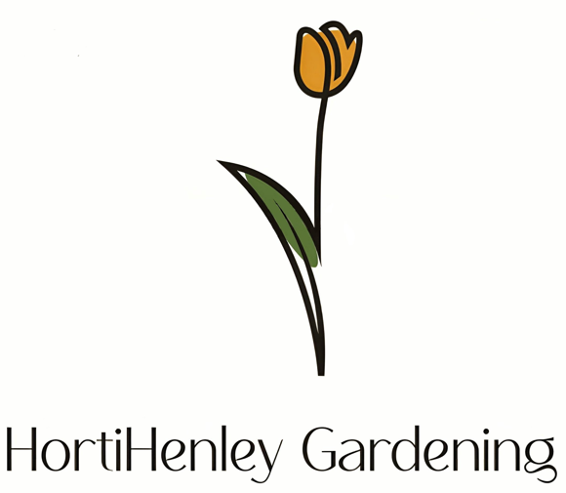
hortihenleygardening@gmail.com
07884 060239

Quote: JPC Hedge Reduction

- Reduction of hedges adjacent to Fieldhouse Close.

- Waste uplift, where necessary and site left in a satisfactory condition.

Quote Total: £120

Please do not hesitate to get in contact if you have any queries regarding this, or future work.
Thanks
John

