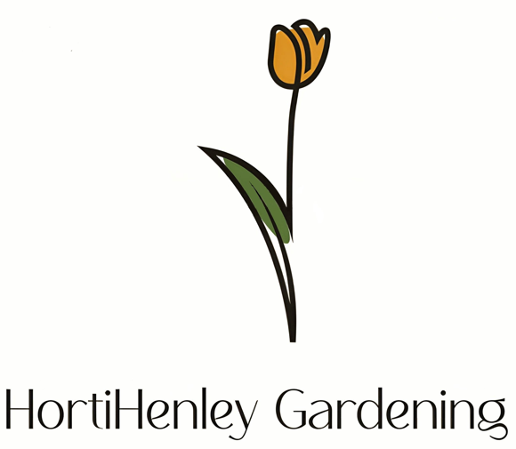
hortihenleygardening@gmail.com
07884 060239

Quote: JPC Jubilee Park

- Provision and installation of bell-mouthed 240mm kerbed structure to North end of park to facilitate redirection of flood water, flanking the existing 5m fence and protruding an additional 5.5m.

- Compensatory measures around kerbing and gated area to provide public safety with installation of MOT base.

- Lifting existing drain grate and cleaning channel to ensure free drainage.

- Safe cordoning of public areas during works.

- Site left in a satisfactory condition.

Quote Total: £1,700

Please do not hesitate to get in contact if you have any queries regarding this, or future work.
Thanks
John

