clerk@henley-in-arden-pc.gov.uk

APPLICATION FOR A JPC GRANT FOR 2025 – OUTCOMES

After due deliberation by the JPC Grants Committee, and subsequent consideration of certain additional records, in accordance with the instructions placed on me by the JPC, I hereby inform you of its final decision, subject to a majority vote conducted at the JPC Ordinary Meeting held on Monday 20 January 2025 at the Memorial Hall.

The outcome of the Grant Awards process is as follows; it should be noted that those who did not receive support this year are invited to apply again in October 2025, for the year 2026.

Society | Grant  Requested | Grant  Awarded | Details  [No grants will be paid prior to the 6th of April 2025]
Henley Arts4All | £3,800 | £3,800 | Brings visitors to the town, community based event.  Award £3,800 to be paid April 2025.
Town Crier | £500 | £250 | The Town Crier ensures that this tradition continues to thrive and contribute to the town's unique identity.  Award £250.00 to be paid April 2025
Evergreens | £500 | £500 | The club has been supporting elderly community members and providing companionship for 102 years.  Award £500 to be paid April 2025
Henley Hot Wheels | £4,000 | £4,000 | Investment in the health, independence, and social inclusion of elderly residents, contributing to a more vibrant and supportive community.  Award £4,000 to be paid in April 2025
Henley Christmas Lights display | £5,000 | £5,000 | Benefitting whole community.  Award £5,000 to be paid in April 2025
Henley Combined Churches | £1,000 | £300 | Illumination of Town Clock  Award £300 to be paid in April 2025
King George V Monument | £5,000 | Up to a maximum of £3,700 | Work required on the trees which make up this monument.  Award up to maximum of £3,700 to be paid in April 2025, subject to match-funding
Community Library | £5,000 | Pending/TBA
The Memory Cafe | £500 | £500 | The Memory Cafe offers essential support to residents with dementia, fostering social engagement, reducing isolation, and enhancing their quality of life within the community.  Award £500 to be paid in April 2025
Totals | £25,3000 | £18,050

May I, on behalf of the JPC, wish you good luck in your endeavours this year towards building a happy and well cared for community.

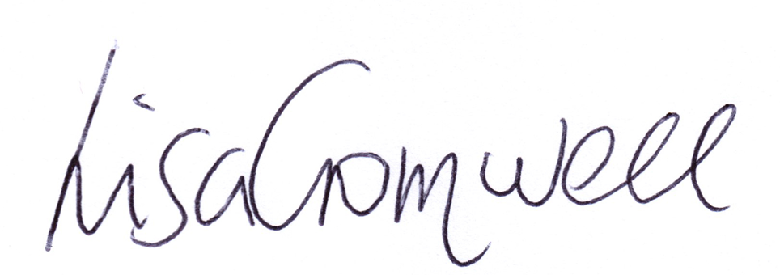

Lisa Cromwell
Clerk & Proper Officer to the JPC

