Dear Councillors

ADDENDUM TO ITEM 12: URGENT BUSINESS

To ratify grounds maintenance invoices received by the Clerk after publication of the agenda. Due to the next Ordinary Meeting not taking place until 1 September, delay in payment may cause operational and reputational issues. Chair’s approval for urgent consideration has been granted, and she recommends that the following invoices be approved for payment:

Signed 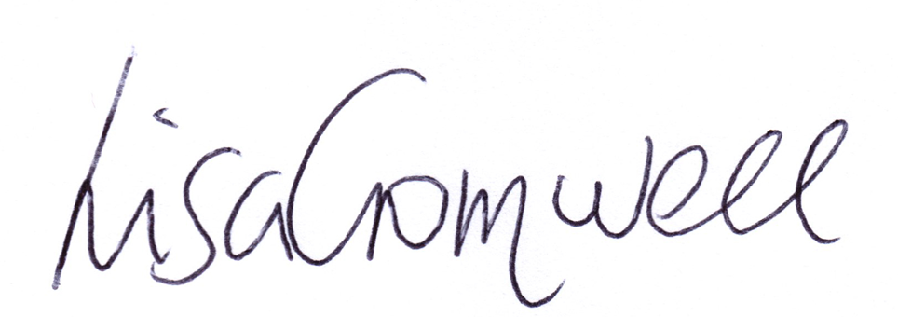
Lisa Cromwell – Parish Clerk Date Issued: 04.07.25

9 | Councillors’ proposals and notes to Council – to be proposed, seconded and voted on
 | Matters concerning expenditure/income
9.1 | Invoice: JPC Grass Cutting and Ground Maintenance – June 2025 (PO Number: 2025-PO#1)[DR] [EA] [SD]
For work carried out between 3rd June and 3rd July 2025:
Grass Cutting and Ground Maintenance in accordance with the accompanying JPC Grass Cutting Schedule, for areas in and around Henley in Arden outlined in the ‘GM ITT Appendix A_Site Plans and Maps’ document, excluding Map references G7 and M6, as advised over email. Total due: £1,765 [DR] [EA]

9.2 | Invoice: JPC Footpaths (PO Number: 2025-PO-1103)
 | Maintenance on areas stated below includes clearance of overhanging hedgerows, sapling trees and weeds encroaching on footpaths. Work to include clearance of leaf fall and immediate margins in outlined areas. Total due: £1,060 [DR] [EA]

