Dear Councillors

An Ordinary Meeting of the Parish Council will be held at 7:00 pm at the Memorial Hall, Station Road, Henley-in-Arden. All council members are requested to attend to discuss and resolve the items listed in the agenda.

Public Session

Before the council meeting begins, the public will have an opportunity to present their concerns or comments. This session, at the discretion of the Chair, is limited to 3 minutes per speaker and a total of 15 minutes. Any issues not listed in the agenda will be noted by the Clerk for future consideration.

Clerk’s note

Planning Committee will consider applications listed in section 11. Outcomes of these applications can be viewed on the Stratford on Avon Planning Portal. Click on:

https://apps.stratford.gov.uk/eplanning/

MAIN TOPICS
4 | County and District Councillors’ reports
9 | Proposals for expenditure
10.1 | NDP update
10.2 | Youth Council update
10.3 | Standing orders and Financial regulations
10.5 | Park Run
11 | Planning applications for consideration

Supporting documents relating to the following subjects can be found on the JPC website prior to the meeting.
Signed 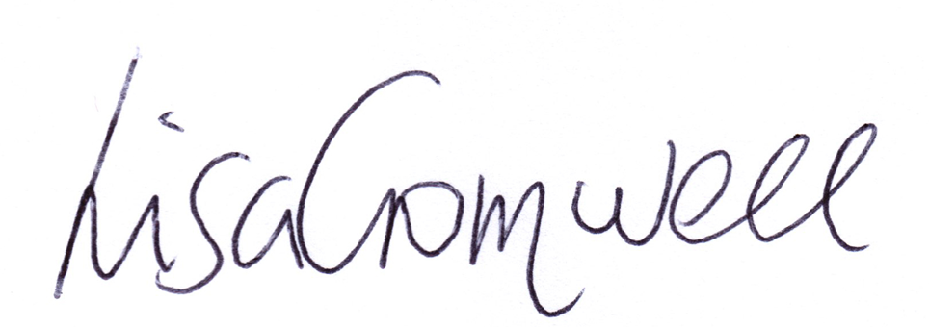
Lisa Cromwell – Parish Clerk Date Issued: 2.7.25

The Chair will open the meeting:

1 | Apologies for absence
2 | Declarations of Interest  Councillors are reminded that their actions must always be in the public interest. They must avoid giving any person an improper advantage or disadvantage, and they should not seek financial or other material benefits for themselves, their family, friends, or close associates.
 | To accept any declarations of interest regarding agenda items
3 | Acceptance of minutes of the last Ordinary Meeting held02.06.25 and those of the Extraordinary Meeting held 30.06.25 to approve the AGAR [DR]
4 | District & County Reports
 | The Chair will invite Cllrs Crocker and Rice to report on matters of interest to residents [SD]
5 | Payments made since the last Ordinary Meeting.  [Consisting annual charges and subs, DD, delegated payments and/or Member voting at an Ordinary Meeting, by email, or,as determined by the JPC Financial Regulations, 5.15].
 | 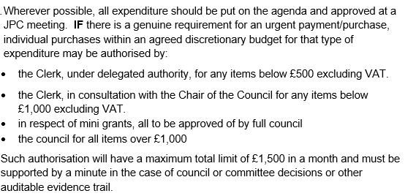
Creditor | Net | Provision
Orbit | £ 51.31 | Garage Rental
Scribe | £ 64.00 | Monthly Finance Software payment
HTDL | £ 585.00 | Website Support
HTDL | £ 760.00 | Website Hosting
HortiHenley | £ 1,700.00 | Payment of PO 1105
HortiHenley | £ 1,765.00 | Grass Cutting PO 01 (from Scribe)
Stratford District Council | £ 133.00 | Emptying of Dog/litter bin
Microsoft | £ 8.49 | Monthly payment for Office365
Fasthosts | £ 15.35 | Internet/website
RBL Poppy Appeal | £ 30.00 | Wreath for 80 Anniversary
Slack | £ 7.14 | Single membership
Lloyds TSB | £ 4.25 | Bank charges
Fasthosts | £ 2.64 | Visit Henley website/internet
Creative Touch Design | £ 430.00 | Office and meeting room rental April
Totals | £ 4,095.87

6 | Creditors payments for consideration by Members
 | NB: Any payment requests received by the Clerk after publication of this agenda MAY be presented at the meeting for consideration.
Creditor | Net | Provision
Midland Mole Control | £ 80.00 | Continued mole activity in Riverside Park. Trap setting and 3 moles caught PO #0002
Creative Touch Design | £ 385.00 | Room rental for May PO #0003
WDS Trees | £ 300.00 | Tree reduction behind 6 Field House Close. PO #1112
Creative Touch Design | £ 350.00 | Room rental for June PO #0005
Totals | £ 1,035.00

7 | Income received since last meeting
Debtor | Net | Provision
Napier | £ 147.62 | The Croft
Napier | £ 315.90 | The Croft SP
Napier | £ 792.68 | The Croft Ringo
Napier | £ 325.00 | The Croft Credorax
Napier | £ 138.26 | The Croft
SDC | £ 940.46 | CIL payment
Allotment tenants | £ 650.00 | Allotment rent
Totals | £ 3,309.92

8 | Banking at 02.07.25
 | 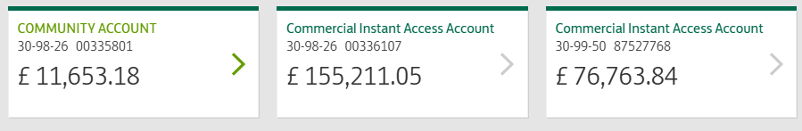
9 | Councillors’ proposals and notes to Council – to be proposed, seconded and voted on
 | Matters concerning expenditure/income
9.1 | HIB mini-grant  An invoice was received from HIB for the flowers in the Gateway troughs, submitted without a Purchase Order, which is contrary to the JPC’s Standing Order 17(b). As such, we requested that HIB complete a mini-grant application form in order for the payment to be processed. Cllr Okey proposes that the amount of £230.40 be approved for this year's planted troughs—which, it must be said, look beautiful. Many thanks to those involved. [DR] [EA] [SD]
9.2 | Annual cost to JPC for Gateway troughs
 | Cllr Okey proposes that, from 2026 onwards, HIB provides an annual quotation for the planting of the troughs, up to £250. The JPC will consider and ratify the quote at a Council Meeting and, if approved, will issue a Purchase Order accordingly. This process aligns with the JPC’s Standing Orders and Financial Regulations. [DR] [EA]
9.3 | Payment to Henley Lights in lieu of Sue Westmacott donation of cakes to Civic Service
A payment of £100 for cakes was ratified at the meeting held on 22/04 (Item #10.3). As Sue generously donated the cakes, the JPC proposed redirecting the approved funds as a donation to Henley Lights. Cllr Andrews proposes that this payment be made accordingly.
[DR] [EA]

9.4 | Allotment work – quote from HortiHenley
 | Further to the last meeting, where it was resolved that HortiHenley be invited to provide a quotation for trimming back the un-tenanted overgrown allotments (2/6 Min #9.2), and following receipt of a quote for £500, Cllr McCaskie proposes that a Purchase Order be issued to HortiHenley to carry out the works. [DR] [EA] [SD]
9.5 | Annual contribution to SDC toward 24/7 CCTV Cameras  This is a four-year contract from 1 July 2023 to 30 June 2027 (two cameras) £2,419 (0 VAT). The Chair proposes that this be paid and SDC be advised that we will not renew the contract in 2027. [DR] [EA] [SD]
9.6 | Henley Market – Mini-grant request
 | Henley Market has submitted a mini-grant request for £500 to support the purchase of a gazebo, trestle tables, and a first aid kit. The group has fulfilled all the criteria required under the mini-grant scheme, and the Chair therefore proposes that the full grant of £500 be awarded. [DR] [EA] [SD]
9.7 | Enhanced DBS Checks required for Youth Council Engagement
 | DBS checks (with Barred list) at a cost of £49.50 per person are required for the Chair and Clerk to enable them to engage directly with the Youth Councillors as part of their supervisory responsibilities. Cllr Andrews proposes the expenditure be approved and the checks carried out. [DR] [EA]
9.8 | Skip Required to clear storage garage
 | There is a lot of rubbish currently being stored in the Whitley Road Garage. Whilst storage is required for certain bulky items, there are items which are no longer required. Cllr McCaskie proposes hiring a skip from Redditch Skip Hire (previously used) to clear these items. [DR] [EA]
10 | Councillors’ proposals and notes to Council – to be proposed, seconded and voted on
 | Business matters – updates only – no financial decisions listed
10.1 | NDP Update  Cllr Andrews (Chair of NDP) to provide an update
10.2 | Youth Council update  The Chair and the Clerk had a meeting at Henley High School, on Friday 27 June to meet the eight pupils who have expressed an interest in establishing a Beaudesert & Henley-in-Arden Youth Council. Their enthusiasm was off the scale, and they have some fabulous ideas. They will attend the 1 September meeting to observe and then we will plan to introduce them at the October meeting. A monthly update from them will be included in the minutes from October onwards.
10.3 | Standing Orders and Financial Regulations Updates  Both have been updated in line with NALC’s model Standing Orders and Financial Regulations, updated in 2025. These have been reviewed by the members. The Chair therefore proposes these be adopted by the JPC.
10.4 | HortiHenley Proposal – Wildflower and Bulb Planting
 | The JPC has received a proposal from Hortihenley to introduce wildflower and bulb planting in selected areas, including Littleworth Field, the Riverlands, Jubilee Park, and Arden Road. Bulbs (e.g. narcissi and daffodils) would be supplied and planted at an estimated cost of 22p each. Cllr Rouse proposes that Horti completes the necessary investigations to provide a quote for both the wildflower and bulb planting areas.
10.5 | Park Run
 | The Chair proposes that the JPC explore the feasibility of establishing a weekly Park Run event at the Arden Recreational Centre, with the Clerk tasked to investigate the necessary arrangements.
11 | Planning Applications for consideration:
 | 25/01518/FUL
12 | Members Urgent Business Matters
 | The Chair will enquire whether Councillors have any urgent business to bring to the attention of the assembly
13 | Next Meeting
 | The next Ordinary Meeting will be held on Monday 1 September at the Memorial Hall.

.

