Dear Councillors

An Extraordinary Meeting of the Parish Council will be held at 6:00 pm in the private Pump Room, The Station, Station Road, Henley-in-Arden on Wednesday 23 July . All council members are requested to attend. This meeting will be convened in accordance with the Local Government Act 1972, ensuring that all decisions relating to the ratification of quotes and approval of payments comply with statutory requirements for transparency, accountability, and lawful expenditure of public funds.

Public Session

Before the council meeting begins, the public may raise questions or make brief comments on items relating to the agenda. This session, at the discretion of the Chair, is limited to 2 minutes per speaker and a total of 10 minutes and will take place prior to the formal consideration of the Agenda.

MAIN TOPICS
1 | Apologies for absence
2 | Declarations of interest
3 | Payments made since last Ordinary meeting, with explanations
4 | Invoices/Quotes for ratification
5 | New Councillor – to be co-opted on to Council
6 | Any other urgent matters
7 | Close of meeting

Signed 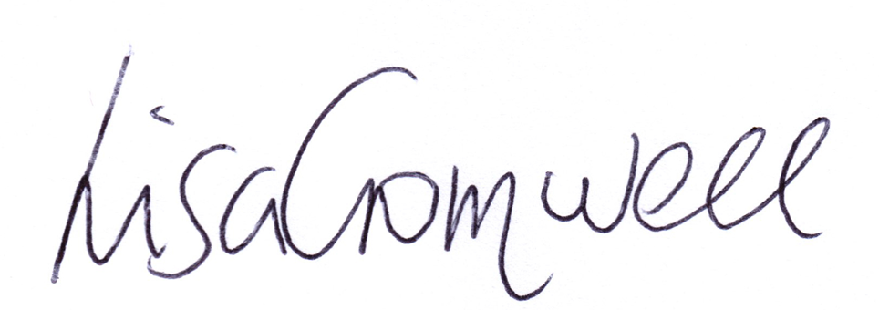
Lisa Cromwell – Parish Clerk Date Issued: 16.07.2025

The Chair will open the meeting:

1 | Apologies for absence
2 | Declarations of Interest  Councillors are reminded that their actions must always be in the public interest. They must avoid giving any person an improper advantage or disadvantage, and they should not seek financial or other material benefits for themselves, their family, friends, or close associates.
 | To accept any declarations of interest regarding agenda items
3 | Payments made since the last Ordinary Meeting.  [Consisting annual charges and subs, DD, delegated payments and/or Member voting at an Ordinary Meeting, by email, or,as determined by the JPC Financial Regulations, 5.15].  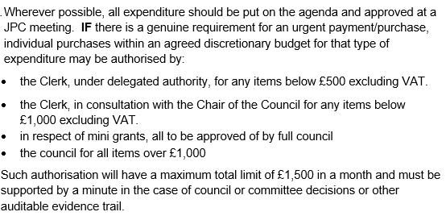
Creditor | Net | Provision
WALC/NALC | £ 905.00 | Subscription to both
Rebound | £ 563.80 | Playsafe rubber chippings for Riverlands
HortiHenley | £ 100.00 | Spreading of chippings in play area
Evergreens Grant | £ 500.00 | Payment of agreed grant
Cllr David Broadbent | £ 44.07 | Councillor's expenses
Totals | £ 2,112.87

 | Explanation concerning paid expenditure – all agreed by councillors but adding for minuting purposes.
3.1 | WALC/NALC subscription
 | This invoice, received in April, was mistakenly filed and not presented for ratification. Councillors were emailed on Friday 11 July for their approval, as the amount exceeded £1,000. Payment was subsequently approved.
3.2 | Play safe rubber chippings for Riverlands park area
 | Following a resident’s concern about sparse rubber safety chippings ahead of the school holidays, the clerk began sourcing quotes but found stock was limited. With approval from the Chair, an urgent order was placed. The JPC was informed and authorised payment to ensure delivery by Friday 11 July.
3.3 | Distribution of rubber chippings around play area
 | HortiHenley agreed to spread the safety chippings around the play area on Saturday 12 July. They requested prompt payment, which was made by the Clerk in accordance with JPC Financial Regulation 5.15.
3.4 | Evergreens Grant
 | Payment of this grant was ratified on 3/3/25 #10.3, however, due to an error with the Evergreens bank account, the payment was paid twice and rejected by Barclays twice. The issue was dealt with last week and so the clerk re-paid the grant payment.
3.5 | Payment of Councillor’s expenses
 | Cllr Broadbent submitted fuel expenses of £44.07, to reflect the increased mileage incurred while undertaking multiple tasks and site visits on behalf of the Council in recent weeks.
4 | Councillors’ proposals and notes to Council – to be proposed, seconded and voted on
 | Matters concerning expenditure/income
4.1 | Memorial Hall hire Sept ’23 – June ’24 and July ’24 – April ‘25
 | Cllr Okey proposes payment of two invoices to the the Memorial hall for hiring for JPC meetings. The Memorial Hall had omitted to send an invoice for the hire of the hall by the JPC in 23/24 (£396 is payable) and also sent the invoice for 24/25 for payment (£415.80). The Chair proposes these payments are made. For the period April 25 – January ’26, the clerk will ensure a Purchase Order is sent to the Memorial Hall. MOTION: To pay both invoices. [DR] [EA] [SD]
4.2 | Skip Hire – Whitley Road Garage
 | Cllr McCaskie proposes hiring a builder’s skip to clear out the Whitley Road garage at a cost of £360. The decision to hire a skip was ratified on 7/7/25 #9.8 after which the clerk sought three quotes (all verbal). MOTION: to issue a PO for skip [DR] [EA]
4.3 | Quote from WDS Trees for two trees at the back of the Medical Centre
 | Cllr McCaskie proposes seeking planning permission for the reduction of two trees at the rear of the Medical Centre, located in the conservation area. A purchase order will be issued upon approval. WDS Trees has visited the site and provided a quote of £850. MOTION: To approve planning permission being sought and PO issued to WDS to carry out the works upon receipt. [DR] [EA] [SD]
4.4 | Quote from WDS Trees for broken branch in Riverlands
 | Cllr McCaskie proposes the issue of a Purchase Order for £40 and the prompt payment of the invoice following the work to remove the broken branch. MOTION: Approval of PO and payment of invoice upon confirmation work has been carried out. [DR] [EA] [SD]
4.5 | Quote from WDS Trees for rear of 37 Chingley Bank, in Jubilee Park
 | Cllr McCaskie proposes provision of a Purchase Order for this urgent tree work. A quote will be provided on Thursday 17/07 and brought to the meeting for ratification. MOTION: Approval of the PO and payment of invoice upon receipt along with proof of completion.
4.6 | Invoice from HortiHenley for Allotments
 | Cllr McCaskie proposes payment of Horti’s invoice for works to the allotments, ratified on 07/07/25 #9.4. MOTION: To approve payment of £500 to HortiHenley.
4.7 | Invoice from HortiHenley for Reduction of Hedgerow in Riverside Gardens
 | Cllr McCaskie proposes payment of Horti’s invoice for reduction of Hedge at Riverside Gardens PO #9. This was carried out urgently due to restriction of access to pavement. MOTION: to approve payment of £150.00.
4.8 | New bike racks for Riverlands in Portacabin space
Cllr Okey proposes that the Council approve the installation of multiple bike racks on JPC-owned land at Riverlands (former portacabin site), to support active travel and local amenities.
The proposed space measures approximately three metres. Planning advice is sought prior to installation, given the scale.
MOTION: To approve the installation in principle, subject to confirmation that planning permission is not required and at a cost of no more than £500.

4.9 | WALC Courses for Clerk (required prior to studying for CILCA)
 | Cllr Andrews proposes that payments are made to WALC for the clerk to study three required certificates leading to study of CiLCA (Certificate in Local Council Administration). MOTION: Approval for clerk to attend WALC’s three “Clerking 1-2-3” training sessions at a cost of £105 (Net) for the three.
4.10 | Scribe – Restate last year’s figures from Edge IT
 | Cllr Andrews proposes that Scribe be instructed to import transactions from Edge for financial year 24/25 now that the clerk has completed the full set up of Scribe. MOTION: That a PO for £300 be sent to Scribe and payment made upon completion of transfer. [DR] [EA] [SD]
4.11 | Invoice from DM Payroll Services Ltd
 | Cllr Okey proposes that the invoice for DM Payroll Services be paid. MOTION: To approve the amount of £157.50 (Net) for services provided 1 April to 30 September 2025.
4.12 | Invoice from HortiHenley for grasscutting July
 | Cllr McCaskie proposes that the invoice for grass cutting for the month of July be paid. MOTION: To approve the £1,765 payment, pertaining to PO #01.
5 | Councillors’ proposals and notes to Council – to be proposed, seconded and voted on
 | Business matters – updates only – no financial decisions listed
5.1 | Introduction/Co-option of new Councillor
 | Cllr Okey proposes that, in accordance with the Local Government Act 1972, the Council considers the appointment of a local business owner who has operated in Henley-in-Arden for a number of years. Their deep-rooted connection to the town’s commercial community would bring valuable insight, particularly in supporting the needs and growth of local enterprises. The Council recognises the importance of strengthening ties with our business sector, and this potential appointment reflects our commitment to inclusive and community-focused representation. MOTION: To approve the co-option of Frankie Johns to the Council.
5.2 | New bin for Riverlands
Cllr Okey proposes that the Council explore the potential purchase of a larger waste bin for Riverlands Park. The Clerk will liaise with SDC Streetscene to obtain a quotation for the bin itself, along with associated costs for its ongoing emptying and maintenance.
MOTION: To seek members’ agreement as to whether a larger bin is warranted.
[DR]
6 | Members Urgent Business Matters
 | The Chair will enquire whether Councillors have any urgent business to bring to the attention of the assembly.
7 | Date of Next Meeting
 | The next Ordinary meeting will be held at the Memorial Hall at 7pm on Monday 1 September.

