.

Dear Councillors

An Ordinary Meeting of the Parish Council will be held at 7:00 pm at the Memorial Hall, Station Road, Henley-in-Arden. All council members are requested to attend to discuss and resolve the items listed in the agenda.

Public Session

Before the council meeting begins, the public will have an opportunity to present their concerns or comments. This session, at the discretion of the Chair, is limited to 3 minutes per speaker and a total of 15 minutes. Any issues not listed in the agenda will be noted by the Clerk for future consideration.

Clerk’s note

Planning Committee will consider applications listed in section 11. Outcomes of these applications can be viewed on the Stratford on Avon Planning Portal. Click on:

https://apps.stratford.gov.uk/eplanning/

MAIN TOPICS
4 | County and District Councillors’ reports
9 | Proposals for expenditure
11 | Planning applications

Supporting documents relating to the following subjects can be found on the JPC website prior to the meeting.
Signed 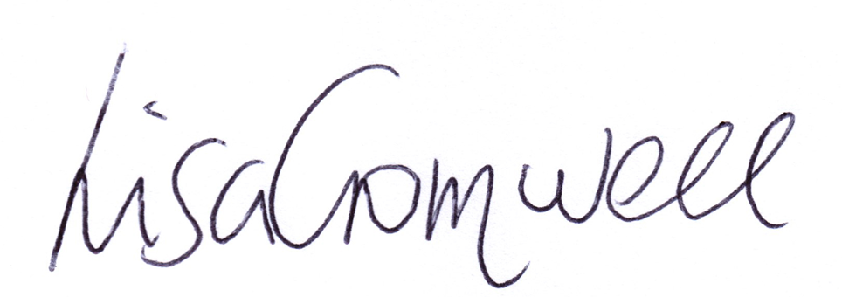
Lisa Cromwell – Parish Clerk Date Issued: 27.08.25

The Chair will open the meeting:

1 | Apologies for absence
2 | Declarations of Interest  Councillors are reminded that their actions must always be in the public interest. They must avoid giving any person an improper advantage or disadvantage, and they should not seek financial or other material benefits for themselves, their family, friends, or close associates.
 | To accept any declarations of interest regarding agenda items
3 | Acceptance of minutes of the last Ordinary Meeting held 02.07.25 and those of the Extraordinary meeting held 23.07.25 to discuss financial transactions [DR]
4 | District & County Reports
 | The Chair will invite Cllrs Crocker and Rice to report on matters of interest to residents [SD]
5 | Payments made since the last Ordinary Meeting.  [Consisting annual charges and subs, DD, delegated payments and/or Member voting at an Ordinary Meeting, by email, or,as determined by the JPC Financial Regulations, 5.15].
 | 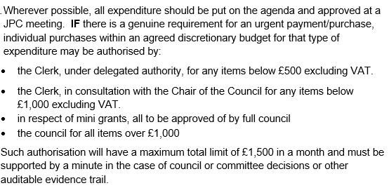
Creditor | Net | Provision
Orbit | £ 51.31 | Garage Rental
Scribe | £ 64.00 | Monthly Finance Software payment
Henley in Bloom | £ 230.40 | Payment for Gateway flowers
Creative Touch Design | £ 430.00 | Office and meeting room rental
Creative Touch Design | £ 360.00 | Office and meeting room rental
Creative Touch Design | £ 385.00 | Office and meeting room rental
Stratford District Council | £ 2,419.00 | Contribution to CCTV cameras
Green Meadow Mole | £ 80.00 | Mole removal Riverlands
HortiHenley | £ 1,765.00 | Grass Cutting PO 01 (from Scribe)
HortiHenley | £ 1,060.00 | PO 1103
HortiHenley | £ 135.00 | PO 06
Re-bound | £ 676.56 | Rubber chippings play area Riverlands
WD Trees | £ 300.00 | PO 1112
Henley in Arden Market | £ 500.00 | JPC mini-grant payment
Christmas Lights Fund | £ 100.00 | JPC donation
WALC/NALC | £ 905.00 | Annual subscription
Microsoft | £ 8.49 | Monthly payment for Office365
Fasthosts | £ 18.42 | Internet/website
Service charge (Bank) | £ 4.25 | Business acct service charge
Slack | £ 8.40 | Single membership
Lloyds TSB | £ 4.25 | Bank charges
Fasthosts | £ 3.17 | Visit Henley website/internet
HWMT | £ 396.00 | Memorial hall hire 2023
HWMT | £ 415.80 | Memorial hall hire 2024
Stratford District Council | £ 1,971.25 | Non-domestic rates
DM Payoll Services | £ 157.50 | Provision of payroll service
Rural Market Town | £ 105.00 | Subscription
HortiHenley | £ 500.00 | Work on allotments
HortiHenley | £ 150.00 | Hedge Riverlands
HortiHenley | £ 1,765.00 | Grass Cutting PO 01 (from Scribe)
HMRC | £ 2,542.93 | Tax
Clerk Salary | £ 2,282.79 | Salary
Clerk expenses | £ 29.00 | Expenses
Councillor expenses | £ 44.10 | David Broadbent (fuel)
Microsoft | £ 8.49 | Monthly payment for Office365
Fasthosts | £ 18.42 | Website provision
Redditch Skip Hire | £ 305.00 | Skip for Whitley Road Garage
Slack | £ 8.40 | Single membership
Service charge (Bank) | £ 4.25 | Business acct service charge
Fasthosts | £ 3.17 | Visit Henley website/internet
Totals | £ 16,275.64

6 | Creditors payments for consideration by Members
 | NB: Any payment requests received by the Clerk after publication of this agenda MAY be presented at the meeting for consideration.
Creditor | Net | Provision
Creative Touch Design | £ 120.00 | Clerk stationery (PO #14)
HortiHenley | £ 150.00 | Green space maintenance (PO #18)
HortiHenley | £ 120.00 | Urgent tree maintenance (Jubilee Park PO #17)
HortiHenley | £ 1,765.00 | Grass cutting August 2025 (PO #1)
WD'S Trees | £ 250.00 | Removal of two willow trees and one ash (PO #12)
WD'S Trees | £ 40.00 | Removal of broken branch (PO #11)
Totals | £ 2,445.00

7 | Income received since last meeting
Debtor | Net | Provision
Napier | £ 131.30 | The Croft
Napier | £ 209.95 | The Croft SP
Napier | £ 115.77 | The Croft
Napier | £ 639.93 | The Croft Ringo
Napier | £ 325.00 | The Croft Credorax
Napier | £ 173.68 | The Croft
Napier | £ 151.97 | The Croft
Napier | £ 182.72 | The Croft
Napier | £ 651.73 | The Croft
Napier | £ 138.26 | The Croft
Allotment tenants | £ 150.00 | Allotment rent

8 | Banking at 27.08.25
 | 
9 | Councillors’ proposals and notes to Council – to be proposed, seconded and voted on
 | Matters concerning expenditure/income
9.1 | Japanese Knotweed Management  Cllr McCaskie proposes that Eco control Solutions be contracted for a 3-year herbicidal in situ Management Plan which aims to control the Japanese Knotweed through to November 2027. The costs have been spread over the entire programme to aid with budgeting. The total cost will be £3,300 plus VAT.  MOTION: To instruct the clerk to issue a PO for the three-year contract, with payments of £1,100 + VAT per year for three years. [DR] [EA] [SD]
9.2 | Croft Car Park – Lighting
Cllr Okey proposes that following a PO sent to G S Adams LTD for a replacement lamp for Croft Light 8, it became apparent open inspection that the lamp itself was not the fault. The light requires replacement control gear, ballast and capacitor to restore functionality. The additional cost will be £195.00 + VAT.
MOTION: A PO to be issued to GS Adams Ltd for the additional equipment to bring Croft Light 8 back into working condition. [DR] [EA]
9.3 | Quote JPC Bulb planning Henley-in-Arden  Cllr Rouse proposes that, following ratification at the July meeting (Agenda item 7.7.25, Min #10.4), the JPC proceed with bulb planting at strategic sites in Henley, based on HortiHenley’s quote of £2,762. A grant application has been submitted to the CCNF at SDC under ‘Project Henley Buzz & Bloom’, which—if successful—will cover the cost. Regardless of the outcome, the decision to proceed has already been ratified.  MOTION: To issue a PO to HortiHenley to carry out the works. [DR] [EA]
9.4 | RoSPA Play Safety
 | Cllr Andrews proposes that RoSPA be engaged to carry out an inspection of our play areas in September when they are in this area. The cost will be no more than £300 +VAT.
 | MOTION: To obtain a quote and issue a PO for the inspection to be carried out. [DR] [EA]
9.5 | HortiHenley quote for JPC footpath maintenance
Cllr McCaskie proposes that HortiHenley’s quote for the footpath maintenance scheduled for this autumn at a cost of £1,170 be approved.
MOTION: To approve and a PO be issued for works to commence last week of September and first week of October. [DR] [EA]
9.6 | Membership renewal to Society of Local Council Clerks (SLCC)
 | Cllr Okey proposes that the Council approve the creation of a Purchase Order for the annual renewal of the Clerk’s SLCC membership, effective from 1 October. The renewal process has been updated to include a 60-day payment term and auto-renewal functionality, which will generate an invoice based on the current salary unless opted out. The Clerk will review and confirm the membership profile upon login post-renewal, with adjustments made accordingly.
 | MOTION: To approve and for the clerk to raise the PO on 1 October for £240. [DR] [EA]
9.7 | 20mph speed signs and roundels to assist with prevention of speeding
Cllr Okey proposes that the quote which WCCC has provided for painting 4 x 20mph Roundels, 2 at each existing 20mph sign, one on each carriageway at £287.96 be approved. The JPC is committed to tackle speeding issues throughout Beaudesert & Henley-in-Arden, particularly on Henley High Street.
MOTION: To approve the works and to issue a Purchase order. [DR] [EA]
9.8 | New Bin at Riverlands Park
Cllr Okey proposes that a new bin is installed at Riverlands Park. SDC’s Waste and Recycling Sustainability officer has visited Riverlands upon our request to review the current (overflowing) bin, costing £250 +VAT. Installation is £150+VAT and then
Service charge annually is £164.52 +VAT and incremental increase each year.
This is for once a week empty and bin bag change. It’s worth noting the bin is the responsibility of the Parish and fire, theft or damage will need to be covered if the need to replace the bin should arise.
MOTION: To approve the purchase and installation of a bin at a cost of £400 + VAT,and for an annual service charge of £164.52 + VAT, and an incremental increase each year and a PO to be issued for same. [DR] [EA]
9.9 | Neighbourhood Development Plan (NDP) update and future expenditure
 | Cllr Andrews to provide an update on the progress of the NDP. In addition, following agreement at the meeting held on 7 July (MIN 10.1), Cllr Andrews proposes that the JPC allocate a maximum of £10,000 from JPC reserves to support the continued development and completion of the NDP, following the governments’ decision to withdraw the NDP grant funding scheme.
 | MOTION: To approve the allocation of up to £10,000 from the JPC reserves to support the continued development and completion of the NDP. [DR] [EA]
9.10 | Gate between Chingley Bank to Jubilee Park
Cllr McCaskie proposes putting in new gate posts as quickly as possible to prevent the gate from falling and harming anyone, at a cost of £550.00 to replace the posts, reset them and transfer the metal work etc.
MOTION: To issue a PO to HortiHenley to make good the gate. [DR] [EA]
9.11 | Dog Fouling - Public Space Protection Order - poster for display
 | Cllr Okey proposes that the poster provided by SDC regarding dog fouling for the notice boards, be printed and placed at strategic places around the town where constant offending is taking place. We have received a large number of complaints regarding this issue.
 | MOTION: To have 50 x A4 cards printed and encapsulated at a cost of £160.00 + VAT [DR] [EA]
9.12 | Recommended works to trees overhanging gardens of Nos. 2 – 5 Fieldhouse Close
 | Cllr McCaskie proposes that a Planning Application be sent to SDC for work at trees at the rear of 2 – 5 Fieldhouse close. WD’S Trees has been to view the site and the cost will be £650.
 | MOTION: The clerk to apply for planning permission for works to be carried out on the trees, and once permission has been granted, for a PO to be issued to WD’S Trees for the sum of £650.00 [DR] [EA]
10 | Councillors’ proposals and notes to Council – to be proposed, seconded and voted on
 | Business matters – updates only – no financial decisions listed
 | There are no proposals/updates or businesss matters to discuss.
11 | Planning Applications: NB: For information only. These applications will be considered and discussed at the Planning working party’s meeting on Wednesday 3 September.
 | 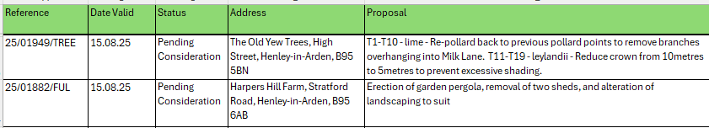
12 | Members Urgent Business Matters
 | The Chair will enquire whether Councillors have any urgent business to bring to the attention of the assembly.
13 | Next Meeting
 | The next Ordinary Meeting will be held on Monday 3 October at the Methodist Church Hall, High Street.

.

