.

Dear Councillors

An Ordinary Meeting of the Parish Council will be held at 7:00 pm at the Baptist Church Hall, High Street, Henley-in-Arden. All council members are requested to attend to discuss and resolve the items listed in the agenda.

Public Session

Before the council meeting begins, the public will have an opportunity to present their concerns or comments. This session, at the discretion of the Chair, is limited to 3 minutes per speaker and a total of 15 minutes. Any issues not listed in the agenda will be noted by the Clerk for future consideration.

Clerk’s note

Planning Committee will consider applications listed in section 11. Outcomes of these applications can be viewed on the Stratford on Avon Planning Portal. Click on:

https://apps.stratford.gov.uk/eplanning/

MAIN TOPICS
4 | County and District Councillors’ reports
9 | Proposals for expenditure:  Youth Council Budget  Tree Removal  Croft Car Park  Councillor Recruitment
11 | Planning applications

Supporting documents relating to the following subjects can be found on the JPC website prior to the meeting.

Signed 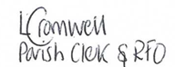
Lisa Cromwell – Parish Clerk Date Issued:29.10.25

The Chair will open the meeting

1 | Apologies for absence
2 | Declarations of Interest  Councillors are reminded that their actions must always be in the public interest. They must avoid giving any person an improper advantage or disadvantage, and they should not seek financial or other material benefits for themselves, their family, friends, or close associates.
 | To accept any declarations of interest regarding agenda items
3 | Acceptance of minutes of the last Ordinary Meeting held 6 October 2025 [DR]
4 | District & County Reports
 | The Chair will invite Councillors Rice and Crocker to present their reports. [SD]
5 | Payments made since the last Ordinary Meeting.  [Consisting annual charges and subs, DD, delegated payments and/or Member voting at an Ordinary Meeting, by email, or,as determined by the JPC Financial Regulations, 5.15].
 | 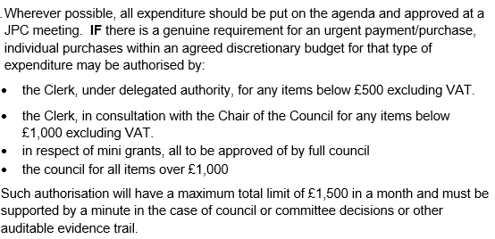
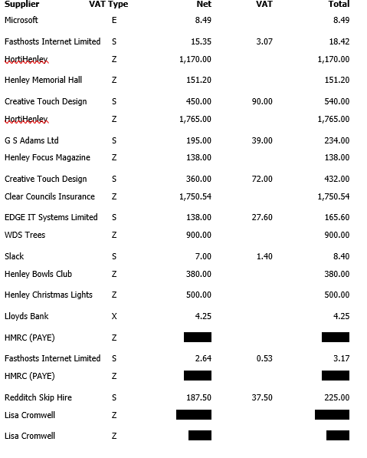
Total 11,615.62 271.10 11,886.72
6 | Creditors payments for consideration by Members
NB: Any payment requests received by the Clerk after publication of this agenda MAY be presented at the meeting for consideration.

Creditor | Net | Provision
Creative Touch Design | £ 385.00 | JPC office rent Se25 (PO #34)
Creative Touch Design | £ 450.00 | JPC office rent Oct 25 (PO #44)
Moore External Auditors | £ 446.25 | Fixed rate fee to complete External Auditor's limited assurance review
HortiHenley | £ 1,765.00 | Grass Cutting and Ground Maintenance - October (PO #1)
Parish Online | £ 104.00 | Annual mapping software fee
Totals | £ 3,535.25

7 | Income received since last meeting
 | 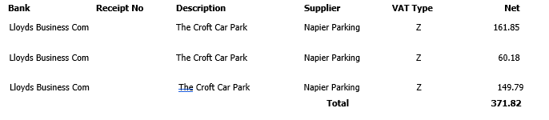
8 | Banking at 29.10.25
 | 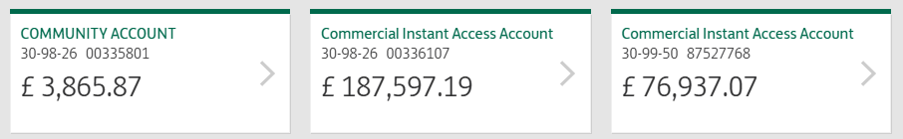
9 | Councillors’ proposals and notes to Council – to be proposed, seconded and voted on
 | Matters concerning expenditure/income
9.1 | Youth Council budget proposal  Cllr Okey proposes the allocation of a £1,500 budget to the Youth Council to enhance their experience of council operations by enabling discussion and planning around expenditure. This initiative aims to foster financial awareness and decision-making skills within a structured framework. All proposed spending will be subject to full JPC ratification prior to any commitment, and the JPC will retain control of the associated bank account.  MOTION: To approve the allocation of a £1,500 budget to the Youth Council under the conditions outlined. [DR] [EA]
9.2 | Cherry Tree removal adjacent to Medical Centre  Cllr Tomlinson proposes the removal of a cherry tree, on JPC land, due to root encroachment on the building and pipework, and canopy overgrowth affecting the roof of the Medical Centre. Anticipated structural damage has prompted the JPC to seek a quote of £450 from WDS Trees for full removal, including roots. As the tree is located within a conservation area, an application for planning permission has been submitted to SDC.  Motion: To approve the quoted works and, subject to planning consent, issue a purchase order to WDS Trees to proceed. [DR] [EA]
9.3. | Croft Car Park
Cllr Okey proposes that, following receipt and consideration of three quotations from legal firms, the Council authorises an initial consultation with Thomas Guise Solicitors. This consultation will be undertaken to obtain a detailed and tangible cost estimate for the provision of legal advice relating to car park matters.

MOTION: To approve and authorise the Clerk to provide a PO for the initial consultation at a cost of no more than £1,000. [DR] [EA]
9.4 | Advertising for Councillor Recruitment  Cllr Andrews proposes that, as part of the current recruitment drive for new JPC Councillors, an advert be included in the Christmas Lights hymn sheets. The JPC would cover the associated cost of no more than £450 +VAT  MOTION: To approve this expenditure and instruct the Clerk to raise a purchase order accordingly.
 | [DR] [EA]
10 | Councillors’ proposals and notes to Council – to be proposed, seconded and voted on
 | Business matters – updates only – no financial decisions listed
10.1 | Planning Comments – Authority to Submit  Carried forward from the previous meeting  Cllr Tomlinson proposes that the Clerk be authorised to submit planning comments between meetings when statutory deadlines fall before the next full council meeting. This would be based on Planning Working Group recommendations reviewed by councillors, in accordance with Section 101 of the Local Government Act 1972 and guidance from Arnold-Baker.  MOTION: To approve authority for the Clerk to submit planning comments agreed by councillors when deadlines fall before the next full council meeting. [DR] [SD]
10.2 | Review and Adoption of Governance Documents
 | Cllr Okey proposes that, following prior circulation and review by councillors, the following documents be formally considered and resolved
10.2.1 | Co-option Policy
10.2.2 | Complaints Procedure
10.2.3 | Planning Working Party Terms of Reference
10.2.4 | Standing Orders (amended to reflect updates to the Planning Working Party Terms of Reference)
 | MOTION: To approve and adopt the above documents as presented.
10.3 | Ratification of Clerk’s Contract
 | Cllr Okey proposes to ratify the Clerk’s contract.
 | MOTION: To approve and ratify.
11 | Planning Applications:
 | 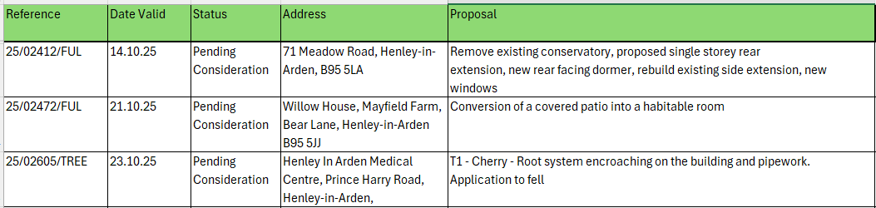
12 | Members Urgent Business Matters
 | The Chair will enquire whether Councillors have any urgent business to bring to the attention of the assembly.
13 | Next Meeting
 | The next Ordinary Meeting will be held on Monday 1 December at the Baptist Church Hall, High Street, followed by Festive drinks and nibbles provided by the JPC.

.

