.

Dear Councillors

An Ordinary Meeting of the Parish Council will be held at 7:00 pm at the Baptist Church Hall, Station Road, Henley-in-Arden. All council members are requested to attend to discuss and resolve the items listed in the agenda.

Public Session

Before the council meeting begins, the public will have an opportunity to present their concerns or comments. This session, at the discretion of the Chair, is limited to 3 minutes per speaker and a total of 15 minutes. Any issues not listed in the agenda will be noted by the Clerk for future consideration.

Clerk’s note

Planning Committee will consider applications listed in section 11. Outcomes of these applications can be viewed on the Stratford on Avon Planning Portal. Click on:

https://apps.stratford.gov.uk/eplanning/

MAIN TOPICS
 | Chair will introduce the founding members of the Beaudesert & Henley-in-Arden Youth Council
4 | County and District Councillors’ reports
9 | Proposals for expenditure
11 | Planning applications

Supporting documents relating to the following subjects can be found on the JPC website prior to the meeting.

Signed 
Lisa Cromwell – Parish Clerk Date Issued: 01.10.25

The Chair will open the meeting:

Introduction of the founding members of Henley-in-Arden’s Youth Council

1 | Apologies for absence
2 | Declarations of Interest  Councillors are reminded that their actions must always be in the public interest. They must avoid giving any person an improper advantage or disadvantage, and they should not seek financial or other material benefits for themselves, their family, friends, or close associates.
 | To accept any declarations of interest regarding agenda items
3 | Acceptance of minutes of the last Ordinary Meeting held 1 September 2025 [DR]
4 | District & County Reports
 | Cllr Crocker will not be attending due to holiday. The Chair will invite Cllr Rice to report on matters of interest to residents [SD]
5 | Payments made since the last Ordinary Meeting.  [Consisting annual charges and subs, DD, delegated payments and/or Member voting at an Ordinary Meeting, by email, or,as determined by the JPC Financial Regulations, 5.15].
 | 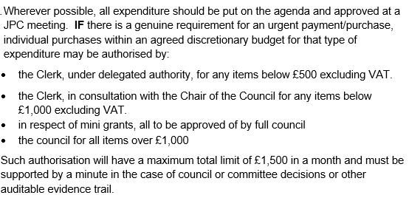
Creditor | Net | Provision
SDC | £ 164.52 | Annual emptying of new Riverlands litter bin (PO #32 )
SDC | £ 400.00 | New bin at Riverlands (PO #32)
ShredPro - (approved under Clerk's delegated authority expenditure under £500) | £ 60.00 | Confidential waste shredding (PO #19)
i-Connect (WCC Pension Scheme) | £ 4,193.28 | Pension payments (backdated to Jan)
i-Connect (WCC Pension Scheme) | £ 1,297.92 | Pension payments (backdated to Jan)
Playsafety Limited | £ 280.00 | Annual inspection of play equipment (PO #30)
Clerk Expenses | £ 29.00 | Clerk Expenses (phone)
Clerk Salary | £ 1,964.33 | September Salary
Orbit - Garage | £ 51.31 | Storage rental
Scribe | £ 64.00 | Monthly Finance Software payment (Sept)
Creative Touch | £ 120.00 | Clerk stationery (PO #14)
HortiHenley | £ 150.00 | Green space maintenance (PO #18)
William Davies | £ 40.00 | Removal of broken branch (PO #11)
William Davies | £ 250.00 | Removal of two willow trees and one ash (PO #12)
Microsoft | £ 8.49 | Monthly payment for Office365
Fasthosts | £ 18.42 | Internet/website
Slack | £ 8.40 | Single membership
HortiHenley | £ 550.00 | Jubilee park gate post repair (PO #21)
GS Adams Limited | £ 120.00 | Replacement light Croft Car Park (PO #27)
WALC | £ 42.00 | Clerk training (pre-CiLCA)
HortiHenley | £ 1,765.00 | Grass Cutting and ground maintenance August (PO #1)
Lloyds service charge | £ 4.25 | Business account service charge
Fastholst | £ 3.17 | Visit Henley website/internet
Amazon | £ 28.32 | Notebooks for Youth Councillors
Scribe | £ 64.00 | Monthly Finance Software payment (Oct)
Allotment Holder | £ 141.00 | New lock for Allotment gates due to fire service having to break lock to attend to fire
Orbit -Garage | £ 44.46 | New Arden Road garage instead of Whitley Road (Oct)
Fasthosts | £ 12.83 | Internet/website
GOV.UK Pay | £ 21.50 | DBS check
Totals | £ 11,911.57

6 | Creditors payments for consideration by Members
 | NB: Any payment requests received by the Clerk after publication of this agenda MAY be presented at the meeting for consideration.
Creditor | Net | Provision
Creative Touch Design | £ 360.00 | JPC office rent August 25 (PO #25
Creative Touch Design | £ 450.00 | JPC office rent July 25 (PO #15)
Creative Touch Design | £ 385.00 | JPC office rent Sept 25 (PO # 34)
Advantedge Finance Read Only | £ 138.00 | Read only access 9.10.25 8.10.26
Hire of Memorial Hall May - August 2025 | £ 151.20 | Hire for Ordinary meetings (PO #29)
WD's Trees | £ 900.00 | Urgent tree maintenance in Riverside gardens (fallen alder tree) (PO #33)
Henley Focus | £ 138.00 | Full page ad regarding Unitary Council and what it means (PO # 35)
Totals | £ 2,522.20

7 | Income received since last meeting
Debtor | Net | Provision
Napier | £ 155.03 | The Croft
Napier | £ 235.70 | The Croft SP
Napier | £ 139.69 | The Croft
Napier | £ 816.25 | The Croft Ringo
Allotment tennants | £ 50.00 | Allotment rent
Allotment tennants | £ 25.00 | Allotment rent
Allotment tennants | £ 50.00 | Allotment rent
Allotment tenants | £ 50.00 | Allotment rent
SDC | £ 65,497.50 | Precept (2nd tranche)
Totals | £ 67,019.17

8 | Banking at 01.10.25
 | 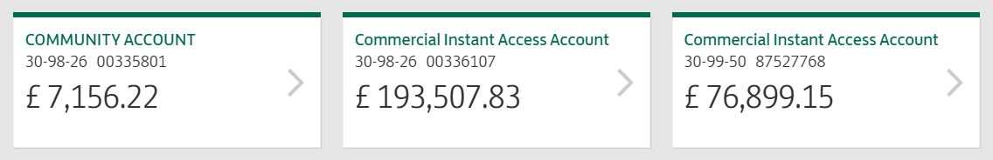
9 | Councillors’ proposals and notes to Council – to be proposed, seconded and voted on
 | Matters concerning expenditure/income
9.1 | Clerk’s contractual correction  Cllr Okey proposes the contractual adjustment to the Clerk/RFO’s pay scale as approved in confidential session.  MOTION: To adjust the clerk’s contract by amending the pay scale by correcting the initial grading in line with NALC’s job evaluation guidance. [DR] [EA]
9.2 | Skip for Allotments  Cllr Norris proposes that a skip be booked for the use of the Allotment holders to clear up the debris and rubbish which has accumulated.
 | MOTION: To book a skip at a cost of no more than £300. Skip to be placed at Bear Lane for one day only. [DR] [EA]
9.3 | Mini-Grant Applications
 | Cllr Andrews proposes that two mini-grant applications received this month and processed by the Grant working party be formally ratified:
9.3.1 | Bowls Club
 | The Bowls Club has requested a mini-grant of £380 to facilitate a raised toilet and grab rail to benefit its more physically challenged members
 | MOTION: That the £380 is awarded to the Bowls Club [DR] [EA]
9.3.2 | Henley Lights
Henley Lights has requested a grant of £500 for new signs advertising the Switch On night.
MOTION: To award £500 to Henley Lights for new signage. [DR] [EA]
9.4 | Handyman
 | Cllr Andrews proposes the issuance of a PO to a handyman, interviewed by the clerk, to carry out several maintenance works around the town/parks. The estimated cost is three days at £150 per day.
 | MOTION: To approve and for the clerk to raise a PO for three days work at £450 [DR] [EA]
9.5 | Council Insurance
 | Cllr Okey proposes the JPC remain with the incumbent insurers for this year. The policy provides the cover we need.
 | MOTION: To instruct the Clerk to issue a PO in the sum of £1,750.54 to Clear Council Insurance Management Ltd [DR] [EA] [SD]
9.6 | St John The Baptist Church Clock - Service
Cllr Okey proposes the JPC organise a biennial service of the clock. The cost for this year’s service will be £366 + VAT.
MOTION: To instruct the Clerk to issue a PO in the sum of £366,00 + VAT to John Taylor Foundary (previously serviced) and then every two years from 2025. [DR] [EA]
9.7 | New Website Provider – Assertion 10 Compliance
Cllr Andrews proposes that the JPC appoint a website provider to deliver a new, compliant council website in line with Assertion 10: Digital and Data Compliance within the Annual Governance Statement, which mandates the JPC must operate from a council-owned domain, maintain an IT policy, and ensure all digital communications meet accessibility and data protection standards. £5,000 has previously been budgeted and ratified for this purpose. Three quotes have been sought; two received to date are highly competitive and under £2,500. The third quote is pending.
MOTION: That the JPC resolves to appoint a suitable website provider, subject to final quote comparison and authorises the Clerk to proceed with issuing a purchase order once the preferred provider is confirmed.

10 | Councillors’ proposals and notes to Council – to be proposed, seconded and voted on
 | Business matters – updates only – no financial decisions listed
10.1 | Cllr Andrews to propose the consideration of formal recognition of the Henley Allotment Association and approval of the Manangement Agreement and Association Constitution. MOTION: That the JPC formally recognises the Henley Allotment Association as the representative body for plot holders and approves the Management Agreement and Association Constitution as presented. The AA Committee will sign both documents at the meeting, confirming mutual responsibilities and governance arrangements  [DR] [SD]
10.2 | Standing Orders and Financial Regulations Updates
 | Cllr Andrews proposes that the Standing Orders and Financial Regulations, which have been updated this year in line with NALC’s model Standing Orders and Financial Regulations, and reviewed by the members, be adopted by the JPC
 | MOTION: To formally approve and adopt the Standing Orders and Financial Regulations [DR] [SD]
10.3 | Grant and Funding Policy - adoption
 | Cllr Okey proposes the approval and adoption of the new Grants and Funding Policy which has been reviewed by the members and will be reviewed again in 2027.
 | MOTION: To approve and adopt the Grants and Funding Policy. [DR] [SD]
10.4 | Planning comments – delegated authority
 | Cllr Broadbent pro.poses that the Clerk be authorised to submit planning comments between meetings when deadlines fall before the next full council, based on Planning Working Group recommendations reviewed by councillors.
 | MOTION: To delegate authority to the Clerk to submit planning comments between meetings, with all decisions reported at the next full council. [DR]
11 | Planning Applications:
 | 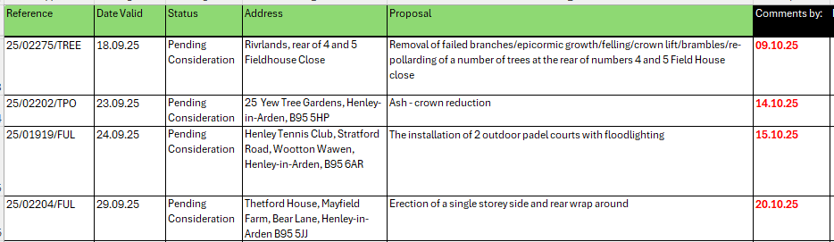
12 | Members Urgent Business Matters
 | The Chair will enquire whether Councillors have any urgent business to bring to the attention of the assembly.
13 | Next Meeting
 | The next Ordinary Meeting will be held on Monday 3 November at the Methodist Church Hall, High Street.

.

