Here are the Minutes of the Ordinary Council Meeting of Beaudesert and Henley in Arden JPC, which took place on Monday, 3 November, at 7.00pm in the Baptist Church Hall, Henley in Arden.

Present: Cllrs Okey [Chair], Andrews [Vice-Chair], Norris, Tomlinson, Broadbent and Rouse

In Attendance: There were 24 members of the public in attendance.

Public Session: Open Forum to provide an opportunity for members of the public to raise questions and to comment on any other items that are on the current agenda.

CLERK’S NOTE
Planning Committee considered applications listed herein. Outcomes of these applications can be viewed on the Stratford on Avon Planning Portal click on - https://apps.stratford.gov.uk/eplanning/

Tribute to Bob Morgan
Prior to the opening of the meeting, the Vice-Chair paid tribute to Bob Morgan, who sadly passed away on Sunday 26 October.
Bob served as Internal Auditor to the JPC with diligence and integrity,and was a generous mentor to the new Clerk. His quiet wisdom, steady guidance, and unwavering professionalism made a lasting impact on the council and the wider community.
The JPC records its gratitude for his service and expresses its deepest condolences to his family and loved ones.

1 | Apologies for absence
 | Apologies were received from Cllr McCaskie
2 | Declarations of Interest  Councillors are reminded that their actions must always be in the public interest. They must avoid giving any person an improper advantage or disadvantage, and they should not seek financial or other material benefits for themselves, their family, friends, or close associates.
 | There were no declarations of interest.
3 | Acceptance of minutes of the last Ordinary Meeting held 06.10.25
 | This motion was proposed by the Chair and carried unanimously by all those present at the meeting. It was RESOLVED that the minutes of the meetings held on 06.10.25 were confirmed as a true record and signed by the Chair.
4 | District and County Reports
Cllr Rice, Stratford District Councillor, and Cllr Crocker, Warwickshire County Councillor both gave a report, where the following was noted:

Cllr Rice reported that Stratford District Council currently lacks a five-year housing land supply, which may increase the risk of speculative development across Stratford and surrounding parishes. He also suggested that the JPC consider joining forces with neighbouring parish councils to mount a coordinated campaign urging Stratford District Council, specifically George Cowcher, Deputy Leader of SDC, and the portfolio holder for Planning and Economic Development. This position makes him the key point of contact for engagement on future governance arrangements.

Cllr Crocker’s September 2025 report to the JPC expressed his personal view that a single Warwickshire unitary council represents “the most compelling” option. It was noted during the meeting that this statement reflects his individual opinion and is not supported by any formal evidence of Henley residents’ preferences. The report does not cite surveys, public feedback, or engagement specific to Henley-in-Arden, and no such evidence has been presented to the JPC to date.

 | Both reports can be found on the JPC’s website.
5 | Payments made since the last Ordinary Meeting.  [Consisting annual charges and subs, DD, delegated payments and/or Member voting at an Ordinary Meeting, by email, or, as determined by the JPC Financial Regulations, 5.15].  Wherever possible, all expenditure should be put on the agenda and approved at a JPC meeting. IF there is a genuine requirement for an urgent payment/purchase, individual purchases within an agreed discretionary budget for that type of expenditure may be authorised by:  - the Clerk, under delegated authority, for any items below £500 excluding VAT.  - the Clerk, in consultation with the Chair of the Council for any items below £1,000 excluding VAT.  - in respect of mini grants, all to be approved of by full council  - the council for all items over £1,000  Such authorisation will have a maximum total limit of £1,500 in a month and must be supported by a minute in the case of council or committee decisions or other auditable evidence trail.  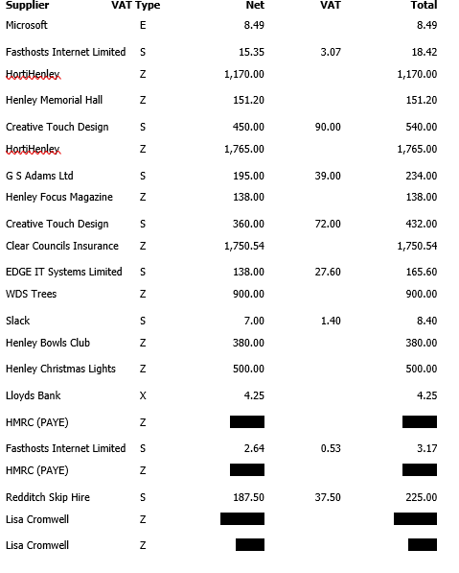
6 | Creditors payments for consideration by Members
 | NB: Any payment requests received by the Clerk after publication of this agenda MAY be presented at the meeting for consideration.
Creditor | Net | Provision
Creative Touch Design | £ 385.00 | JPC office rent Se25 (PO #34)
Creative Touch Design | £ 450.00 | JPC office rent Oct 25 (PO #44)
Moore External Auditors | £ 446.25 | Fixed rate fee to complete External Auditor's limited assurance review
HortiHenley | £ 1,765.00 | Grass Cutting and Ground Maintenance - October (PO #1)
Parish Online | £ 104.00 | Annual mapping software fee
Totals | £ 3,535.25

7 | Income received since last meeting
 | 
Nos. 5, 6, 7 and 8
The Chair enquired whether all members had reviewed the data for payments, receipts, and bank balances. It was RESOLVED that all members confirmed they had inspected the data and unanimously approved the content.
8 | Banking at 29.10.25
 | 
9 | Councillors’ proposals and notes to Council – to be proposed, seconded and voted on
 | Matters concerning expenditure/income
9.1 | Youth Council budget proposal  Cllr Okey proposed the allocation of a £1,500 budget to the Youth Council to enhance their experience of council operations through discussion and planning around expenditure.  The allocation, under the conditions outlined on the agenda, was seconded by Cllr Andrews and approved unanimously by a show of hands. RESOLVED.
9.2 | Cherry Tree removal adjacent to Medical Centre  Cllr Tomlinson proposed the removal of a cherry tree located on JPC land, citing root encroachment on the building and pipework, as well as canopy overgrowth affecting the roof of the Medical Centre. The proposal to approve the quoted works and, subject to planning consent, issue a purchase order to WDS Trees in the sum of £450 to carry out the removal was seconded by Cllr Broadbent and approved unanimously by a show of hands. RESOLVED.
9.3 | Croft Car Park
 | Cllr Okey proposed that the Council authorises an initial consultation with Thomas Guise Solicitors to obtain a detailed and tangible cost estimate for the provision of legal advice relating to car park matters. The proposal to authorise the Clerk to provide a PO for the initial consultation at a cost of no more than £1,000 was seconded by Cllr Andrews and approved unanimously by a show of hands. RESOLVED.
9.4 | Advertising for Councillor Recruitment  Cllr Andrews proposed that, as part of the current recruitment drive for new JPC Councillors, an advert be included in the Christmas Lights hymn sheets. The JPC would cover the associated cost of no more than £450 +VAT. The motion to approve the expenditure and instruct the Clerk to raise a purchase order accordingly was seconded by Cllr Okey and approved unanimously by a show of hands. RESOLVED.
10 | Councillors’ proposals and notes to Council – to be proposed, seconded and voted on
 | Business matters – updates only – no financial decisions listed
10.1 | Planning Comments – Authority to Submit  Carried forward from the previous meeting  Cllr Tomlinson proposed that the Clerk be authorised to submit planning comments to SDC’s Planning Portal, between meetings when statutory deadlines fall before the next full council meeting. This would be based on Planning Working Group recommendations reviewed by all councillors and their approval received via email. This motion was seconded by Cllr Broadbent and approved unanimously by a show of hands. RESOLVED.
10.2 | Review and Adoption of Governance Documents
 | Further to the Clerk’s commitment at the Internal Audit conducted in May 2025 to review and update all JPC Policies and Procedures by March 2026 — in line with the principles of the Accounts and Audit Regulations 2015 and NALC best practice guidance — Cllr Okey proposed that, following prior circulation and review by councillors, the following documents be formally considered and resolved:
10.2.1 | Co-option Policy
10.2.2 | Complaints Procedure
10.2.3 | Planning Working Party Terms of Reference
10.2.4 | Standing Orders (amended to reflect updates to the Planning Working Party Terms of Reference)
 | The motion to approve and adopt the above documents as presented was seconded by Cllr Andrews and approved unanimously by a show of hands. RESOLVED.
10.4 | Ratification of Clerk’s Contract
 | Cllr Okey proposed that the Clerk’s amended contract be ratified. This motion was seconded by Cllr Andrews and approved unanimously by a show of hands. RESOLVED.
11 | Planning
 | Cllr Tomlinson presented the Planning Working Party’s recommended submissions to Stratford District Council’s Planning Portal, all of which had been reviewed and formally approved by full council.
 | 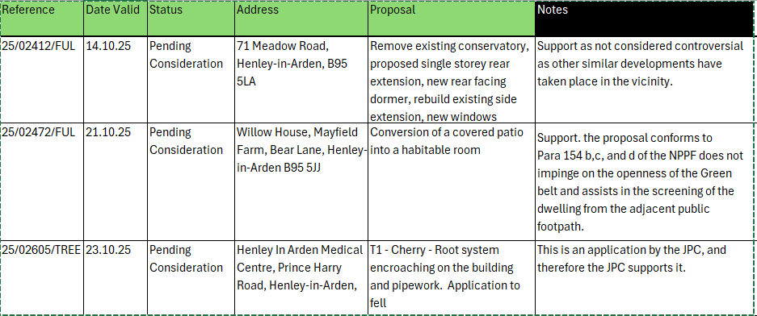
12 | Members Urgent Business Matters
 | The Chair will enquire whether Councillors have any urgent business to bring to the attention of the assembly.
 | EV Chargers
12.1 | Cllr Andrews urged any residents who oppose the 8 x EV charger spaces on Henley High Street which would be for electric vehicles only and not for dual purpose i.e. can’t also be used by non-electric vehicles, to write to WCC with their objections. Details below:
Any objections or representations to the proposals, which must be in writing and specify the grounds on which they are made, should be addressed to Candie Humphreys, County Highways Minor Works, Communities Directorate, Shire Hall Post Room, Northgate Street, Warwick, CV34 4RL or sent by email to chminorworks@warwickshire.gov.uk using "Countywide EV Project - Stratford on Avon" as the subject. (Objections, representations, and the name of the objector will normally be treated as public information and may be published. For further information on how Warwickshire County Council processes personal data please refer to the Customer Privacy Notice which is available at https://www.warwickshire.gov.uk/privacy.)

Objections and representations must be sent so as to be received by: 17 November 2025

12.2 | Alne Close (Monkey Run) Lighting
Cllr Andrews advised that following sustained pressure from the JPC, Warwickshire County Council has raised an order to implement a temporary solution aimed at restoring lighting in Alne Close (Monkey Run), while the longer-term fix continues to progress.

WCC expects this temporary measure to be in place by the end of next week. If it proves unsuccessful, an alternative solution involving overhead cable feeds is being actively explored to ensure a more reliable temporary outcome.

The JPC will continue to press for swift action and provide updates as the situation develops.

12.3 | JPC Grant deadline imminent
 | Cllr Okey reiterated that the deadline for grant applications is 14 November 2025.
12.4 | SDC grant available
 | There is community funding available from SDC. Please see below:
 | Community Grant Scheme 2025 | Stratford-on-Avon District Council
12.5 | Buzz and Bloom Project
 | The JPC has provisionally been awarded £5,530 in capital funding from the Community Climate and Nature fund from SDC. The project will create around 700 sq metres of wildflower habitat, expand forage and nesting areas and increase community engagement through hands-on stewardship. Updates will be provided on a regular basis.
12.6 | Congratulations to the Youth Council
 | Our new Youth Council raised a concern about a damaged fence near to the High School at the October meeting. This was highlighted to WCC who are now making provisions to fix the fencing. Updates on progress will be provided.

.

Signed ………………………………………………………………………………….

Date……………………………………………………….

