REPORT FROM WARWICKSHIRE COUNTY COUNCILLOR
JAMES CROCKER

BEAUDESERT & HENLEY JOINT PARISH LOCAL ISSUE UPDATE
- Alne Close: Works have begun, but still unfinished
- Stylers Way: Update awaited from WCC officers
- Loose manhole cover on High Street fixed
- Stratford Road Parking issues noted
- Yellow lines outside fire station approved
- Flood defences/drains success failure to be reviewed post Storm Claudia

NEWS FROM SHIRE HALL
Community Speed Watch Scheme
Warwickshire Police and Warwickshire County Council are working together to address speeding concerns through a data-led approach. Here’s how you can help:
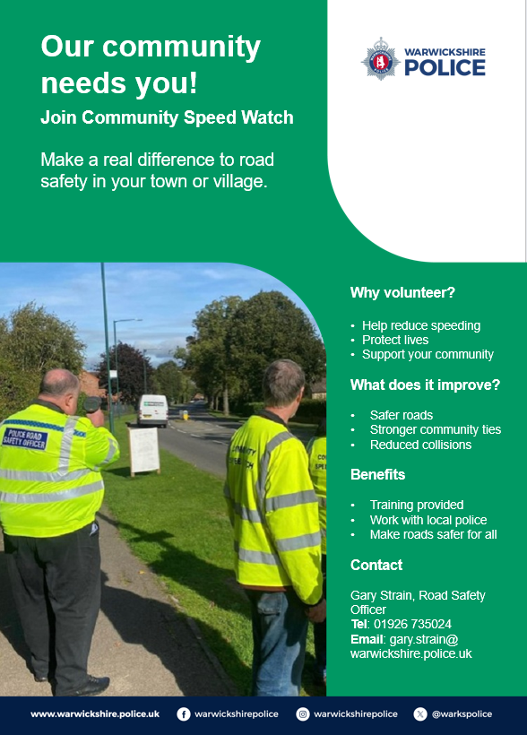
Report Speed Concerns
If you notice speeding issues in your area, report them via the Warwickshire Road Safety Partnership:
Report Speed Concerns here: https://warksspeedconcerns.org/

Join Community Speed Watch
Want to make our roads safer? Set up a Community Speed Watch group with support from Warwickshire Police.
Contact:
Gary Strain – Road Safety Officer
01926 735024 gary.strain@warwickshire.police.uk

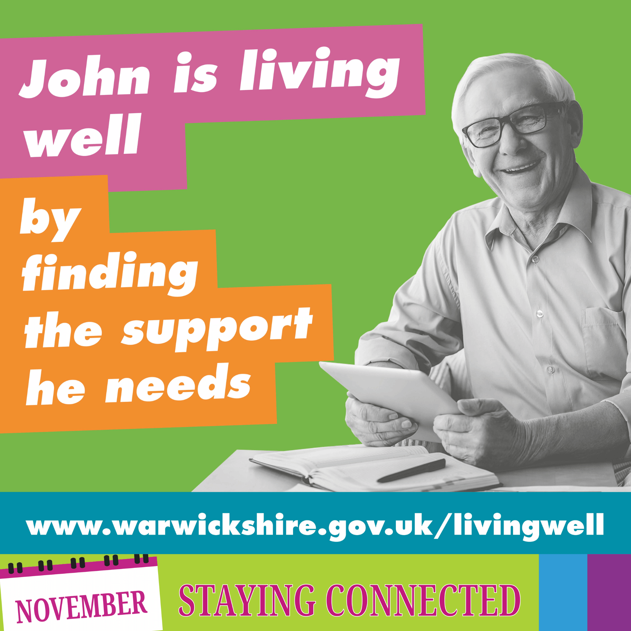
Stay Connected and Reduce Loneliness with the Living Well Webpages
Warwickshire County Council (WCC) is encouraging residents to visit the Living Well webpages which provide free access to resources designed to help people stay connected and reduce loneliness.

Mobile Phone Users With Poor Phone Signal Urged to Take Survey
A survey has been launched to find the areas in Warwickshire suffering from poor mobile phone coverage.
The latest initiative from Warwickshire County Council aims to gather reports directly from residents and businesses about signal quality and to identify coverage ‘blackspots’ which require service improvements from the mobile phone operators.
Councillor Rob Howard, Warwickshire County Council’s Portfolio Holder for Economy, said:
“We are acutely aware that people in areas of poor coverage are at a disadvantage, socially and economically, and we want to address that.
“We are launching our mobile phone service survey to find out the level of coverage people are getting from their mobile phone providers and pinpoint where the problematic areas are. This will help inform our conversations with the industry when they are making plans for future service improvements in Warwickshire.”
Help us build an understanding of coverage in your area by completing our mobile connectivity survey online at https://ask.warwickshire.gov.uk/mobile-coverage/issues/

MY RESPONSIBILTIES AS WARWICKSHIRE COUNTY COUNCILLOR
- Within Warwickshire County Council, other parishes in the Arden division include Wootton Wawen, Ullenhall, Claverdon, Langley, Tanworth-in-Arden (including Earlswood), Wolveron and Preston Bagot.
- Serving on both the Warwickshire Fire & Rescue Local Pension Board of the Firefighters’ Pension Scheme and the Warwickshire Pension Fund Local Pension Board.
- Member of the cross-party working group for the Bus Service Improvement Plan. I have recently received a number of requests from residents asking for service extensions to key areas such as Warwick Hospital. If you have any views or suggestions regarding local bus services, please do not hesitate to get in touch.
Separately, also Chair of the Reform UK branch for Stratford-on-Avon.

Getting in Touch
For any issues or ideas that would benefit Beaudesert and Henley-in-Arden, as your representative, I am always available to listen and support local priorities at Warwickshire County Council.

James Crocker
County Councillor for Arden
Warwickshire County Council Email: jamescrocker@warwickshire.gov.uk
Mobile: 07353 157962

