.

Dear Councillors

An Ordinary Meeting of the Parish Council will be held at 7:00 pm at the Memorial Hall, Station Road, Henley-in-Arden. All council members are requested to attend to discuss and resolve the items listed in the agenda.

Public Session

Before the council meeting begins, the public will have an opportunity to present their concerns or comments. This session, at the discretion of the Chair, is limited to 3 minutes per speaker and a total of 15 minutes. Any issues not listed in the agenda will be noted by the Clerk for future consideration.

Clerk’s note

Planning Committee will consider applications listed in section 11. Outcomes of these applications can be viewed on the Stratford on Avon Planning Portal. Click on:

https://apps.stratford.gov.uk/eplanning/

MAIN TOPICS
4 | County and District Councillors’ Reports [SD]
5 | NDP/SWLP Update
6 | Youth Council Update
7 | Chair’s Report
8 - 11 | Finance Update
12 | Matters Concering Expenditure
13 | Council’s Business Matters
14 | Planning Applications

Supporting documents relating to the following subjects can be found on the JPC website prior to the meeting.

Signed 
Lisa Cromwell – Parish Clerk Date Issued:7.01.26

The Chair will open the meeting

1 | Apologies for absence
2 | Declarations of Interest  Councillors are reminded that their actions must always be in the public interest. They must avoid giving any person an improper advantage or disadvantage, and they should not seek financial or other material benefits for themselves, their family, friends, or close associates.
 | To accept any declarations of interest regarding agenda items
3 | Acceptance of minutes of the last Ordinary Meeting held 2 December 2025 [DR]
4 | District and County Reports
 | The Chair will invite Councillor Crocker to present his report. Councillor Rice is unavailable however his report is on the JPC website. [SD]
5 | NDP/SWLP update
 | Cllr Andrews, Vice-Chair and Chair of the NDP working party will provide an update.
6 | Youth Council Update
 | The Chair will invite representatives from the Youth Council to provide an update
7 | Chair’s Report
 | The Chair will provide an overview of key matters since the last meeting
8 | Payments made since the last Ordinary Meeting.  [Consisting annual charges and subs, DD, delegated payments and/or Member voting at an Ordinary Meeting, by email, or,as determined by the JPC Financial Regulations, 5.15].
 | 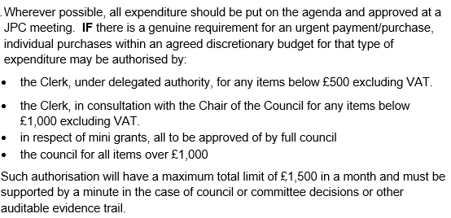
 | 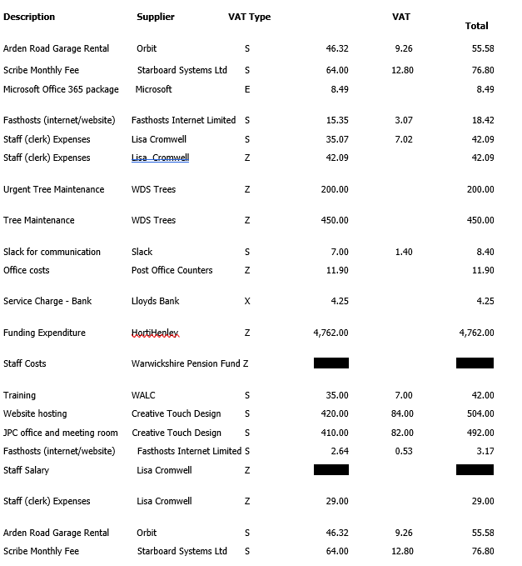
 | 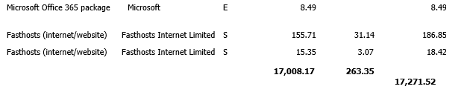
9 | Creditors payments for consideration by Members
NB: Any payment requests received by the Clerk after publication of this agenda MAY be presented at the meeting for consideration.

Creditor | Net | Provision
Creative Touch Design | £ 270.00 | JPC office and meeting room rental December 2025
DM Payroll | £ 127.50 | Payroll Services Oct 25 - March 26
Totals | £ 397.50

10 | Income received since last meeting
 | 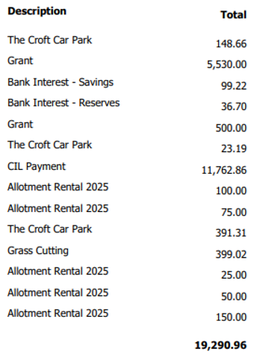
11 | Banking at 7.1.26
 | 
12 | Councillors’ proposals and notes to Council – to be proposed, seconded and voted on
 | Matters concerning expenditure/income
12.1 | Budget
 | Cllr Andrews proposes that, following all members’ review of the draft budget prepared by the Finance and Grants Working Party, the 2026/27 budget be approved.
 | MOTION: The Council resolves to approve the 2026/27 budget. [DR] [EA]
12.2 | Precept 2026/27
 | Cllr Andrews proposes that following resolution of the 2026/27 budget that the pre-cept for 2026/27 of a 9.9% increase is approved.
 | MOTION: To approve the 9.9% increase and advise SDC by 23 January of the pre-cept required. [DR] [EA]
12.3 | Grants
 | Cllr Rouse proposes that, following receipt of the 2026/27 grant applications, consideration by the Finance and Grants Working Party, and subsequent review by members, the following requests be approved.
 | Each grant proposed and approved will require an individual vote to support expenditure. [DR] [EA]
 | MOTION: To approve the listed grant payments and instruct the Clerk to pay the grant monies during week commencing 30.03.26 [DR] [EA]
12.4 | Subscription to Stratford Herald
 | Cllr Andrews proposes that the JPC take out a subscription to the Stratford Herald to enable timely sharing of any news items affecting Henley.
 | MOTION: To approve the cost of subscription at no more than £55 and instruct the Clerk to subscribe. [DR] [EA]
13 | Councillors’ proposals and notes to Council – to be proposed, seconded and voted on
 | Business matters – updates only – no financial decisions listed
13.1 | Co-option of Councillors
 | Cllr Andrews proposes that the Council consider the applications received for co‑option to fill two current vacancies on the Joint Parish Council (Mrs Elaine Field and Mr Peter Glaze), and invite both candidates to speak about their background and connection to Beaudesert & Henley.
 | MOTION: That the Council proceed to an anonymous ballot once the candidates have withdrawn from the meeting and subsequently invite them back in to hear the outcome. [DR]
13.2 | Polytunnel at Allotments
 | Cllr McCaskie would like to propose that the JPC proceed with the creation of a growing space and polytunnel at the allotments as a long‑term cost‑saving resource for producing plants for wildflower areas and wider town improvements. As £2,000 had already been budgeted for planting costs but remained unspent following receipt of a grant, (Project Buzz and Bloom) members are asked to approve the use of this existing budget to deliver the project. No additional expenditure is required.
 | MOTION: To approve the project and instruct the Clerk to issue a PO to HortiHenley for the sum of £2,000. [DR]
13.3 | Review and Adoption of Governance Documents
 | Cllr McCaskie proposes that, following prior circulation and review by Councillors, the following document be formally considered and resolved:
 | Habitual and Unreasonable Complaints Policy
 | MOTION: To approve and adopt the above document as presented. [DR] [SD]
13.4 | Ratification of Deed of Execution
Cllr Tomlinson proposes that the council considers and resolves the execution of the Financial Contribution Agreement from SDC for the release of s.106 funds.
In accordance with Order 23 of the Council’s Standing Orders, documents executed as deeds must be sealed following a resolution of the Parish Council. The grant agreement requires execution as a deed.
 | MOTION: That the Council resolves to ratify the execution of the Financial Contribution Agreement with Stratford District Council for the release of s.106 funds, as a deed, authorises electronic signature by theVice-Chair and witnessing by the Clerk via DocuSign, and confirms compliance with Standing Orders regarding sealing of documents. [DR]
13.5 | Allotment Update
 | Cllr McCaskie proposes that, as the Allotment Association is currently unable to operate due to the absence of an active Chair, the Council consider formally disbanding the Association and bringing its functions back under direct JPC management.
 | MOTION: That the Allotment Association be suspended with immediate effect due to the absence of an active Chair, and that its responsibilities revert to the JPC until such time as the Association can be re-established. [DR]
13.6 | Clerk’s Hours
 | Cllr Andrews proposes that due to the current volume of work and to account for the extra workload approaching with SWLP, NDP and other projects, the Clerk reverts to full time hours from 5 January 2026.
 | MOTION: To approve the Clerk reverting to full-time hours (37 per week). [DR]
14 | Planning Applications:
The application listed below will be discussed at the next JPC Planning Working Party meeting.
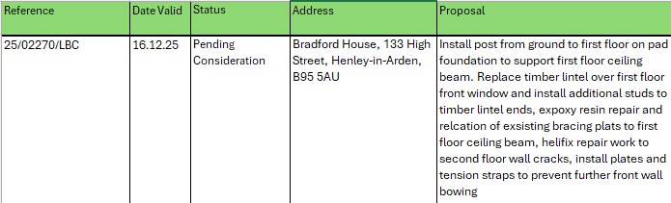
 | The applications listed below were supported by all members and SDC Planning were advised. The JPC can confirm that these particular applications have been given consent by SDC.
Reference | Date Valid | Status | Address | Proposal
25/01975/FUL | 05.09.25 | Consent granted | Land North Of , Liveridge Hill, Henley-in-Arden, B95 5Q | Planning permission for an agricultural combinable crop storage barn and part change of use from haulage yard (sui generis) to agricultural use (sui generis). The proposal will include associated levelling, hardstanding, attenuation and ecological enhancements.
25/02792/TREE | 26.11.25 | Consent granted | The Elms, 14 High Street, Henley-in-Arden, B95 5AG | T1 Tilia sp (Lime) - Re-pollard the Lime tree back to previous historic pollard points
2502791/FUL | 24.11.25 | Consent granted | Hollyhock Cottage, 138 High Street, Henley-in-Arden B95 5BS | T1 beech - remove 3 lowest limbs overhanging the boundary. T2 Cherry - remove lowest limb on cherry
25/02691/FUL | 19.11.25 | Consent granted | Elite Performance And Innovation Centre, Stratford Road, Henley-in-Arden B95 6AB | Proposed : Erection of a grounds management building; installation of squad planning pod, security cabin and ball-stop netting; and all associated works (retrospective)

15 | Members Urgent Business Matters
 | The Chair will enquire whether Councillors have any urgent business to bring to the attention of the assembly.
16 | Next Meeting
 | The next Ordinary Meeting will be held on Monday 2 February at the Memorial Hall, Station Road.

.

