.

Dear Councillors

An Ordinary Meeting of the Parish Council will be held at 7:00 pm at the Memorial Hall, Station Road, Henley-in-Arden. All council members are requested to attend to discuss and resolve the items listed in the agenda.

Public Session

Before the council meeting begins, the public will have an opportunity to present their concerns or comments. This session, at the discretion of the Chair, is limited to 3 minutes per speaker and a total of 15 minutes. Any issues not listed in the agenda will be noted by the Clerk for future consideration.

Clerk’s note

Planning Committee will consider applications listed in section 11. Outcomes of these applications can be viewed on the Stratford on Avon Planning Portal. Click on:

https://apps.stratford.gov.uk/eplanning/

MAIN TOPICS
4 | County and District Councillors’ Reports [SD]
5 | NDP/SWLP Update
6 | Youth Council Update
7 | Chair’s Report
8 - 11 | Finance Update
12 | Matters Concering Expenditure
13 | Council’s Business Matters
14 | Planning Applications

Supporting documents relating to the following subjects can be found on the JPC website prior to the meeting.

Signed 
Lisa Cromwell – Parish Clerk Date Issued:28.01.26

The Chair will open the meeting

1 | Apologies for absence
2 | Declarations of Interest  Councillors are reminded that their actions must always be in the public interest. They must avoid giving any person an improper advantage or disadvantage, and they should not seek financial or other material benefits for themselves, their family, friends, or close associates.
 | To accept any declarations of interest regarding agenda items
3 | Acceptance of minutes of the last Ordinary Meeting held 12 January 2026 [DR]
4 | District and County Reports
 | The Chair will invite Councillors Rice and Crocker to present their reports. Both reports can be found on the JPC website. [SD]
5 | NDP/SWLP update
 | Cllr Andrews, Vice-Chair and Chair of the NDP working party will provide an update.
6 | Youth Council Update
 | The Chair will invite representatives from the Youth Council to provide an update
7 | Chair’s Report
 | The Chair will provide an overview of key matters since the last meeting.
8 | Payments made since the last Ordinary Meeting.  [Consisting annual charges and subs, DD, delegated payments and/or Member voting at an Ordinary Meeting, by email, or,as determined by the JPC Financial Regulations, 5.15].
 | 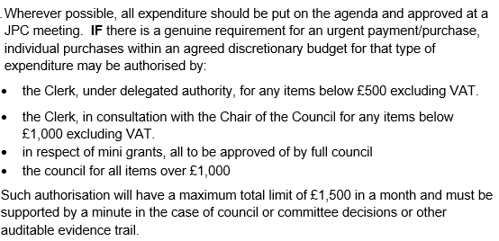
 | 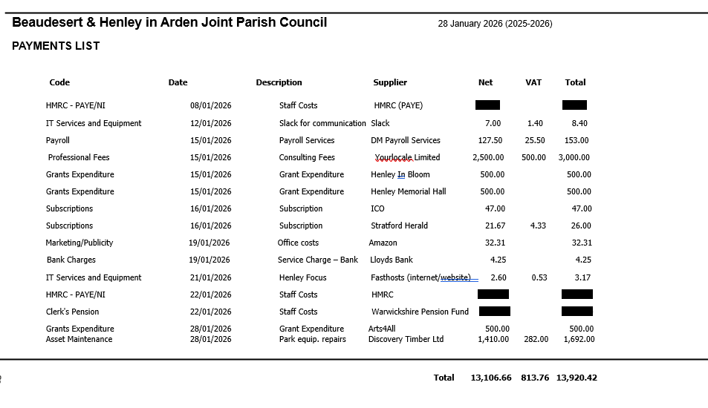
9 | Creditors payments for consideration by Members
 | There aren’t any current payments for consideration.
10 | Income received since last meeting  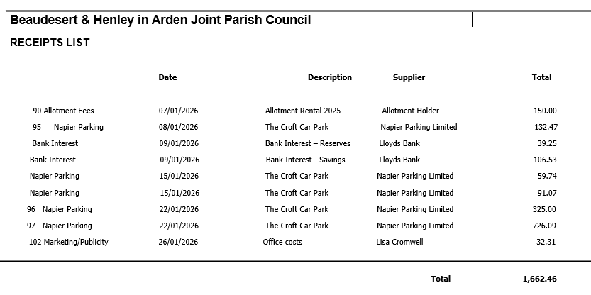
11 | Banking at 28.01.26
 | 
12 | Councillors’ proposals and notes to Council – to be proposed, seconded and voted on
 | Matters concerning expenditure/income
12.1 | Removal of snapped branch at Riverlands
 | Cllr McCaskie proposes the removal of a large snapped branch between the footpath and the river bank at Riverlands. A quote has been obtained from WDS Trees in the sum of £50.
 | MOTION: To approve the quote and instruct the Clerk to issue a purchase order to WDS Trees for £50 and make payment once the job is completed. [DR] [EA]
12.2 | Removal of failed stem and snapped branches at Riverlands
 | Cllr McCaskie proposes the removal of the failed stem, covered in ivy leaning towards the river into another tree and the two snapped branches located nearby. A quote has been obtained in the sum of £500 .
 | MOTION: To approve the quote and instruct the Clerk to issue a purchase order to WDS Trees for £500 and make payment once the job is completed. [DR] [EA]
12.3 | Re-pollard willow trees behind the Medical Centre
 | Cllr McCaskie proposes that the willows behind the Medical Centre be re-pollarded to stop them from growing further into the building. A quote has been obtained from WDS Trees in the sum of £350.
 | MOTION: To agree that the work needs to be carried out. To instruct the Clerk to apply for planning permission (the trees are within a conservation area), and once planning has been consented, for the Clerk to issue a Purchase Order to WDS Trees and make payment once the job is completed. [DR] [EA]
12.4 | Mole removal at Riverlands
 | Cllr McCaskie proposes that humane mole removal at Riverlands is carried out as soon as possible.
 | MOTION: To instruct the Clerk to issue a Purchase Order to Midland Mole Control. Costings are £60 trap setting fee and £5 per mole caught and to pay the invoice upon receipt and evidence of the number of moles caught. [DR] [EA]
12.5 | Youth Council – Litter Campaign
 | Cllr Rouse proposes that the winning poster for the litter campaign be printed and in waterproof material for attaching to lampposts in litter-ridden areas around the town. A quote from Creative Touch Design has been obtained in the sum of £485 plus £30 for cable ties. This amount will come out of the Youth Council’s budget.
 | MOTION: To approve the cost and instruct the Clerk to issue a PO in the sum of £515 and make payment upon receipt of invoice. [DR] [EA]
12.6 | JPC Wasteland Regeneration Programme
Cllr McCaskie proposes that the Council consider and approve the proposed Wasteland Regeneration Programme, including:
• Clearance of 3 selected wasteland areas around the town
• Tilling of designated areas
• Planting with a mixture of seeds and plug plants throughout spring 2026
• Disposal of generated waste, including recycling of green waste and responsible disposal of non-compostable materials. A quotation has been obtained from HortiHenley of up to £800.
 | MOTION: To approve the scheme and instruct the Clerk to issue a purchase order to HortiHenley and make payment upon receipt of invoice. [DR] [EA]
12.7 | Tree Works Contract and Maintenance Service
 | Cllr McCaskie proposes the consideration and approval of the award of the contract for tree works and maintenance service. Approval of this contract will enable the JPC to move from a predominantly reactive approach to tree maintenance to a structured programme of proactive arboricultural works, ensuring regular inspection, planned interventions, and improved long‑term management of the town’s trees. Following the ITT process issued to three contractors (one of whom declined to bid) the received tenders have been evaluated and recommendations shared with members.
 | MOTION: To approve the recommendation that the contract be awarded to WDS Trees. WDS Trees is the incumbent Tree Surgeon and has an excellent working knowledge of Henley‑in‑Arden’s tree stock. The tender submitted was comprehensive, with each tree explicitly listed and individually priced. The JPC is therefore pleased to give formal approval to award the contract to WDS Trees for the forthcoming programme of arboricultural works. [DR] [EA]
13 | Councillors’ proposals and notes to Council – to be proposed, seconded and voted on
 | Business matters – updates only – no financial decisions listed
13.1 | Adoption of Risk Register
 | Cllr Andrews proposes that following the recent revision of the JPC’s Risk Register and its review by members, the Council is requested to consider the updated document and resolve to adopt it as the Council’s formal Risk Register.
 | MOTION: To approve and adopt the revised Risk Register. [SD]
13.2 | UK Town of Culture 2028 – Confirmation of Intent to Bid and Formation of Working Bid Group
Cllr Rouse proposes that the JPC formally submits an Expression of Interest (EOI) for the UK Town of Culture 2028 programme, noting that the deadline for submissions is 31 March 2026.

Subject to ratification, the JPC will begin the process of establishing a Working Group, inviting expressions of interest from residents, community organisations, and local partners who wish to contribute to the development of the EOI.
.
MOTION: That the Joint Parish Council confirms its intention to submit an Expression of Interest for the UK Town of Culture 2028 programme, ahead of the 31 March 2026 deadline.
Following this decision, the JPC will invite residents and local partners to join a Working Group to support development of the submission. [SD]
14 | Planning Applications:
The applications listed below will be discussed at the next JPC Planning Working Party meeting, following site visits to investigate the trees.
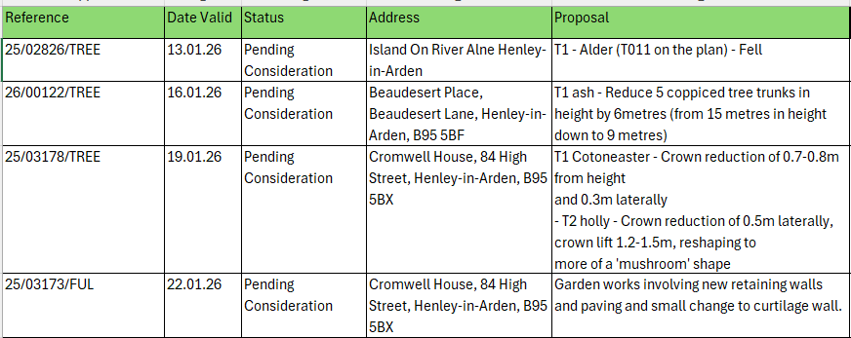
 | 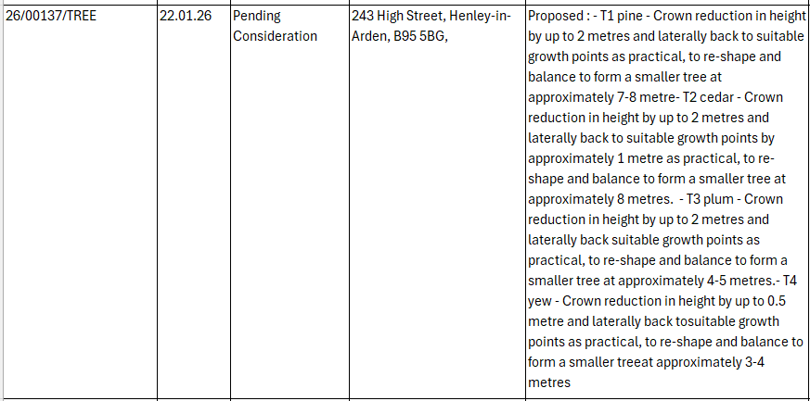
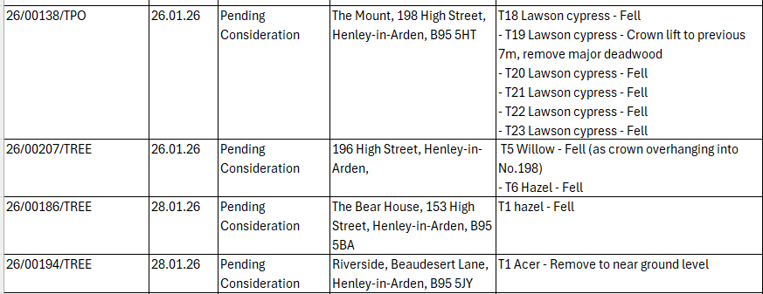

The applications listed below were supported by all members and SDC Planning were advised:

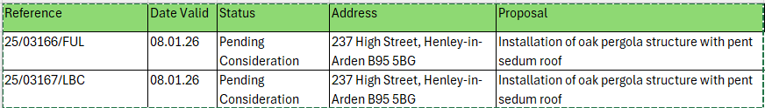
15 | Members Urgent Business Matters
 | The Chair will enquire whether Councillors have any urgent business to bring to the attention of the assembly.
16 | Next Meeting
 | The next Ordinary Meeting will be held on Monday 2 March at the Memorial Hall, Station Road at 7pm.

.

