Here are the Minutes of the Ordinary Council Meeting of Beaudesert and Henley in Arden JPC, which took place on Monday, 12 January, at 7.00pm in the Memorial Hall, Henley in Arden.

Present: Cllrs Andrews [Vice-Chair], McCaskie, Rouse, Tomlinson, Norris and Broadbent
Also Present: Lisa Cromwell [Clerk and RFO]

In Attendance: There were 17 members of the public in attendance plus Cllr Crocker.
The meeting was also attended by 5 members of the Youth Council (names withheld for safeguarding).

In the absence of the Chair, the meeting was chaired by the Vice-Chair, Cllr Andrews.

Public Session: Open Forum to provide an opportunity for members of the public to raise questions and to comment on any other items that are on the current agenda.

CLERK’S NOTE
Planning Committee considered applications listed herein. Outcomes of these applications can be viewed on the Stratford on Avon Planning Portal click on - https://apps.stratford.gov.uk/eplanning/

1 | Apologies for absence
 | Apologies were received from Cllr Okey and Cllr Rice
2 | Declarations of Interest  Councillors are reminded that their actions must always be in the public interest. They must avoid giving any person an improper advantage or disadvantage, and they should not seek financial or other material benefits for themselves, their family, friends, or close associates.
 | There were no declarations of interest.
3 | Acceptance of minutes of the last Ordinary Meeting held 01.12.25
 | This motion was proposed by the Chair and carried unanimously by all those present at the meeting. It was RESOLVED that the minutes of the meeting held on 01.12.25 were confirmed as a true record and signed by the Vice-Chair.
4 | District and County Reports
 | Cllr Crocker was invited to share his reports on matters affecting Beaudesert & Henley-in-Arden. The Council noted the following community updates:
 | Cllr Crocker – main points:
- Urged all mobile phone users with poor signal to take the mobile phone survey https://ask.warwickshire.gov.uk/mobile-coverage/issues/
- Encouraged residents to join the Voice of Warwickshire resident panelhttps://ask.warwickshire.gov.uk/voice-of-warwickshire/registration2025/
- Chicken pox vaccination offered to children across Warwickshire
- Alne Close (Monkey Run) lighting – National Grid has now identified the issue and works are being carried out to finally repair
- Stylers Way – WCC acutely aware of urgency. Solution has been identified and awaiting contractors to carry out work.
 | Copies of both reports can be found on the JPC’s website.
5 | NDP/SWLP update
 | Cllr Andrews provided an update on SWLP including that the inaugural meeting of ARC (Arden Resilience and Co‑ordination), a Beaudesert & Henley JPC initiative, was held on Thursday with representatives from Bearley, Aston Cantlow, Great Alne, Ullenhall and Preston Bagot. Kinwarton and Alcester were unable to attend due to weather, and Wilmcote and Lapworth will join the next meeting. The cross‑parish Flooding Working Group will share evidence, respond to the South Warwickshire Local Plan, and ensure national requirements such as the NPPF sequential test are applied, strengthening collective resilience and influence.
6 | Youth Council Update
 | The Youth Council presented its report to the Joint Parish Council. Members confirmed they are continuing work on their Community Grant Fund application to support the rejuvenation of Jubilee Park. They also reported that, in response to concerns about litter along the school walking route, they launched a poster competition to discourage littering. A request was made for a £20 Amazon gift voucher for the winning student. Cllr Rouse seconded, and it was resolved that the Clerk provide the voucher (to be funded from the Youth Council’s budget) and forward it to the school.
7 | Chair’s Report
 | The Vice-Chair presented in the Chair’s absence. Main points:
- The main change in next year’s budget is the correction of staff costs, with the Clerk’s salary aligned to SCP 35 and the appropriate employer pension and NI contributions included. The budget lines for trees and the car park reflect only planned spend, not total reserves: the tree reserve now stands at £45,000 and the car park reserve at £15,000 following additional contributions this year. A new approach has been adopted across all assets, with annual contributions now being made to build proper reserves for items such as The Croft carpark resurfacing, fencing, play areas, signage and lighting etc, reducing the risk of large one‑off repair costs.
- Stratford-on-Avon District Council is consulting on proposed double yellow lines for Prince Harry Road. Residents are encouraged to view the plans and submit comments directly to SDC. Responses may support the proposals, support them in principle with comments, or not support them. The JPC notes concerns that the current plans may not fully address parking and access issues, and residents may therefore wish to consider the option allowing support in principle with suggested amendments. https://bit.ly/3N7q7X9
 | A copy of the report can be found on the JPC website.
8 | Payments made since the last Ordinary Meeting.  [Consisting annual charges and subs, DD, delegated payments and/or Member voting at an Ordinary Meeting, by email, or, as determined by the JPC Financial Regulations, 5.15].  Wherever possible, all expenditure should be put on the agenda and approved at a JPC meeting. IF there is a genuine requirement for an urgent payment/purchase, individual purchases within an agreed discretionary budget for that type of expenditure may be authorised by:  - the Clerk, under delegated authority, for any items below £500 excluding VAT.  - the Clerk, in consultation with the Chair of the Council for any items below £1,000 excluding VAT.  - in respect of mini grants, all to be approved of by full council  - the council for all items over £1,000  Such authorisation will have a maximum total limit of £1,500 in a month and must be supported by a minute in the case of council or committee decisions or other auditable evidence trail.  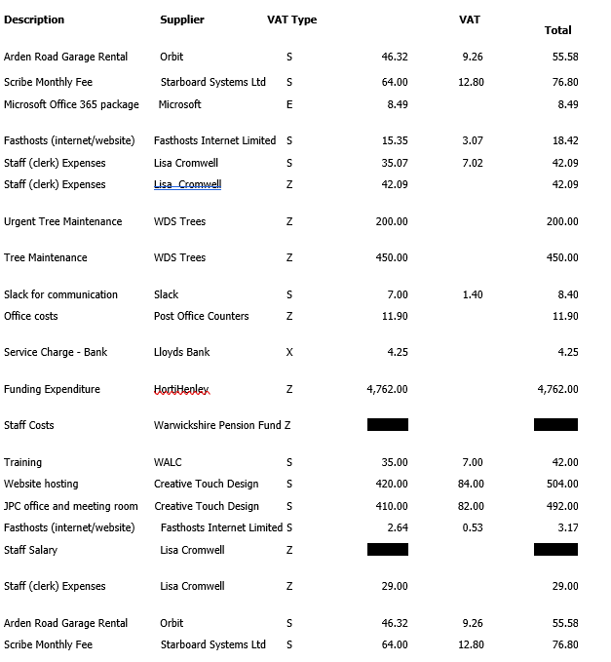
 | 
9 | Creditors payments for consideration by Members
 | NB: Any payment requests received by the Clerk after publication of this agenda MAY be presented at the meeting for consideration.
Creditor | Net | Provision
Creative Touch Design | £ 270.00 | JPC office and meeting room rental December 2025
DM Payroll | £ 127.50 | Payroll Services Oct 25 - March 26

10 | Income received since last meeting
 | 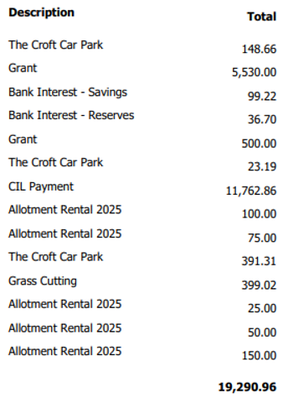
 | .
11 | Banking at 07.01.26
 | 
Nos. 8, 9, 10 and 11

The Chair enquired whether all members had reviewed the data for payments, receipts, and bank balances. It was RESOLVED that all members confirmed they had inspected the data and unanimously approved the content
12 | Councillors’ proposals and notes to Council – to be proposed, seconded and voted on
 | Matters concerning expenditure/income
12.1 | Budget
 | Cllr Andrews proposed that, following all members’ review of the draft budget prepared by the Finance and Grants Working Party, the 2026/27 budget be approved.
 | The motion to approve the 2026/27 budget was seconded by Cllr Rouse and approved unanimously by a show of hands. RESOLVED.
12.2 | Precept 2026/27
 | Cllr Andrews proposed that following resolution of the 2026/27 budget that the precept for 2026/27 of a 9.9% increase is approved.
 | The motion to approve the 9.9% increase and advise SDC by 23 January of the precept required was seconded by Cllr McCaskie and unanimously approved by a show of hands. RESOLVED.
12.3 | Grants  Cllr Rouse proposed that, following receipt of the 2026/27 grant applications, consideration by the Finance and Grants Working Party, and subsequent review by members, the applications listed be approved.
 | The motion to approve the grant payments and to instruct the Clerk to release the agreed grant monies after 6 April 2026 was seconded and voted on as follows:
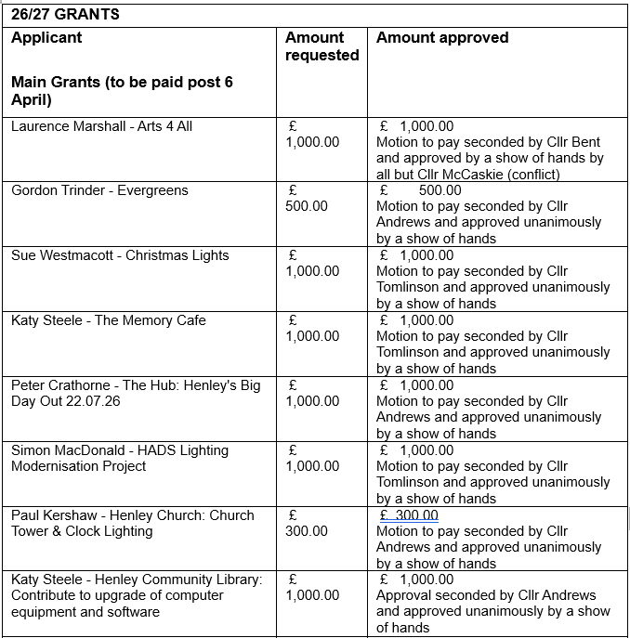
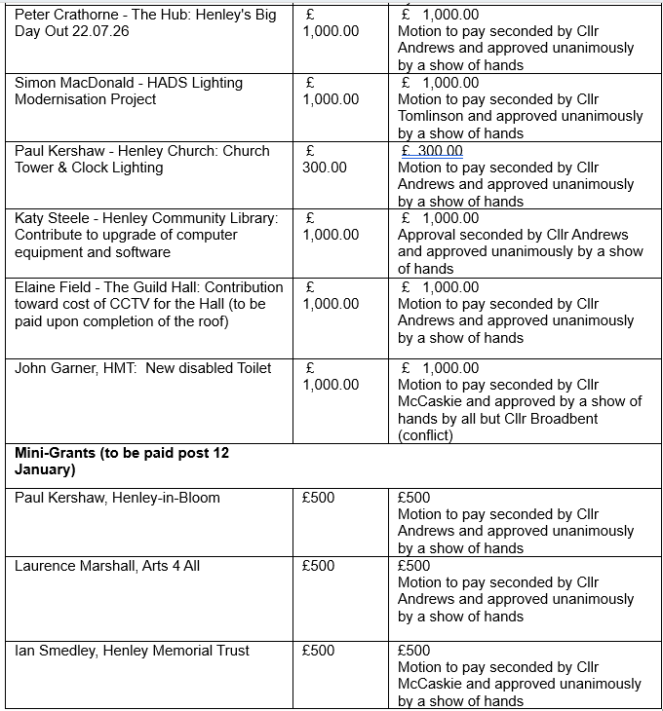
 | The motion to approved and pay the grants was RESOLVED.
12.4 | Subscription to Stratford Herald
 | Cllr Andrews proposed that the JPC take out a subscription to the Stratford Herald to enable timely sharing of any news items affecting Henley.
 | The motion to approve the cost of subscription at no more than £55 and instruct the Clerk to subscribe to the Stratford Herald was seconded by and approved unanimously by a show of hands. RESOLVED.
13 | Councillors’ proposals and notes to Council – to be proposed, seconded and voted on
 | Business matters – updates only – no financial decisions listed
13.1 | Co-option of Councillors
Cllr Andrews proposed that the Council consider the applications received for co‑option to fill the two current vacancies on the Joint Parish Council (Mrs Elaine Field and Mr Peter Glaze). Both candidates were invited to address the Council and outline their background and connection to Beaudesert & Henley.
Following an anonymous ballot, both candidates were duly co‑opted onto the Joint Parish Council. They were invited to sign their Declarations of Acceptance of Office, and took their seats with the Members.
 | RESOLVED: That Mrs Elaine Field and Mr Peter Glaze be co‑opted onto the Joint Parish Council.
13.2 | Polytunnel at Allotments
 | The item was deferred. It was noted that the JPC is not permitted to hold an allotment tenancy due to the allotment’s statutory status, and legal clarification is required before any decision can be made regarding the proposed growing space and polytunnel. The matter will be carried forward to the next meeting once a solution has been identified. [CF]
13.3 | Review and Adoption of Governance Documents
 | Cllr McCaskie proposed that, following prior circulation and review by Councillors, the following document be formally considered and resolved:
 | Habitual and Unreasonable Complaints Policy
 | The motion to approve and adopt the above document as presented was seconded by Cllr Andrews and approved unanimously by a show of hands. RESOLVED.
13.4 | Ratification of Deed of Execution
Cllr Tomlinson proposed that the council consider and resolve the execution of the Financial Contribution Agreement from SDC for the release of s.106 funds.
In accordance with Order 23 of the Council’s Standing Orders, documents executed as deeds must be sealed following a resolution of the Parish Council. The grant agreement requires execution as a deed.
 | The motion that the Council ratify the execution of the Financial Contribution Agreement with Stratford District Council for the release of s.106 funds, as a deed and authorise electronic signature via DocuSign,was seconded by Cllr Andrews and approved unanimously by a show of hands. RESOLVED.
13.5 | Allotment Update
 | Cllr McCaskie proposed that, as the Allotment Association is currently unable to operate effectively, the Council consider formally suspending the Association and bringing its functions back under direct JPC management until such time as the Council brings the allotments into a position where all fees are paid, records and documents are up to date, and the site can be handed over in good order to an active chair and Committee.
 | The motion to temporarily suspend the Allotment Association was seconded by Cllr Andrews and approved unanimously by a show of hands. RESOLVED.
13.6 | Clerk’s Hours
 | Cllr Andrews proposed that due to the current volume of work and to account for the extra workload approaching with SWLP, NDP and other projects, the Clerk reverts to full time hours from 5 January 2026.
 | The motion to approve the Clerk reverting to full-time hours (37 per week) was seconded by Cllr Rouse and approved unanimously by a show of hands. RESOLVED.
14 | Planning Applications:
 | Cllr Tomlinson, Portfolio Holder of the Planning Working Party, recommended the JPC submits ‘No Objection’ to the following, to SDC.
 | This motion was seconded by Cllr Andrews and approved unanimously by a show of hands.
 | 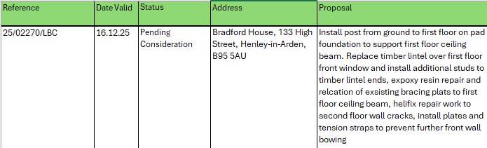
 | The applications listed below were supported by all members and SDC Planning were advised. The JPC can confirm that these particular applications have been given consent by SDC.
Reference | Date Valid | Status | Address | Proposal
25/01975/FUL | 05.09.25 | Consent granted | Land North Of , Liveridge Hill, Henley-in-Arden, B95 5Q | Planning permission for an agricultural combinable crop storage barn and part change of use from haulage yard (sui generis) to agricultural use (sui generis). The proposal will include associated levelling, hardstanding, attenuation and ecological enhancements.
25/02792/TREE | 26.11.25 | Consent granted | The Elms, 14 High Street, Henley-in-Arden, B95 5AG | T1 Tilia sp (Lime) - Re-pollard the Lime tree back to previous historic pollard points
2502791/FUL | 24.11.25 | Consent granted | Hollyhock Cottage, 138 High Street, Henley-in-Arden B95 5BS | T1 beech - remove 3 lowest limbs overhanging the boundary. T2 Cherry - remove lowest limb on cherry
25/02691/FUL | 19.11.25 | Consent granted | Elite Performance And Innovation Centre, Stratford Road, Henley-in-Arden B95 6AB | Proposed : Erection of a grounds management building; installation of squad planning pod, security cabin and ball-stop netting; and all associated works (retrospective)

15 | Members Urgent Business Matters
 | Cllr McCaskie provided an update on the five year housing plan. He noted that some emerging policy directions within the plan suggest reduced weight may be given to Neighbourhood Development Plans in future decision‑making. Cllr McCaskie assured residents that the JPC continues to monitor all planning applications submitted to Stratford District Council and will respond to consultations as appropriate.
16 | Next Meeting
 | The next Ordinary Meeting will be held on Monday 2 February at the Memorial Hall, Station Road at 7pm.

.

Signed ………………………………………………………………………………….

Date……………………………………………………….

