REPORT FROM WARWICKSHIRE COUNTY COUNCILLOR
JAMES CROCKER

BEAUDESERT & HENLEY JOINT PARISH LOCAL ISSUE UPDATE
- Alne Close Lighting: source problem identified, new power cable and routing solution has been proposed by WCC, awaiting agreement with National Grid.
- Stylers Way: lighting in design stage – WCC lighting team acutely aware of urgency.
- Yellow lines outside fire station approved and will require road closures.
- Numerous road closures planned in the coming months for more details found here: https://www.warwickshire.gov.uk/roadworksmap#closures
- For detail on grit bins visit: www.warwickshire.gov.uk/gritting.

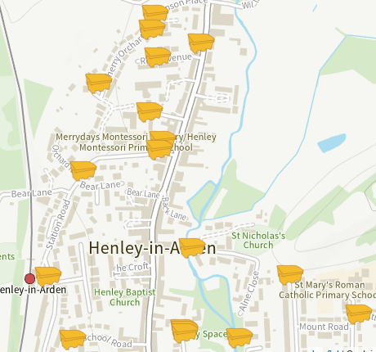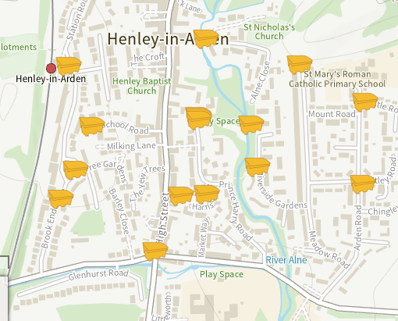

NEWS FROM SHIRE HALL
Mobile Phone Users With Poor Phone Signal Urged to Take Survey
A survey has been launched to find the areas in Warwickshire suffering from poor mobile phone coverage.
The latest initiative from Warwickshire County Council aims to gather reports directly from residents and businesses about signal quality and to identify coverage ‘blackspots’ which require service improvements from the mobile phone operators.
Councillor Rob Howard, Warwickshire County Council’s Portfolio Holder for Economy, said:
“We are acutely aware that people in areas of poor coverage are at a disadvantage, socially and economically, and we want to address that.
“We are launching our mobile phone service survey to find out the level of coverage people are getting from their mobile phone providers and pinpoint where the problematic areas are. This will help inform our conversations with the industry when they are making plans for future service improvements in Warwickshire.”
Help us build an understanding of coverage in your area by completing our mobile connectivity survey online at https://ask.warwickshire.gov.uk/mobile-coverage/issues/

Voice of Warwickshire
We are inviting people who live in Warwickshire to join the Voice of Warwickshire resident panel and help shape local services and decisions.
The residents panel gives local people the opportunity to:
- Share views through surveys and engagements
- Influence decisions that affect your community
- Make sure a wide range of voices are heard across Warwickshire
Who can join?
- Anyone aged 18 or over
- Anyone living in Warwickshire

Taking part is flexible and can be done online at times to suit. You can choose how often you get involved and there is no requirement to take part in every survey.
Sign up here: https://ask.warwickshire.gov.uk/voice-of-warwickshire/registration2025/ For more details, please visit our dedicated webpage: https://www.warwickshire.gov.uk/voice which includes previous surveys and further information.
Chickenpox Vaccination Offered to Children Across Warwickshire
January 2026 sees the introduction of an update to the childhood immunisation schedule, the MMRV vaccine, which now includes protection against chickenpox as well as Measles, Mumps and Rubella.
Measles, Mumps, Rubella and Varicella (chicken pox) will be offered as a combined vaccine - ensuring a comprehensive coverage against the four main highly contagious diseases for children. The combined vaccine means fewer doses and fewer appointments.
https://www.gov.uk/government/news/free-chickenpox-vaccination-offered-for-first-time-to-children
Support available for anyone struggling with alcohol this January

January is a time when many people cut back on drinking, but for those struggling with alcohol, it’s also a vital opportunity to seek help.
Alcohol Change highlight that there are an estimated 600,000 dependent drinkers in England alone, people who are in a relationship with alcohol that is bringing them and their families ill-health, conflict and pain. Four in five of them are receiving no treatment. *
Drinking in excess can lead to serious health, social and financial consequences, and Warwickshire County Council wants residents to know that free, confidential support is available locally through Change Grow Live (CGL).
CGL, commissioned by Warwickshire County Council, offers a comprehensive range of services for adults and young people affected by alcohol misuse. These include:
- Free and confidential assessments
- Structured treatment plans and psychosocial support
- Detox and rehabilitation pathways
- Specialist services for young people and families
- Harm reduction initiatives, including supervised consumption and needle exchange
Anyone can access these services at hubs in Leamington Spa, Nuneaton and Rugby, or online. Warwickshire County Council also provides practical advice for reducing alcohol intake, such as pacing drinks, keeping a diary, and scheduling alcohol-free days. For those looking to start the conversation around reducing alcohol intake, the Alcohol Change UK Try Dry app is recommended for goal setting and tracking progress.

MY RESPONSIBILTIES AS WARWICKSHIRE COUNTY COUNCILLOR
- Within Warwickshire County Council, other parishes in the Arden division include Wootton Wawen, Ullenhall, Claverdon, Langley, Tanworth-in-Arden (including Earlswood), Wolveron and Preston Bagot.
- Serving on both the Warwickshire Fire & Rescue Local Pension Board of the Firefighters’ Pension Scheme and the Warwickshire Pension Fund Local Pension Board.
- Member of the cross-party working group for the Bus Service Improvement Plan. I have recently received a number of requests from residents asking for service extensions to key areas such as Warwick Hospital. If you have any views or suggestions regarding local bus services, please do not hesitate to get in touch.
Separately, also Chair of the Reform UK branch for Stratford-on-Avon.

Getting in Touch
For any issues or ideas that would benefit Beaudesert and Henley-in-Arden, as your representative, I am always available to listen and support local priorities at Warwickshire County Council.

James Crocker
County Councillor for Arden
Warwickshire County Council Email: jamescrocker@warwickshire.gov.uk
Mobile: 07353 157962

