Here are the Minutes of the Ordinary Council Meeting of Beaudesert and Henley in Arden JPC, which took place on Monday, 2 January, at 7.00pm in the Memorial Hall, Henley in Arden.

Present: Cllrs Andrews [Vice-Chair], McCaskie, Rouse, Tomlinson, Field and Glaze

In Attendance: There were 26 members of the public in attendance plus Cllrs Crocker and Rice.
The meeting was also attended by 3 members of the Youth Council (names withheld for safeguarding).

In the absence of the Chair, the meeting was chaired by the Vice-Chair, Cllr Andrews.
In the absence of the Clerk, Cllr Rouse agreed to take notes to support minute drafting. It was noted that the agenda could not be displayed on a laptop during the meeting, but hard copy documents were available and documents were accessible via the website.

Public Session: Open Forum to provide an opportunity for members of the public to raise questions and to comment on any other items that are on the current agenda.

CLERK’S NOTE
Planning Committee considered applications listed herein. Outcomes of these applications can be viewed on the Stratford on Avon Planning Portal click on - https://apps.stratford.gov.uk/eplanning/

1 | Apologies for absence
 | Apologies were received from Cllrs Okey, Norris, Broadbent, plus the Clerk.
2 | Declarations of Interest  Councillors are reminded that their actions must always be in the public interest. They must avoid giving any person an improper advantage or disadvantage, and they should not seek financial or other material benefits for themselves, their family, friends, or close associates.
 | There were no declarations of interest.
3 | Acceptance of minutes of the last Ordinary Meeting held 12.01.26
 | The Vice‑Chair advised that, due to the Clerk’s absence and the minutes not being available for signing, approval of the previous minutes would be deferred to the next meeting. [CF]
4 | District and County Reports
 | Cllrs Rice and Crocker were invited to share their reports on matters affecting Beaudesert & Henley-in-Arden. The Council noted the following community updates:
 | Cllr Mike Rice - SDC
- The date for renewing postal votes has now passed (was 31 Jan)
- District consultations have taken place on increasing Council Tax on second homes. Final decision to be taken by the Cabinet, no date given.
- Budget items referenced, including work relating to Stratford town centre site (Gateway) and associated rationale.
- Neighbourhood Development Plan support funding: Stratford-on-Avon District Council has budgeted funding over the next three years (£300k) to support neighbourhood planning work, primarily to cover specialist consultancy and technical input.
- SWLP – Consultants have proposed a link road around Stratford that would open potential for further housing to the south of the town, easing pressure to build around Henley. However, significant funding is needed.

Cllr James Crocker - WCC

- Highways contract update: noted Balfour Beatty contract extension/award (Highways).
- Delegated budget: referenced use for local highways matters (example given: yellow lines outside the fire station).
- Proposed to organise a “walk-round” / site review of priority issues in Henley such as pavements. Action - Will contact the Clerk to organise a date/time in the future. Also a request was made by the JPC to be consulted, prior to any work commencing, about the materials to be used.
- Budget discussion: strong objection to proposed on-street parking charges in Henley being included in draft County budget proposals; Cllr Crocker stated he had challenged this and did not support it proceeding. Although it needs to be voted on by the whole council, the proposal is to reject this initiative.
- Discussion with councillors/public about access to traffic monitoring data (speed/volume), quality of pavement repairs, sensitive/heritage materials, tree management (pollarding/cycle and epicormic growth), and the value of advance communication to support joined-up planning.
Action: County Councillor to share dates required / arrange access to traffic monitoring data (speed and volume) as requested.

 | Copies of both reports can be found on the JPC website.
5 | NDP/SWLP update
Cllr Andrews provided an update on NDP/SWLP including:

- Local Plan: no material update (awaiting information from Stratford).
- NDP Working Party met the previous week and had been set tasks by the consultant to gather information.
Planning monitoring update:
- Ongoing monitoring of applications referencing five-year housing land supply / NDP status and planning policy changes.
- Example referenced: Bellway proposal for 89 homes near Bordon Hill Farm (noted as likely to progress quickly).
6 | Youth Council Update
Youth Council provided an update including:
- Work to build an application to renovate Jubilee Park (surveys and usage evidence to support grant applications).
- Anti-litter posters and related competition; request for £20 prize money.
- Concerns about dog fouling and mud/leaves on paths (including areas used by elderly residents); discussion about potential involvement of the eco team and improved signage/awareness. Local residents suggested Doctors and Beaudesert Lane were good starting points due to their frequent use by the elderly. There was also a request to put up more dog fouling posters
7 | Chair’s Report
 | The Vice-Chair presented in the Chair’s absence
Cllr Andrews provided an interesting snapshot of transportation along the High Street, courtesy of SmartMicro UK, a Henley based business:

January

Total vehicles through the town: 251,002 this month to date

This week – Snapshot (26th January – 1 day 0000hrs – 2359hrs)

Vehicle movements: 10,342 (167 bicycles, 63 motorbikes/scooters, 5270 cars, 3776 vans, 805 short trucks, 261 Long trucks/buses)

Average speed:

Between 0700 – 1700 the average speed on High Steet was 19.6mph
Outside of these hours average speed was 34mph
Fastest recorded speed was between 0100 and 0200 at 42mph

The JPC would like to take this opportunity to thank SmartMicro UK for offering to provide this information free of charge on a monthly basis.
8 | Payments made since the last Ordinary Meeting.  [Consisting annual charges and subs, DD, delegated payments and/or Member voting at an Ordinary Meeting, by email, or, as determined by the JPC Financial Regulations, 5.15].  Wherever possible, all expenditure should be put on the agenda and approved at a JPC meeting. IF there is a genuine requirement for an urgent payment/purchase, individual purchases within an agreed discretionary budget for that type of expenditure may be authorised by:  - the Clerk, under delegated authority, for any items below £500 excluding VAT.  - the Clerk, in consultation with the Chair of the Council for any items below £1,000 excluding VAT.  - in respect of mini grants, all to be approved of by full council  - the council for all items over £1,000  Such authorisation will have a maximum total limit of £1,500 in a month and must be supported by a minute in the case of council or committee decisions or other auditable evidence trail.  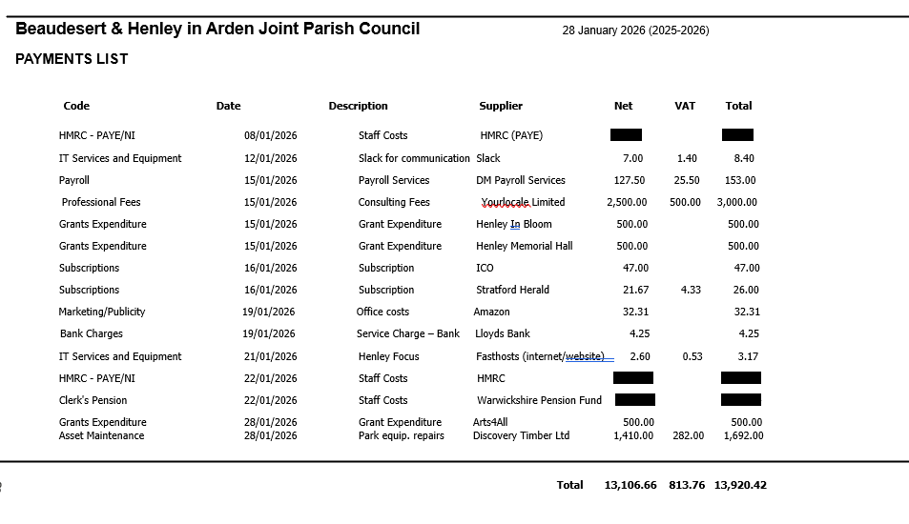
9 | Creditors payments for consideration by Members
 | NB: Any payment requests received by the Clerk after publication of this agenda MAY be presented at the meeting for consideration.
 | There weren’t any payments for consideration by members.
10 | Income received since last meeting
 | 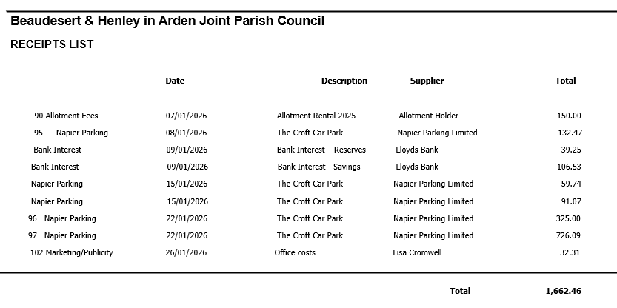
11 | Banking at 28.01.26
 | 
Nos. 8, 9, 10 and 11

The Chair enquired whether all members had reviewed the data for payments, receipts, and bank balances. It was RESOLVED that all members confirmed they had inspected the data and unanimously approved the content
12 | Councillors’ proposals and notes to Council – to be proposed, seconded and voted on
 | Matters concerning expenditure/income
12.1 | Removal of snapped branch at Riverlands
 | Cllr McCaskie reported the previously referenced branch was not longer present and therefore the £50 quote for clearance no longer needed to be considered.
 | RESOLVED.
12.2 | Removal of failed stem and snapped branches at Riverlands
 | Cllr McCaskie proposed the removal of the failed stem, covered in ivy leaning towards the river into another tree and the two snapped branches located nearby. A quote has been obtained in the sum of £500 .
 | The motion to approve the quote and instruct the Clerk to issue a purchase order to WDS Trees for £500 and make payment once the job is completed was seconded by Cllr Andrews and unanimously approved by a show of hands. RESOLVED.
12.3 | Re-pollard willow trees behind the Medical Centre
 | Cllr McCaskie proposed that the willows behind the Medical Centre be re-pollarded to stop them from growing further into the building. A quote has been obtained from WDS Trees in the sum of £350.
 | The motion o agree that the work needs to be carried out and instruct the Clerk to apply for planning permission (the trees are within a conservation area), and once planning has been consented, for the Clerk to issue a Purchase Order in the sum of £350 to WDS Trees and make payment once the job is completed was seconded by Cllr Andrews and approved unanimously by a show of hands. RESOLVED.
12.4 | Mole removal at Riverlands
 | Cllr McCaskie proposed that humane mole removal at Riverlands is carried out as soon as possible.
 | The motion to instruct the Clerk to issue a Purchase Order to Midland Mole Control (£60 trap setting fee and £5 per mole caught) and to pay the invoice upon receipt and evidence of the number of moles caught, with a maximum spend cap at £200 was seconded by Cllr Andrews and agreed unanimously by a show of hands. RESOLVED.
12.5 | Youth Council – Litter Campaign
 | Cllr Rouse proposed that the winning poster for the litter campaign be printed in waterproof material for attaching to lampposts in litter-ridden areas around the town. A quote from Creative Touch Design has been obtained in the sum of £485 plus £30 for cable ties. This amount will come out of the Youth Council’s budget.
 | The motion to approve the cost and instruct the Clerk to issue a PO in the sum of £515 and make payment upon receipt of invoice was seconded by Cllr Field and agreed unanimously by a show of hands. RESOLVED.
12.6 | JPC Wasteland Regeneration Programme
As the previously budgeted £2,000 allocation for bulbs was no longer required following receipt of the South Warwickshire Climate Change Fund grant from SDC, (Project Buzz and Bloom) Cllr McCaskie proposed that the Council consider and approve the proposed Wasteland Regeneration Programme, comprising:
• Clearance of 3 selected wasteland areas around the town (including Riverside Gardens triangle, Brook End Drive circle, and Bear Lane area),
• Tilling of designated areas
• Planting with a mixture of seeds and plug plants throughout spring 2026
• Disposal of generated waste, including recycling of green waste and responsible disposal of non-compostable materials. A quotation has been obtained from HortiHenley of up to £800.
 | The motion to approve the scheme and instruct the Clerk to issue a purchase order to HortiHenley and make payment upon receipt of invoice was seconded by Cllr Andrews and agreed unanimously by a show of hands. RESOLVED.
12.7 | Tree Works Contract and Maintenance Service
 | Cllr McCaskie proposed the consideration and approval of the award of the contract for tree works and maintenance service. Approval of this contract will enable the JPC to move from a predominantly reactive approach to tree maintenance to a structured programme of proactive arboricultural works, ensuring regular inspection, planned interventions, and improved long‑term management of the town’s trees. Following the ITT process issued to three contractors (one of whom declined to bid) the received tenders have been evaluated and recommendations shared with members.
 | The motion to approve the recommendation that the contract be awarded to WDS Trees was put to the meeting, seconded by Cllr Andrews and approved unanimously by a show of hands. As the incumbent contractor, WDS Trees has an excellent working knowledge of Henley‑in‑Arden’s tree stock, and its tender was comprehensive, with each tree explicitly listed and individually priced. The JPC therefore confirmed the award of the contract to WDS Trees for the forthcoming programme of arboricultural works. RESOLVED.
13 | Councillors’ proposals and notes to Council – to be proposed, seconded and voted on
 | Business matters – updates only – no financial decisions listed
13.1 | Adoption of Risk Register
 | Cllr Andrews proposed that following the recent revision of the JPC’s Risk Register and its review by members, the Council consider the updated document and resolve to adopt it as the Council’s formal Risk Register.
 | The motion to approve and adopt the revised Risk Register was seconded by Cllr McCaskie and approved unanimously by a show of hands. RESOLVED.
13.2 | UK Town of Culture 2028 – Confirmation of Intent to Bid and Formation of Working Bid Group
Cllr Rouse proposed that the JPC formally submit an Expression of Interest (EOI) for the UK Town of Culture 2028 programme, noting that the deadline for submissions is 31 March 2026. He highlighted that the scheme operates as a two‑stage process, with Stage 2 providing £60,000 to support development of a full proposal, and that the overall winner receives an award of £3,000,000. He further noted the need for strong community involvement and the establishment of a Working Group to support preparation of the EOI, with no commitment required to proceed beyond the EOI stage should the Council choose not to.
Subject to ratification, the JPC will begin the process of establishing a Working Group and will invite expressions of interest from residents, community organisations and local partners.
During discussion, it was noted that Stratford is expected to bid in a different category; the importance of engaging community groups and using social media to recruit support was emphasised; and general support was expressed, including from members of the public. Cllr Crocker also expressed interest in supporting the initiative and indicated that some potential budget may be available to assist.

The motion that the Joint Parish Council submit an Expression of Interest for the UK Town of Culture 2028 programme, ahead of the 31 March 2026 deadline, and subsequently invite residents and local partners to join a Working Group to support development of the submission, was seconded by Cllr Andrews and approved unanimously by a show of hands. RESOLVED.
14 | Planning Applications:
 | The applications listed below will be discussed at the next JPC Planning Working Party meeting, following site visits to investigate the trees
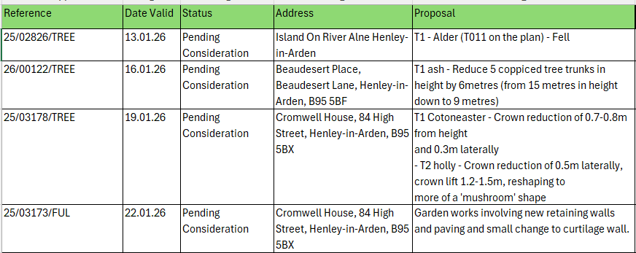
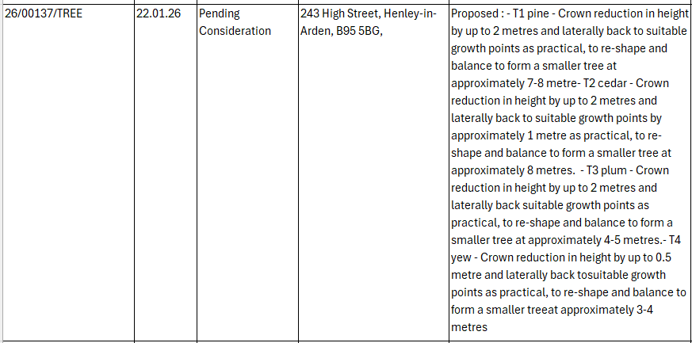
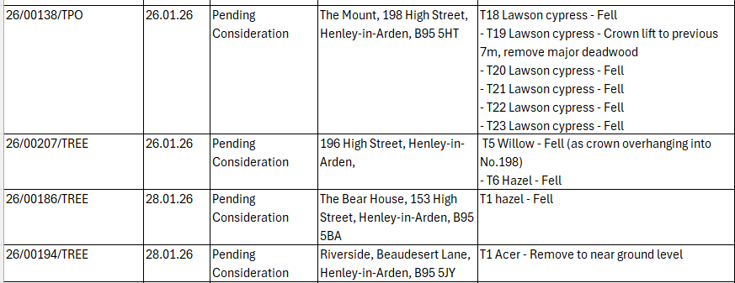
The applications listed below were supported by all members and SDC Planning were advised:

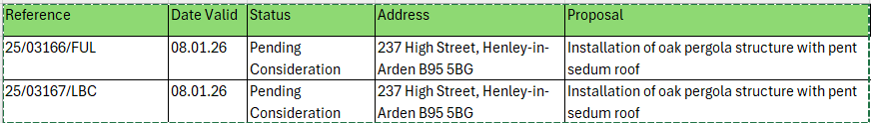
15 | Members Urgent Business Matters
 | Cllr McCaskie raised an urgent matter concerning unauthorised works carried out on parish‑owned land, including possible tree works within the Conservation Area. He reported that the Planning Enforcement Officer had advised this may constitute an offence and should be formally referred to the District Council. In light of the implications for the parish — including trespass, land ownership and potential damage — he requested that an urgent agenda item be scheduled at the earliest opportunity for the Council to consider next steps and ensure the parish’s position is protected. Members agreed to action this urgently.
16 | Next Meeting
 | The next Ordinary Meeting will be held on Monday 2 March at the Memorial Hall, Station Road at 7pm.

.

Signed ………………………………………………………………………………….

Date……………………………………………………….

