Here are the Minutes of the Ordinary Council Meeting of Beaudesert and Henley in Arden JPC, which took place on Monday, 2 March, at 7.00pm in the Memorial Hall, Henley in Arden.

Present: Cllrs Andrews [Vice-Chair], McCaskie, Rouse, Tomlinson, Field and Glaze (Cllr Glaze attended the first part of the meeting only) plus Lisa Cromwell (Clerk)

In Attendance: There were 14 members of the public in attendance plus Cllrs Crocker and Rice.
The meeting was also attended by 2 members of the Youth Council (names withheld for safeguarding).

The meeting was chaired by the Vice-Chair, Cllr Andrews.

Public Session: Open Forum to provide an opportunity for members of the public to raise questions and to comment on any other items that are on the current agenda.

CLERK’S NOTE
Planning Committee considered applications listed herein. Outcomes of these applications can be viewed on the Stratford on Avon Planning Portal click on – https://apps.stratford.gov.uk/eplanning/

1 | Apologies for absence
 | Apologies were received from Cllr Norris.
2 | Declarations of Interest  Councillors are reminded that their actions must always be in the public interest. They must avoid giving any person an improper advantage or disadvantage, and they should not seek financial or other material benefits for themselves, their family, friends, or close associates.
 | There were no declarations of interest.
3 | Acceptance of minutes
 | The motion was proposed by the Vice-Chair and carried unanimously by all those present at the meeting. It was RESOLVED that the minutes of the meetings held on 12 January and 2 February were confirmed as a true record and signed by the Vice-Chair.
4 | District and County Reports
 | Cllrs Rice and Crocker were invited to share their reports on matters affecting Beaudesert & Henley-in-Arden. The Council noted the following community updates:
 | Cllr Mike Rice – SDC
- Provided an update of precept charges across the district
- Advised that SDC has voted to impose a 100% council tax premium on second homes – some exemptions may be applied.

Cllr Rice excused himself from the meeting following delivery of his report as he had another engagement to attend.
Cllr James Crocker – WCC

- Noted that WCC’s budget had been approved at a 4.4% increase
- Referenced the ongoing LGR consultation and encouraged as many people as possible to complete the survey
- Road closures – there are many in the area, particularly around Claverdon, however the WCC website is not as up to date as it should be and the JPC has not been receiving notifications of closures either. Cllr Crocker advised he will ensure he personally passes the information on to the JPC to share with residents.
- Potholes – Cllr Crocker encouraged everyone to refer to the link on his report (to be found on the JPC website) to report any potholes.
- Town of Culture. Cllr Crocker advised that be he and George Finch will provide support for Henley-in-Arden’s bid.

 | Copies of both reports can be found on the JPC website.
5 | NDP/SWLP update
Cllr Andrews provided an update on NDP/SWLP including:

- That there will be an SWLP related announcement made in May
6 | Youth Council Update
 | The Youth Council had no report/update for this month.
7 | Chair’s Report
The Vice-Chair presented the report. Main points:
- All lighting works at Alne Close (Monkey Run) have been completed and the lights are now working. The JPC will continue to chase WCC regarding the lighting situation at Stylers Way
- An update on progress in setting up a working party for the Expression of Interest (EOI) for UK Town of Culture 2028
- The JPC has secured a £10K grant for the planting of new trees across Henley
- An update on the new JPC website
- Damaged fencing on the Warwick Road has finally been repaired. Thanks to the Youth Council for flagging this.
- Cllr Shenton has been chasing a resolution with Openreach and Talk Talk regarding the loss of service of up to 800 landlines in and around Henley. BT have informed customers that service should be restored by 3 March
- The JPC has signed up to the Keep Britain Tidy Campaign regarding the Great British Spring Clean. Cllr Field is coordinating volunteer litter pickers on Sunday 22 March at 10:00am. Please meet at the Medical Centre if you would like to help
- Traffic data kindly supplied by Smart Micro, showed that there has been an increase in speed along the High Street over the last week despite the temporary traffic lights being in place. We will share the data next month when hopefully the lights will have been removed.

The full report can be found on the JPC’s website.

8 | Payments made since the last Ordinary Meeting.  [Consisting annual charges and subs, DD, delegated payments and/or Member voting at an Ordinary Meeting, by email, or, as determined by the JPC Financial Regulations, 5.15].  Wherever possible, all expenditure should be put on the agenda and approved at a JPC meeting. IF there is a genuine requirement for an urgent payment/purchase, individual purchases within an agreed discretionary budget for that type of expenditure may be authorised by:  - the Clerk, under delegated authority, for any items below £500 excluding VAT.  - the Clerk, in consultation with the Chair of the Council for any items below £1,000 excluding VAT.  - in respect of mini grants, all to be approved of by full council  - the council for all items over £1,000  Such authorisation will have a maximum total limit of £1,500 in a month and must be supported by a minute in the case of council or committee decisions or other auditable evidence trail.  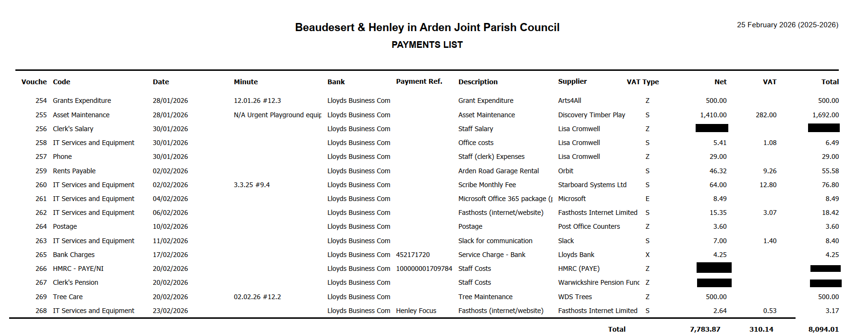
9 | Creditors payments for consideration by Members
 | NB: Any payment requests received by the Clerk after publication of this agenda MAY be presented at the meeting for consideration.
Creditor | Net | Provision
Creative Touch Design | £ 295.00 | JPC office and meeting room rental December 2026
Creative Touch Design | £ 410.00 | JPC office and meeting room rental January 2026
Midland Mole Control | £ 75.00 | Mole catching @ Riverlands
Total | £ 780.00

10 | Income received since last meeting
 | 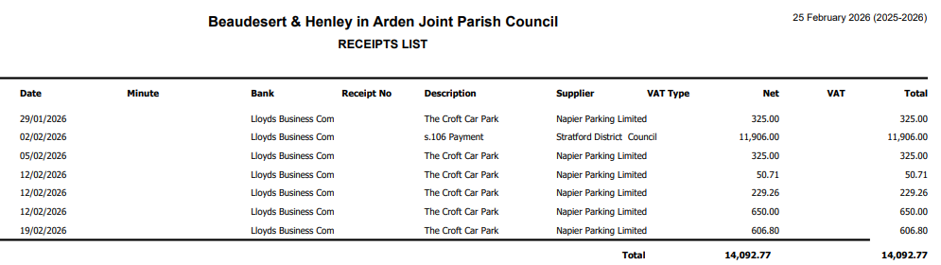
11 | Banking at 25.02.26
 | 
Nos. 8, 9, 10 and 11

The Vice-Chair enquired whether all members had reviewed the data for payments, receipts, and bank balances. It was RESOLVED that all members confirmed they had inspected the data and unanimously approved the content
12 | Councillors’ proposals and notes to Council – to be proposed, seconded and voted on
 | Matters concerning expenditure/income
12.1 | Civic Service – 17 May 2026
 | Cllr Field proposed a donation of £100 to St John’s Church for the purchase of cakes for the gathering following the Civic Service Ceremony.
 | The motion to approve the donation of £100 to St John’s Church, and instruct the Clerk to make payment, was seconded by Cllr McCaskie and approved unanimously by a show of hands. RESOLVED.
12.2 | Appointment of Internal Auditor
 | Cllr Andrews proposed the appointment of a new Internal Auditor. Mr Kenneth Dunn is a member of the Institute of Chartered Accountants of Scotland and experienced in parish council audit requirements. The cost of the annual internal audit, together with assistance on any Year End and AGAR queries, would be £300 per annum.
 | The motion to appoint Mr Dunn as Internal Auditor for the 2026/27 financial year at a cost of £300 was seconded by Cllr Tomlinson and approved unanimously by a show of hands. RESOLVED.
13 | Councillors’ proposals and notes to Council – to be proposed, seconded and voted on
 | Business matters – updates only – no financial decisions listed
13.1 | Chair and Vice-Chair Succession
The Vice-Chair advised that a written resignation had been received from Angela Okey on the afternoon of 2 March, resigning not only from the office of Chair, but also from her position as a Councillor of the Joint Parish Council. The office of Chair was therefore vacant at the commencement of the meeting.

In accordance with Standing Orders, the Vice‑Chair presided and invited nominations for the election of a Chair for the remainder of the municipal year. Cllr Andrews proposed herself for the office of Chair.
The motion that Councillor Wendy Andrews be elected Chair of Henley‑in‑Arden Parish Council for the remainder of the municipal year was seconded by Cllr Field and approved of unanimously by a show of hands. RESOLVED.

Following her election as Chair, the office of Vice‑Chair became vacant. The Chair invited nominations for the election of a Vice‑Chair for the remainder of the municipal year.
Cllr Andrews proposed Cllr McCaskie for the office of Vice‑Chair.

The motion that Councillor Sandy McCaskie be elected Vice Chair of Henley‑in‑Arden Parish Council for the remainder of the municipal year was seconded by Cllr Tomlinson and approved of unanimously by a show of hands. RESOLVED.

The motion that following the election of the Chair and Vice Chair, the Council update all governance and administrative records accordingly, including:
1. Updating bank mandates and authorised signatories to reflect the new office‑holders.
2. Updating the Council’s website, noticeboard and statutory information.
3. Notifying the Monitoring Officer of Stratford‑on‑Avon District Council.
4. Authorising the Clerk/RFO to implement these changes immediately.
Was seconded by Cllr McCaskie and approved unanimously by a show of hands. RESOLVED.
13.2 | Delegated Authority for Approval and Execution of Legal Deeds
Cllr McCaskie proposed that, in order to avoid delays in receiving funds from the District or County Council, the Clerk be authorised to sign deeds required solely to give effect to decisions already made by the Council.
It was confirmed that Standing Order 23 remains the method of execution for Council documents, and that this authorisation does not permit the Clerk to make new decisions or enter into any agreement not previously approved by the Council.
The Clerk would exercise this authority only after consulting with the Chair and Vice‑Chair.
 | The motion that the Council adopt a standing delegation authorising the Clerk, in consultation with the Chair and Vice‑Chair, to approve the final form of legal deeds and to arrange their execution in accordance with Standing Order 23, where such deeds are required solely to give effect to decisions already taken by the Council, including decisions made under delegated authority within the Council’s Scheme of Delegation was seconded by Cllr Field and approved of unanimously by a show of hands. RESOLVED.
13.3 | Review and Adoption of Governance Documents
 | Cllr McCaskie proposed that, following prior circulation and review by Councillors, the following documents be formally considered and adopted:
Scheme of Delegation
Health and Safety Policy
Equality and Diversity Policy
Data Protection Policy
Insurance Policy Statement
 | The motion to approve and adopt the above documents as presented was seconded by Cllr Tomlinson and approved unanimously by a show of hands. RESOLVED.
13.4 | Clerk’s CiLCA studies
 | Cllr Andrews proposed that, in line with NALC guidance and to support the Clerk’s CiLCA studies commencing in March, the Council agrees to support her throughout her CiLCA qualification; provide paid study time and cover training costs where agreed; recognise the time commitment required (approximately four hours per week) and monitor workload accordingly.
 | The motion to agree and approve the amount of study time at four hours per week.was seconded by Cllr Rouse and approved of unanimously by a show of hands. RESOLVED.
13.5 | Submission of Application for Community Grant Fund for Jubilee and Riverlands Park Areas - Ratification
 | Cllr McCaskie proposed the formal ratification of the Clerk’s submission of an application to Stratford‑on‑Avon District Council’s Community Grant Fund for the “Henley for All: Sensory & Inclusive Play Project”. The Clerk submitted the application under delegated authority due to the fund deadline of Friday 27 February. The project seeks funding to introduce the town’s first wheelchair‑accessible, sensory‑friendly and neurodiverse‑inclusive play equipment at Jubilee Park and the Riverlands, addressing the current lack of provision for disabled and neurodiverse children.
 | The motion that the Council ratifies the Clerk’s submission of the Community Grant Fund application made under delegated authority was seconded by Cllr Andrews and approved of unanimously by a show of hands. RESOLVED.
14 | Planning Applications
 | The applications listed below will be discussed at the next JPC Planning Working Party Meeting:
 | Planning applications on which comments have been submitted under delegated authority since the last meeting have been circulated to councillors. Full details are available on the SDC Planning Portal.
15 | Members Urgent Business Matters
The Chair will enquired whether Councillors have any urgent business to bring to the attention of the assembly.
- Cllr Broadbent advised that 200 metres worth of hedgerow saplings have now been planted at the Sports Ground
- Cllr Field reminded everyone that the Parish Assembly will be held on Monday 20 April. As the statutory Annual Parish Meeting of the electors, (it is not a Parish Council meeting), it provides an important opportunity for residents, community groups, clubs and voluntary organisations across the Beaudesert & Henley parishes to showcase their work, highlight local projects, share ideas, and encourage new volunteers. Anyone with suggestions for how we can bring this event to life is invited to contact the Clerk as soon as possible.
16 | Next Meeting
 | The next Ordinary Meeting will be held on Wednesday 8 April at the Memorial Hall, Station Road.

.

Signed ………………………………………………………………………………….

Date……………………………………………………….

