.

Dear Councillors

An Ordinary Meeting of the Parish Council will be held at 7:00 pm at the Memorial Hall, Station Road, Henley-in-Arden. All council members are requested to attend to discuss and resolve the items listed in the agenda.

Public Session

Before the council meeting begins, the public will have an opportunity to present their concerns or comments. This session, at the discretion of the Chair, is limited to 3 minutes per speaker and a total of 15 minutes. Any issues not listed in the agenda will be noted by the Clerk for future consideration.

Clerk’s note

Planning Committee will consider applications listed in section 11. Outcomes of these applications can be viewed on the Stratford on Avon Planning Portal. Click on:

https://apps.stratford.gov.uk/eplanning/

MAIN TOPICS
4 | County and District Councillors’ Reports [SD]
5 | NDP/SWLP Update
6 | Youth Council Update
7 | Chair’s Report
8 - 11 | Finance Update
12 | Matters Concering Expenditure
13 | Council’s Business Matters
14 | Planning Applications

Supporting documents relating to the following subjects can be found on the JPC website prior to the meeting.

Signed 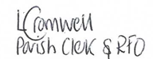
Lisa Cromwell – Parish Clerk Date Issued: 01.04.26

The Vice-Chair will open and preside at this meeting

1 | Apologies for absence
2 | Declarations of Interest  Councillors are reminded that their actions must always be in the public interest. They must avoid giving any person an improper advantage or disadvantage, and they should not seek financial or other material benefits for themselves, their family, friends, or close associates.
 | To accept any declarations of interest regarding agenda items
3 | Acceptance of minutes of the last Ordinary Meeting held 2 March. [DR]
4 | District and County Reports
 | The chair will invite councillors Rice and Crocker to present their reports. Both reports can be found on the JPC website. [SD]
5 | NDP/SWLP update
 | Cllr Andrews, chair of the NDP working party will provide an update.
6 | Youth Council Update
 | Cllr Andrews will invite representatives from the youth council to provide an update
7 | Chair’s Report
 | Cllr Andrews will provide an overview of key matters since the last meeting
8 | Payments made since the last Ordinary Meeting.  [Consisting annual charges and subs, DD, delegated payments and/or Member voting at an Ordinary Meeting, by email, or,as determined by the JPC Financial Regulations, 5.15].
 | 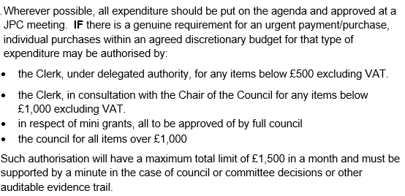
 | 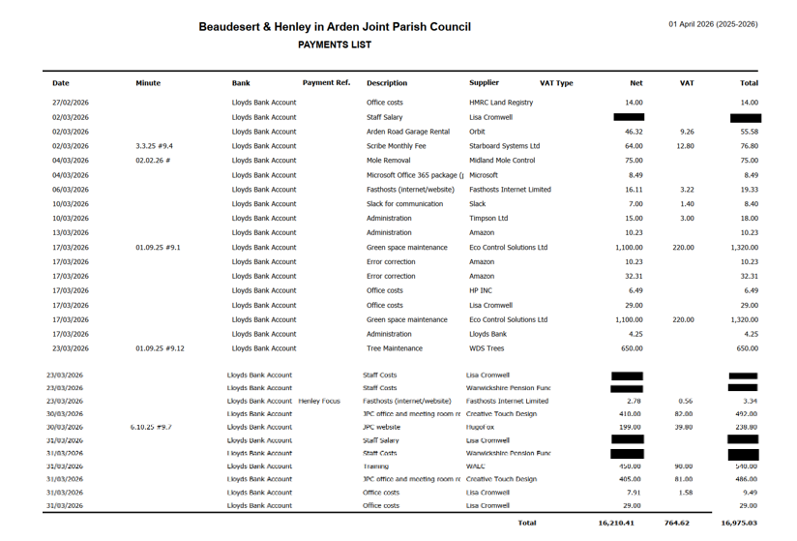
9 | Creditors payments for consideration by Members
NB: Any payment requests received by the Clerk after publication of this agenda MAY be presented at the meeting for consideration.

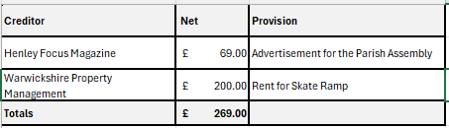
10 | Income received since last meeting
 | 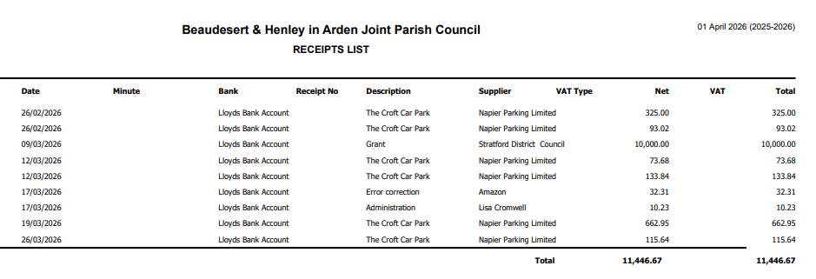
11 | Banking at 01.04.26  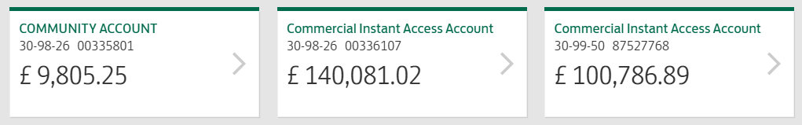
12 | Councillors’ proposals and notes to Council – to be proposed, seconded and voted on
 | Matters concerning expenditure/income
12.1 | Mini Grant request from Court Leet for £300
 | Cllr Andrews proposes the council consider a mini-grant request from the Court Leet for £300 for monitoring river health. Henley-in-Arden currently lacks an upstream monitoring point on the River Alne, despite active monitoring elsewhere downstream. A Riverlands site would fill this gap and strengthen the wider catchment picture.
 | MOTION: To consider and approve the mini-grant request of £300 to be paid to Safe Avon, a community-led programme creating long-term, publicly accessible data on river health. [DR], [EA]
12.2 | Parish Assembly – 20 April
 | Cllr Andrews proposes a budget of no more than £500 be provided for drinks and pizza to be served at The Parish Assembly, and also for £100 raffle prize.
 | MOTION: To approve the budget of no more than £500.00. [DR], [EA]
12.3 | IT Support for Clerk
 | Cllr Andrews proposes that, due to significant issues experienced with email and calendar functionality, and having reviewed the clerk’s current IT arrangements with the vice-chair, it was determined that the use of a personal Microsoft account was not fit for purpose. A gap in formal IT support was also identified.
 | MOTION: To ratify the instruction of Blue Squirrel, a Henley‑based IT provider, to manage the clerk’s Office 365 Business account at a cost of £25 per month and also provide ad hoc IT support as required at a cost of £75 per hour with a minimum charge of 15 minutes. [DR], [EA]
12.4 | Additional Community Notice Board
 | Cllr Broadbent proposes that, in response to substantial feedback from local groups, a new centrally located noticeboard is provided for community notices. Residents highlighted that the existing boards at Beaudesert Lane and Arden Way are not sufficiently central for general use. The new community board will be positioned on the High Street.
 | MOTION: That the JPC investigates suitable suppliers and associated costs for the required works and brings the findings to the next Council meeting for consideration and ratification. Subject to approval, planning permission will then be required before any works can progress [DR], [EA]
12.5 | Skate ramp at The Hub
 | Cllr Andrews proposes that, following an informal poll of local young people which showed strong support for retaining the ramp and identified it as a valued asset, the JPC considers undertaking the necessary repairs.
 | MOTION: That the JPC agrees to commission the necessary repairs to ensure the ramps continued safe use and to instruct the clerk to issue a PO in the sum of £1275 to the manufacturer to carry out the repairs. [DR], [EA]
12.6 | Henley-in-Arden Gateway Troughs
 | Cllr Broadbent proposes that, noting the JPC’s 07.07.25 #9.2 resolution to receive an annual quotation from Henley in Bloom (HIB) for the planting of the gateway troughs and HIB’s subsequent notification that they can no longer undertake this work for health and safety reasons, the JPC supersedes that resolution and makes its own arrangements for the planting and watering of the gateway troughs at a cost not exceeding £250.
 | MOTION: That the members approve and instruct the clerk to investigate an alternative solution and issue a PO for no more than £250 for the planting and maintenance of the Gateway troughs. [DR], [EA]
13 | Councillors’ proposals and notes to Council – to be proposed, seconded and voted on
 | Business matters – updates only – no financial decisions listed
13.1 | Model Publication Scheme
Cllr Andrews proposes that the members consider and approve the formal adoption of the Information Commissioner’s Office (ICO) Model Publication Scheme, as required under Assertion 10 of the Annual Governance and Accountability Return (AGAR). Adoption of the Scheme confirms that the Joint Parish Council meets its statutory obligations for transparency and public access to information, and that it publishes information in accordance with the Freedom of Information Act 2000.

MOTION: That the Joint Parish Council adopts the ICO Model Publication Scheme and confirms that it is operating in accordance with the requirements of AGAR Assertion 10. [DR], [SD]
13.2 | Adoption of IT Policy as required by Assertion 10
 | Cllr Andrews proposes that, having reviewed the updated Joint Parish Council IT Policy — drafted in accordance with NALC guidance and the requirements of Assertion 10 of the Annual Governance and Accountability Return (AGAR) — the Council approves its adoption. The policy sets out the Council’s standards for the secure and lawful use of digital systems, email, devices, data management and website compliance, as required by the 2025 Practitioners’ Guide and the new digital and data governance obligations.
 | MOTION: To ratify the adoption of the IT policy. [DR], [SD]
13.3 | Adoption of revised Data Protection Policy (Assertion 10 Compliance)
 | Cllr Andrews proposes that, having reviewed the updated Data Protection Policy — including the provisions relating to the Council’s Privacy Notice and the handling of Freedom of Information requests — the JPC approves the policy to ensure full compliance with Assertion 10 of the Annual Governance and Accountability Return (AGAR).
 | MOTION: To ratify the adoption of the revised Data Protection policy. [DR], [SD]
14 | Planning Applications:
 | The applications listed below have been discussed by the JPC Planning Working Party, which has made the following recommendations to full council.
 | 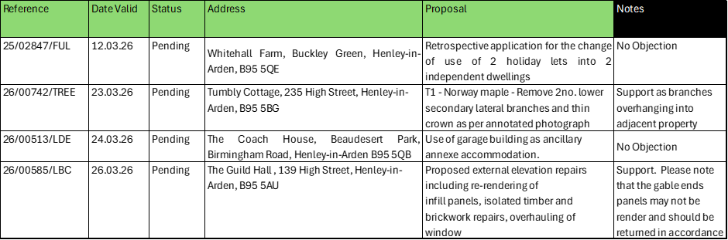
 | Full details are available on the SDC Planning Portal.
15 | Members Urgent Business Matters
 | The chair will enquire whether councillors have any urgent business to bring to the attention of the assembly.
16 | Next Meeting
 | The Parish Assembly will be held at the Memorial Hall, Station Road, on 20 April at 6:00pm. The Annual Parish Council Meeting will take place on 4 May at the Memorial Hall, Station Road on Tuesday 5 May at 7:00pm.

.

