Here are the Minutes of the Ordinary Council Meeting of Beaudesert and Henley in Arden JPC, which took place on Wednesday, 8 April, at 7.00pm in the Memorial Hall, Henley in Arden.

Present: Cllrs Andrews [Chair], Tomlinson, Broadbent, Field and Glaze plus Lisa Cromwell [Clerk and RFO]

In Attendance: Cllr Rice, Stratford District Council,(SDC), Cllr Crocker, Warwickshire County Council, (WCC), along with 11 members of the public were in attendance.

Public Session: Open Forum to provide an opportunity for members of the public to raise questions and to comment on any other items that are on the current agenda.

CLERK’S NOTE
Planning Committee considered applications listed herein. Outcomes of these applications can be viewed on the Stratford on Avon Planning Portal click on – https://apps.stratford.gov.uk/eplanning/

Cllr Andrews [Chair], opened the meeting.

1 | Apologies for absence
 | Apologies were received from Cllrs McCaskie, Norris and Rouse.
2 | Declarations of Interest  Councillors are reminded that their actions must always be in the public interest. They must avoid giving any person an improper advantage or disadvantage, and they should not seek financial or other material benefits for themselves, their family, friends, or close associates.
 | Cllr Field expressed a declaration of interest in item 12.1 and confirmed she would abstain from voting.
3 | Acceptance of minutes
 | The motion was proposed by Cllr Andrews and carried unanimously by all those present at the meeting. It was RESOLVED that the minutes of the meetings held on 2 March 2026 were confirmed as a true record and signed by the Cllr Andrews.
4 | District and County Reports
 | Cllrs Rice and Crocker were invited to share their reports on matters affecting Beaudesert & Henley-in-Arden. The Council noted the following community updates:
 | Cllr James Crocker - WCC
 | - Encouraged attendees to share views on Warwickshire County Council’s Draft Council Plan 2026-30 by completing an online survey before Tuesday 14 April.
 | Take part here: https://orlo.uk/TRJJJ
- Provided an update on Warwickshire’s latest bus satisfaction survey and is going to provide a method of gathering data/requests for service extensions from Beaudesert & Henley residents. Information to follow.
- Advised that a cross-party working group for the agricultural industry has been set up and further details will follow.
 | Cllr Mike Rice – SDC
 | - Advised that mobile health screening for prostate cancer, cholesterol and diabetes will return in November 2026.
 | Copies of both reports can be found on the JPC website.
5 | NDP/SWLP update
Cllr Andrews provided an update on NDP/SWLP including:

- Once the SWLP related announcement is made in May, work on the NDP will be progressed.
- The JPC is aware that potential developers have approached SDC to ask whether an Environmental Impact Assessment (EIA) can be avoided. The JPC is monitoring this activity closely and will share verified updates as they are received.
- Cllr Andrews also confirmed that the JPC will request that SDC carry out a full seasonal EIA before any planning applications are considered.
6 | Youth Council Update
 | The Youth Council did not attend due to the Easter school holidays.
7 | Chair’s Report
 | Main Points:
- Stylers Way – Repairs to lighting have finally been carried out – one remains faulty and WCC will keep us updated
- Litter picking was a huge success and the next date is 19 April
- The Parish Assembly is taking place on 20 April. This is not a council meeting, it is a gathering for the electors. The JPC will provide pizza, drinks and a raffle and this is a fantastic opportunity to gather the community together to see who can help who.
- The JPC remains committed to managing the allotments in a way that is fair, consistent and in the best interests of the Beaudesert & Henley-in-Arden community.

 | The full report can be found on the JPC’s website.
8 | Payments made since the last Ordinary Meeting.  [Consisting annual charges and subs, DD, delegated payments and/or Member voting at an Ordinary Meeting, by email, or, as determined by the JPC Financial Regulations, 5.15].  Wherever possible, all expenditure should be put on the agenda and approved at a JPC meeting. IF there is a genuine requirement for an urgent payment/purchase, individual purchases within an agreed discretionary budget for that type of expenditure may be authorised by:  - the Clerk, under delegated authority, for any items below £500 excluding VAT.  - the Clerk, in consultation with the Chair of the Council for any items below £1,000 excluding VAT.  - in respect of mini grants, all to be approved of by full council  - the council for all items over £1,000  Such authorisation will have a maximum total limit of £1,500 in a month and must be supported by a minute in the case of council or committee decisions or other auditable evidence trail.  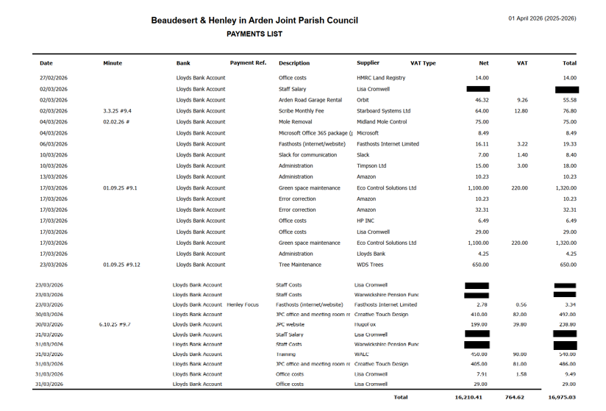
9 | Creditors payments for consideration by Members
 | NB: Any payment requests received by the Clerk after publication of this agenda MAY be presented at the meeting for consideration.
 | 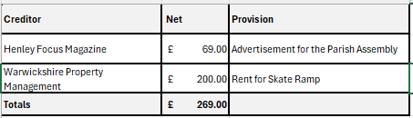
10 | Income received since last meeting
 | 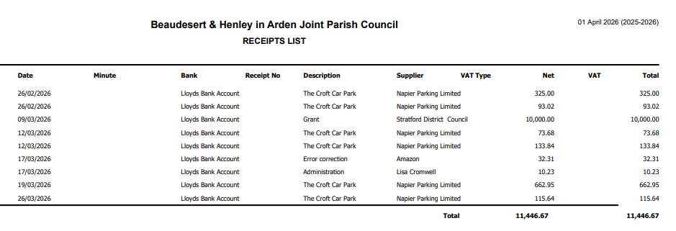
11 | Banking at 01.04.26
 | 
Nos. 8, 9, 10 and 11

The Vice-Chair enquired whether all members had reviewed the data for payments, receipts, and bank balances. It was RESOLVED that all members confirmed they had inspected the data and unanimously approved the content
12 | Councillors’ proposals and notes to Council – to be proposed, seconded and voted on
 | Matters concerning expenditure/income
12.1 | Mini Grant request from Court Leet for £300
 | Cllr Andrews proposed that the council consider a £300 mini‑grant request from the Court Leet for river‑health monitoring, noting that a Riverlands site would fill the current upstream gap on the River Alne.
 | The motion that the council ratify the mini-grant request of £300 to be paid to the Court Leet, for equipment from Safe Avon, a community-led programme creating long-term, publicly accessible data on river health was seconded by Cllr Broadbent, and approved by all members present except Cllr Field (declaration of interest) by a show of hands. RESOLVED.
12.2 | Parish Assembly – 20 April
 | Cllr Andrews proposed a budget of no more than £500 be provided for drinks and pizza to be served at The Parish Assembly, and also for £100 raffle prize.
 | The motion to ratify the budget of no more than £500.00 was seconded by Cllr Field and unanimously approved by a show of hands. RESOLVED.
12.3 | IT Support for Clerk
 | Cllr Andrews proposed that, due to significant issues experienced with email and calendar functionality, and having reviewed the clerk’s current IT arrangements with the vice-chair, it was determined that the use of a personal Microsoft account was not fit for purpose. A gap in formal IT support was also identified.
 | The motion to ratify the instruction of Blue Squirrel, a Henley‑based IT provider, to manage the clerk’s Office 365 Business account at a cost of £25 per month and also provide ad hoc IT support as required at a cost of £75 per hour with a minimum charge of 15 minutes was seconded by Cllr Broadbent and approved unanimously by a show of hands. RESOLVED.
12.4 | Additional Community Notice Board
 | Cllr Broadbent proposed that a new centrally located noticeboard be provided for community notices. The new community board will be positioned on the High Street.
 | MOTION: That the JPC investigates suitable suppliers and associated costs for the required works and brings the findings to the next Council meeting for consideration and ratification. Subject to approval, planning permission will then be required before any works can progress [CF]
12.5 | Skate ramp at The Hub
 | Cllr Andrews proposed that, following an informal poll of local young people which showed strong support for retaining the ramp and identified it as a valued asset, the JPC should consider undertaking the necessary repairs.
 | The motion that the council ratify commissioning the necessary repairs to ensure the ramps continued safe use and to instruct the clerk to issue a PO in the sum of £1275 to the manufacturer to carry out the repairs was seconded by Cllr Broadbent and approved of unanimously by a show of hands. RESOLVED.
12.6 | Henley-in-Arden Gateway Troughs
 | Cllr Andrews proposed that, noting the JPC’s 07.07.25 #9.2 resolution to receive an annual quotation from Henley in Bloom (HIB) for the planting of the gateway troughs and HIB’s subsequent notification that they can no longer undertake this work for health and safety reasons, the JPC supersede that resolution and makes its own arrangements for the planting and watering of the gateway troughs at a cost not exceeding £250.
 | The motion that the members approve and instruct the clerk to investigate an alternative solution and issue a PO for no more than £250 for the planting and maintenance of the Gateway troughs was agreed unanimously by a show of hands. RESOLVED.
13 | Councillors’ proposals and notes to Council – to be proposed, seconded and voted on
 | Business matters – updates only – no financial decisions listed
13.4 | Co-option of a new councillor
 | Item 3.4 was included on a supplementary agenda, publised on the same day as the main agenda. For procedural reasons, this should be the first item in this section.
 | Cllr Andrews proposed that the council consider the application received for co-option to fill one of the current vacancies on the Joint Parish Council (Mr Charles Barlow). Mr Barlow was invited to address the council and outline his backgound and connection to Beaudesert & Henley. Following an anonymous ballot, Mr Barlow was invited to sign the Declation of Acceptance of Office and took his seat with the members.
 | RESOLVED: That Mr Charles Barlow be co-opted onto the JPC.
13.1 | Model Publication Scheme
Cllr Andrews proposed that the members consider and approve the formal adoption of the Information Commissioner’s Office (ICO) Model Publication Scheme, as required under Assertion 10 of the Annual Governance and Accountability Return (AGAR).

The motion that the Joint Parish Council adopt the ICO Model Publication Scheme and confirms that it is operating in accordance with the requirements of AGAR Assertion 10 was seconded by Cllr Tomlinson and approved of unanimously by a show of hands. RESOLVED.
13.2 | Adoption of IT Policy as required by Assertion 10
 | Cllr Andrews proposed that, having reviewed the updated Joint Parish Council IT Policy -drafted in accordance with NALC guidance and the requirements of Assertion 10 of the Annual Governance and Accountability Return (AGAR) - the council approve its adoption.
 | The motion to adopt the new IT Policy, was agreed on the proviso that a few unnecessary words were removed from section 2.2.7 of the policy; these amendments have now been made. RESOLVED.
13.3 | Adoption of revised Data Protection Policy (Assertion 10 Compliance)
14 | Cllr Andrews proposed that, having reviewed the updated Data Protection Policy , the JPC approve the policy to ensure full compliance with Assertion 10 of the Annual Governance and Accountability Return (AGAR).
 | The motion to ratify the adoption of the revised Data Protection Policy was RESOLVED.
Privacy Notice
It was brought to the council’s attention that the Privacy Notice is not currently published on the legacy website inherited by the clerk. This is a housekeeping matter and not a breach of GDPR. All required GDPR policies are held by the council and that the Privacy Notice will be added as part of the new website development.
 | Planning Applications:
 | The applications listed below have been discussed by the JPC Planning Working Party, which has made the following recommendations to full council. Members agreed with the Working Party’s recommendations and comments will be submitted to SDC by the clerk.
 | 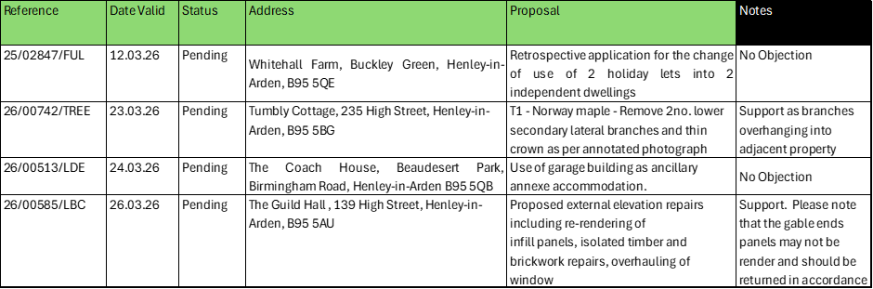
 | Full details are available on the SDC Planning Portal.
15 | Members Urgent Business Matters
The Chair enquired whether councillors had any urgent business to bring to the attention of the assembly.

There were no urgent business matters.
16 | Next Meeting
 | The Parish Assembly will be held on Wednesday 8 April at the Memorial Hall, Station Road at 6pm. The Annual Parish Council Meeting (APCM) will be held on Tuesday 5 May at the Memorial Hall, Station Road at 7pm.

.

Signed ………………………………………………………………………………….

Date……………………………………………………….

