REPORT FROM WARWICKSHIRE COUNTY COUNCILLOR
JAMES CROCKER

BEAUDESERT & HENLEY JOINT PARISH LOCAL ISSUE UPDATE
- The traffic surveys around Wootton Wawen and Henley are being undertaken by WCC:
The purpose of the recent ATC surveys is solely to gather traffic volume data, which will be used to support updates to our transport models. These models are an essential evidence base for future planning work, particularly in preparation for the release of the Local Plan for the area. They are not being used to monitor vehicle speeds or assess compliance with the current speed limit.
The data can be purchased via this link: https://www.warwickshire.gov.uk/traffic-surveys/request-traffic-survey-data after the survey period. However, we don't recommend using the data for speed because the survey wasn't planned to gather speed data.
As such if the Parish Councils are interested in this data, they should contact:
trafficsurveys@warwickshire.gov.uk
- Redditch to Warwick Hospital (via Henley, Claverdon) new bus route to be investigated.
- Championing Farming in Warwickshire following a recent motion at full council, we will be setting up a cross party group to support farmers, the agricultural industry and wider countryside initiatives. This includes looking into rural fuel syndicates and how WCC can help following the collapse of WRCC.

NEWS FROM SHIRE HALL
Warwickshire tops bus service satisfaction survey

Warwickshire County Council is very pleased with the results of the 2025-26 ‘Your Bus Journey’ survey, conducted by independent watchdog Transport Focus, which revealed a 93% overall passenger satisfaction rating.
Read more: https://www.warwickshire.gov.uk/news/article/7517/warwickshire-bus-services-top-national-satisfaction-charts-in-latest-survey
Pothole Allegations Made by Rachel Taylor MP Dismissed By George Finch, WCC Leader
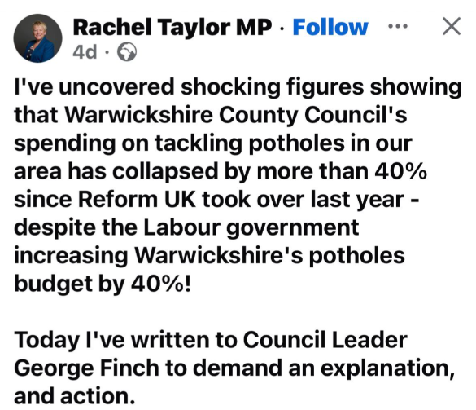
In a written response from George Finch, Rachel Taylor MP misused selective FOI data on potholes and ignored key context. Capital spending on carriageways and footways has risen 45%, from £16.9m to £23.9m, with extra focus on pothole repair and prevention. The council states 11,486 potholes have been filled so far this year and that more of the network is now in good condition. He explains funding is still limited, work is prioritised by data not “wish-lists”, new methods and the JCB Pothole Pro are being used, and invites discussion instead of public misrepresentation.

Businesses in Warwickshire can now access a range of support through the new Warwickshire Business Growth Service.

The new service and website includes a range of business support including advice, events and peer support, all available in one place.
Businesses can access the new service using the contact details:
- Phone number: 01926 412 709
- Email: business@warwickshire.gov.uk
- Website: business.warwickshire.gov.uk
Businesses can explore the new website to access help and guidance from a wide range of services across the council and partners including skills, property, access to finance, Trading Standards and business support from Warwickshire Fire and Rescue Service.
The new service provides a single route for businesses to discover the types of support available and understand what they need based on their needs and goals.


Recalibrating Warwickshire: Warwickshire County Council’s Council Plan 2026-30
WCC has published its draft Council Plan and wants to hear what matters most to you. Click here to read the draft Council Plan
Share your views by completing the online survey before Tuesday 14 April 2026.
Take part here: https://orlo.uk/TRJJJ
Prefer a paper copy? Call 01926 410410 or pick one up at any WCC library.

Warwickshire Libraries Spring/Summer 2026 What’s On Guide
Warwickshire Libraries is pleased to announce the launch of its Spring/Summer 2026 What’s On Guide highlighting a lively and engaging programme of cultural, creative and community activities taking place from April to September 2026 across all 18 council-managed libraries.
From Polesworth to Shipston-on-Stour, the new guide brings together a diverse mix of events for children, young people, and adults. With most activities offered free of charge, Warwickshire Libraries continues to support access to inclusive, high-quality cultural experiences for residents across the county.
Season Highlights
The Spring/Summer programme includes a wide range of events and activities, such as:
- Monthly author talks.
- Creative workshops including crafts, henna art and Chinese Fan Dance sessions.
- A free filmmaking course for teens.
- The much-loved Warwickshire Libraries Bookmark Competition.
Regency Revels Return
As a National Portfolio Organisation supported by Arts Council England, Warwickshire Libraries continues to deliver high-quality cultural programming across the county.
This year marks the return of the hugely popular Regency Revels, running across three libraries between May and June. These immersive evenings celebrate the world of Jane Austen through performed readings from her most cherished novels, accompanied by traditional period dancing.
Tickets: £10 per person. Book via Eventbrite: https://www.eventbrite.co.uk/cc/regency-revels-4825719

MY RESPONSIBILTIES AS WARWICKSHIRE COUNTY COUNCILLOR
- Within Warwickshire County Council, other parishes in the Arden division include Wootton Wawen, Ullenhall, Claverdon, Langley, Tanworth-in-Arden (including Earlswood), Wolverton and Preston Bagot.
- Serving on both the Warwickshire Fire & Rescue Local Pension Board of the Firefighters’ Pension Scheme and the Warwickshire Pension Fund Local Pension Board.
- Member of the cross-party working group for the Bus Service Improvement Plan. I have recently received a number of requests from residents asking for service extensions to key areas such as Warwick Hospital. If you have any views or suggestions regarding local bus services, please do not hesitate to get in touch.
- Appointed to the Member Oversight Group, a cross-party body focused on WCC’s investments, trading companies and including the Warwickshire Investment Fund.
- Member of the Audit & Standards Committee, concerned with ensuring that WCC has robust systems of internal control and making sure that both councillors and officers follow high standards in the way they conduct the business of the council.
Separately, also Chair of the Reform UK branch for Stratford-on-Avon.

Getting in Touch
For any issues or ideas that would benefit Beaudesert and Henley-in-Arden, as your representative, I am always available to listen and support local priorities at Warwickshire County Council.

James Crocker
County Councillor for Arden
Warwickshire County Council Email: jamescrocker@warwickshire.gov.uk
Mobile: 07353 157962

