.

Dear Councillors

The Annual Parish Council Meeting (ACPM) will be held at 7:00 pm at the Memorial Hall, Station Road, Henley-in-Arden. All council members are summoned to attend to discuss and resolve the items listed in the agenda.

Public Session

Before the council meeting begins, the public will have an opportunity to present their concerns or comments. This session, at the discretion of the Chair, is limited to 3 minutes per speaker and a total of 15 minutes. Any issues not listed in the agenda will be noted by the Clerk for future consideration.

Clerk’s note

Planning Committee will consider applications listed in section 11. Outcomes of these applications can be viewed on the Stratford on Avon Planning Portal. Click on:

https://apps.stratford.gov.uk/eplanning/

MAIN TOPICS
1 | Election of the Chair
5 | Presentation from R Adams & Sons
6 | County and District Councillors’ Reports [SD]
7 | NDP/SWLP Update
8 | Youth Council Update
9 | Chair’s Report
10 - 14 | Finance Update
14 | Matters Concering Expenditure
15 | Council’s Business Matters
16 | Planning Applications

Supporting documents relating to the following subjects can be found on the JPC website prior to the meeting.

Signed 
Lisa Cromwell – Parish Clerk Date Issued: 29.04.26

The Clerk will open this meeting.

1 | Election of the Chair of the Council
 | The first business at the annual meeting of a parish council shall be the election of the chair. LGA 1972, s.15(1)
 | Signing of Declaration of Office.
2 | Apologies for absence
3 | Declarations of Interest  Councillors are reminded that their actions must always be in the public interest. They must avoid giving any person an improper advantage or disadvantage, and they should not seek financial or other material benefits for themselves, their family, friends, or close associates.
 | To accept any declarations of interest regarding agenda items
4 | Acceptance of minutes of the last Ordinary Meeting held 8 April. [DR]
5 | Presentation from R Adams & Sons
 | Cllr Andrews invites guest speaker Mr Mark Adams, representing R Adams & Sons, to provide an update on the construction of the new grain store on their land and to outline the associated planting and landscaping proposals.
6 | District and County Reports
 | The chair will invite councillor Crocker to present his report. Both his and Cllr Rice’s reports can be found on the JPC website. [SD]
7 | NDP/SWLP update
 | Cllr Andrews, chair of the NDP working party will provide an update.
8 | Youth Council Update
 | Cllr Andrews will invite representatives from the youth council to provide an update
9 | Chair’s Report
 | Cllr Andrews will provide an overview of key matters since the last meeting
10 | Payments made since the last Ordinary Meeting.  [Consisting annual charges and subs, DD, delegated payments and/or Member voting at an Ordinary Meeting, by email, or,as determined by the JPC Financial Regulations, 5.15].
 | 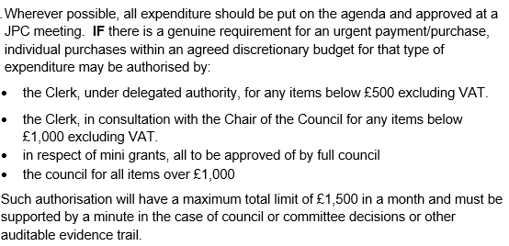
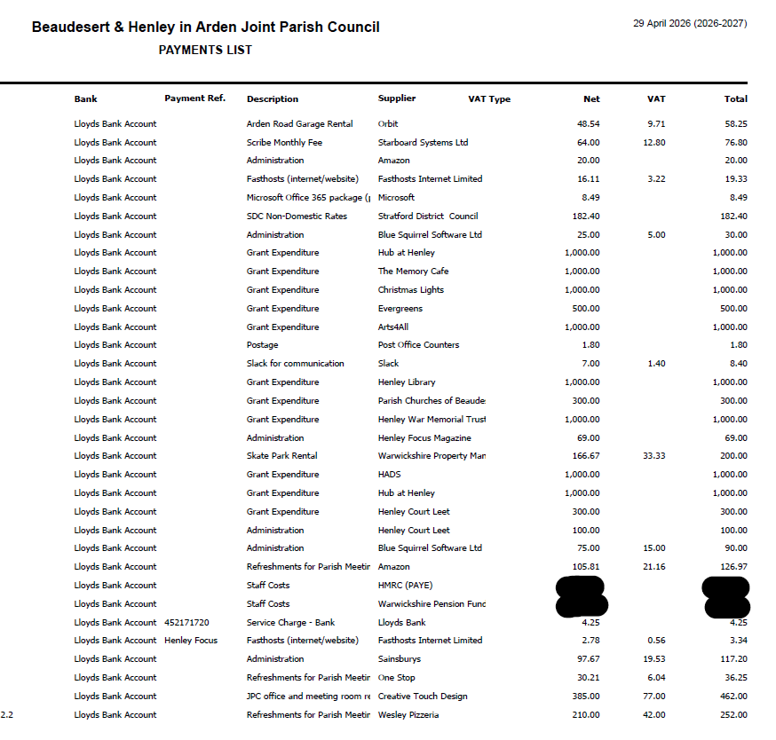
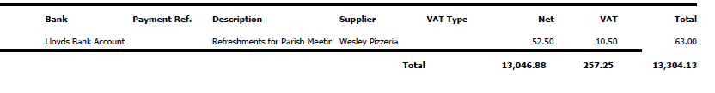
11 | Creditors payments for consideration by Members
NB: Any payment requests received by the Clerk after publication of this agenda MAY be presented at the meeting for consideration.

No payments for consideration at time of publication of agenda.
12 | Income received since last meeting
 | 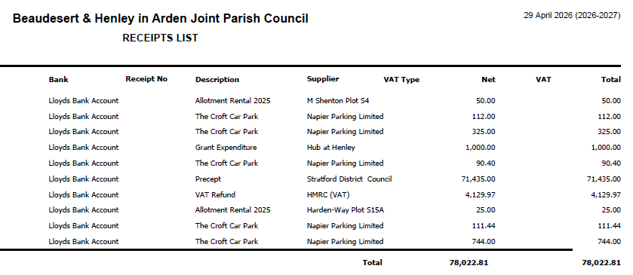
13 | Banking at 29.04.26  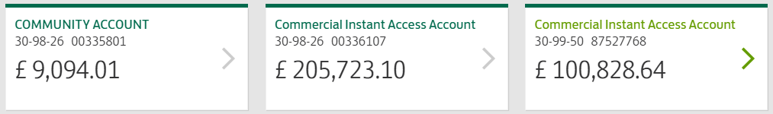
14 | Councillors’ proposals and notes to Council – to be proposed, seconded and voted on
 | Matters concerning expenditure/income
14.1 | Commission of Pottery Business line drawing for Visit Henley website  Cllr Andrews proposes the commission of a line drawing of a new business on the High Street, The Old Bank Pottery, for the Visit Henley website at a cost of £50.00
 | MOTION: To approve the cost of a line drawing and issue a PO to Gary Nicklin in the sum of £50.00. [DR], [EA]
14.2 | Tree maintenance at Riverlands, Prince Harry Road  Cllr Andrews proposes approval of reduction of two trees, T535 and T536, which currently have branches overhanging the roof of the Medical Centre. WD Trees, our Tree Maintenance Contractor has quoted £850.00 for these works and SDC has granted planning permission.  MOTION: To approve the cost and instruct the clerk to issue a PO in the sum of £850 to WD Trees. [DR], [EA]
14.3 | Rent due to National Rail Infrastructure Ltd
 | Cllr Andrews proposes the payment of the rent for water pipes under Bear Lane from National Rail at a cost of £348.53
 | MOTION: To approve the cost and instruct the clerk to issue a PO for the invoice in the sum of £348.53. [DR], [EA]
14.4 | Additional Community Notice Board [Carried forward from 8 April. No update has been received and the item remains ongoing]
 | Cllr Broadbent proposes that, in response to substantial feedback from local groups, a new centrally located noticeboard is provided for community notices. Residents highlighted that the existing boards at Beaudesert Lane and Arden Way are not sufficiently central for general use. The new community board will be positioned on the High Street.
 | MOTION: That the JPC investigates suitable suppliers and associated costs for the required works and brings the findings to the next Council meeting for consideration and ratification. Subject to approval, planning permission will then be required before any works can progress [CF]
14.5 | Payment of WALC/NALC subscription
Cllr Andrews proposes that the JPC approves payment of the annual subscription to the Warwickshire Association of Local Councils (WALC) and the National Association of Local Councils (NALC).
WALC and NALC provide essential support to parish councils, including governance and legal guidance, training for councillors and clerks, model policies, updates on legislative changes, and access to sector-wide best practice. Membership ensures the JPC continues to operate in line with current statutory requirements and recognised standards within the local council sector.

 | MOTION: To approve the cost of 947.00 for subscription to NALC/WALC and instruct the clerk to create a purchase order and make payment. [DR], [EA]
14.6 | Avenue of cherry blossom trees - Littleworth
 | Cllr Andrews proposes that the members consider the suggestion from HortiHenley to plant a small avenue of cherry blossom trees in Littleworth. This would match up the area with the avenues created in Jubilee and Riverlands. If approved, seven Kanzan cherry trees, a small variety, would be planted.
 | MOTION: To consider the proposal at a cost of £900 for the purchase and planting of seven cherry trees at Littleworth in the Autumn and if approved, instruct the clerk to issue a PO. [DR], [EA]
15 | Business matters – updates only – no financial decisions listed
15.1 | Amendments to policies and new policies for adoption
 | Cllr Andrews proposes that the following policies, which have either had amendments made, or which are new, and have been reviewed by the members, be ratified.
- Standing Orders
- Specifically amends to 3g, 3h and 3i
- An addition – xvii
- Reserves Policy
- This has been updated to include information about Earmarked Reserves and s.106 and CILS payments
New policies which have been reviewed by the members to be ratified:
- Equality and Diversity Policy
- Freedom of Information Policy
- Privacy Notice
- Code of Conduct
15.4 | Henley Market – Licence Request from SDC
Cllr Andrews proposes, that following a market licence application Henley-in-Arden Market CIC for Henley Market dates that fall within 2026, that the JPC support the application and advise SDC Licensing Department accordingly. The application seeks permission for up to 20 traders (market stalls) within the car park of the White Swan, Henley in Arden to which permission from the landowner has been obtained. The application seeks to allow traders from 9.30 – 17:30 hrs with trading to the public to take place between 10:00 – 15:00 hrs on the following dates:
7 June, 5 July, 2 August, 6 September, 4 October, 1 November
28 November (Christmas Market – will operate from 12:00 – 17:00 )

MOTION: To approve the licence request and instruct the clerk to advise SDC of the JPC’s decision. [DR]
15.5 | Civic Church Service
 | Cllr Andrews proposes that Cllr Broadbent represents the council at a civic church service, and therefore gives her consent for Cllr Broadbent to wear the Chain of Office as there is no legislation preventing this.
 | MOTION: That the council formally authorises Cllr Broadbent to represent the council at the civic church service on 17 May, and approves the wearing of the Chain of Office, with the Chair’s consent, for that engagement.
15.6 | Working Party Review
 | Cllr Andrews proposes the updating of and appointment of new members of the council to working parties. Working parties have no decision-making powers and operate informally to support the council’s work by developing ideas, gathering information, and making recommendations for formal decision at council meetings.
 | MOTION: To ratify the inclusion of Cllr Glaze on to the Green Spaces working party, Cllr Field on to the Town Liaison and NDP working parties and Cllr Barlow on to the Finance and Grants working party.
 | [DR]
15.7 | Review of Asset Register  Cllr Andrews proposes that following a review of the council’s asset register by members, that there are no changes to the current register.
 | MOTION: To ratify that the current register is up to date and will be reviewed again at the APCM in 2027 – unless other assets are either purchased or disposed of. [DR]
15.8 | Shakespeare Statues – Formal agreement
 | Cllr Glaze proposes that a formal agreement between the JPC and Alderley Holdings Ltd regarding the placement of the Shakespeare statues on Alderley Holdings land, be signed by Cllr Andrews (Chair) and Mr Andy Robinson (Alderley Holdings Ltd).
 | MOTION: To ratify the agreement and for Cllr Andrews and Mr Andy Robinson to sign and date. [SD], [DR]
15.9 | Agree schedule of meetings for 2027
 | Cllr Andrews proposes that the schedule of meetings proposed for 2027 be ratified. [SD], [DR]
 | MOTION: To approve the schedule of meetings and instruct the clerk to publish this on the website and to advise electors/residents of the confirmed date of next year’s Annual Parish Assembly. [SD], [DR]
16 | Planning  The below to be discussed by the planning working party and suggestions shared with members. Update will be provided at the next meeting.
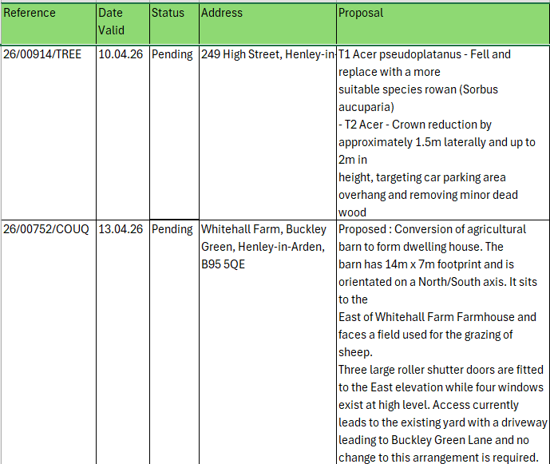
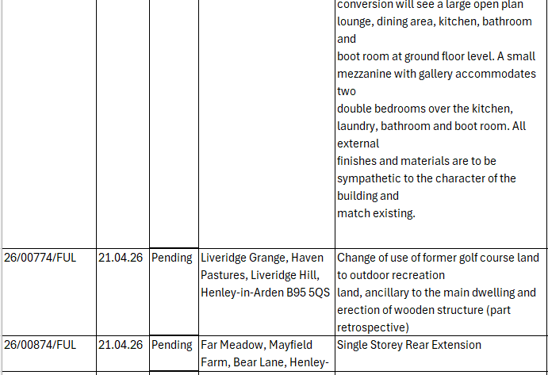
17 | Urgent Business Matters
 | Cllr Andrews will enquire whether any of the members have any urgent business to report.
18 | Next Meeting
 | The next Ordinary Meeting of the Council will be held at the Memorial Hall, Station Road, on Monday 1 June at 7pm.

.

