Here are the Minutes of the Annual Parish Council Meeting of Beaudesert and Henley in Arden JPC, which took place on Tuesday, 8 April, at 7.00pm in the Memorial Hall, Henley in Arden.

Present: Cllrs Andrews [Chair], Rouse, Broadbent, Barlow and Glaze plus Lisa Cromwell [Clerk]

In Attendance: There were 20 members of the public in attendance plus Cllr Crocker.
The meeting was also attended by four members of the Youth Council (names withheld for safeguarding).

Public Session: Open Forum to provide an opportunity for members of the public to raise questions and to comment on any other items that are on the current agenda.

Members of the public addressed the Council.
In accordance with the JPC’s Standing Orders, this session does not form part of the formal meeting business. Questions raised do not require a response at the meeting and no debate or decisions are taken. The minutes record the occurrence of the public session and the resolutions made under agenda items only.

CLERK’S NOTE
Planning Committee considered applications listed herein. Outcomes of these applications can be viewed on the Stratford on Avon Planning Portal click on – https://apps.stratford.gov.uk/eplanning/

The Clerk opened the 2026 Annual Parish Council Meeting

1 | Election of Chair (LGA 1972 s.15(1))
Cllr Andrews was the only candidate for the position of Chair.
Members were asked to indicate by a show of hands if they were in favour of electing Cllr Andrews as Chair. The vote was carried unanimously.
Cllr Andrews was duly elected as Chair and signed the Declaration of Acceptance of Office. RESOLVED.

2 | Apologies for absence
 | Apologies were received from Cllrs Norris, McCaskie, Tomlinson, Field and Rice.
3 | Declarations of Interest  Councillors are reminded that their actions must always be in the public interest. They must avoid giving any person an improper advantage or disadvantage, and they should not seek financial or other material benefits for themselves, their family, friends, or close associates.
 | There were no declarations of interest.
4 | Acceptance of minutes
 | The motion was proposed by Cllr Andrews and carried unanimously by all those present at the meeting. It was RESOLVED that the minutes of the meeting held on 8 April were confirmed as a true record and signed by the Chair.
5 | Presentation from R Adams & Sons
 | Mr Mark Adams attended and provided an update on the construction of the new grain store. He advised that the building will be clad in green materials and that a programme of tree planting (approximately 80% oak and 20% maple) is underway to assist with screening the structure. The development will incorporate a solar-powered roof, and the company has recently acquired its first electric truck. In addition, a road sweeper has been purchased and will be used regularly to clear any gravel from local roads associated with site operations.
6 | District and County Reports
 | Cllr Crocker was invited to share his report on matters affecting Beaudesert & Henley-in-Arden. The Council noted the following community updates:
- Beaudesert & Henley-in-Arden pavements issue. Cllr Crocker and Jennifer Warren, the portfolio holder for Planning & Highways, along with Cllr Andrews and L Cromwell (Clerk) walked the High Street last Friday to inspect pavements, trees (lack of pollarding and the disastrous effects this has on the pavements), roads/potholes and lampposts etc. This will be followed up with Highways officers and Heritage dept. to look at improving the issues.
- UK terrorism threat level has been increased from substantial to severe. If you do see anything that doesn’t feel right, please report it via www.gov.uk/ACT. In an emergency, always call 999.
- Cost of living website – funds may be available for those with no other access, to pay for food or energy bills.
- Crime survey
- SEND support

Finally, Cllr Crocker shared that as from 14 May 2026, he will be the Deputy Leader of Warwickshire County Council – congratulations Cllr Crocker!

Reports from both Cllrs Rice and Crocker are available on the JPC website.
7 | NDP/SWLP update
Cllr Andrews provided an update on NDP/SWLP including:

- The publication version of the local plan will be considered at the Joint Cabinet Committee on 28 May 2026
- The agenda papers will be published on 19 May 2026.
- Officers from both SDC and WDC will be holding two virtual briefing sessions for town and parish councillors at 6pm on 19 May and 11am on 20 May.2026
- Formal start of the Period of Representations 12 June 2026 (this will be open for residents, business owners and stakeholders to comment)
- Deadline for submission of representations 27 July 2026
 | Cllr Andrews advised that updates regarding information/meetings will be provided as soon as is appropriate.
8 | Youth Council Update
The Youth Council provided a detailed and comprehensive update, including:

- An update on the analysis of the data produced from the ‘comments box’ at the Parish Assembly on 20 April;
- That they are working with a teacher at the High School to support some of the Duke of Edinburgh Award students in organising a litter picking event;
- That they are liaising with key staff at the High School regarding a programme to make the school’s sports facilities available to the community for a small charge, with proceeds contributing to the school fund;
- That they are proposing to organise a charity car wash, with the Henley-in-Arden charity beneficiary to be determined by the Youth Council. If successful, further events may be held with a rotating list of beneficiaries.

9 | Chair’s Report  Cllr Andrews presented her report – the main points were as follows:  - Henley’s new trees. Amongst other tree planting, two avenues have been created along pathways in both Riverlands and Jubilee Park. HortiHenley has done an excellent job delivering the full programme before the 30 April deadline required by Stratford District Council, which awarded the £10,000 tree grant. The JPC thanks both SDC and HortiHenley for supporting this investment in Henley’s green spaces. Please be assured, the new trees are being watered regularly and monitored in case extra care is required.  - Update on this year’s Parish Assembly, held on 20 April, which was a resounding success.  - There is a huge issue with dog fouling and the mess being left by dog owners. This has been reported to SDC Environmental Protection with certain ‘hot-spots’ being monitored regularly.  - Explanation of JPC funds and Earmarked Reserves.
 | The full report can be found on the JPC’s website.
10 | Payments made since the last Ordinary Meeting.  [Consisting annual charges and subs, DD, delegated payments and/or Member voting at an Ordinary Meeting, by email, or, as determined by the JPC Financial Regulations, 5.15].  Wherever possible, all expenditure should be put on the agenda and approved at a JPC meeting. IF there is a genuine requirement for an urgent payment/purchase, individual purchases within an agreed discretionary budget for that type of expenditure may be authorised by:  - the Clerk, under delegated authority, for any items below £500 excluding VAT.  - the Clerk, in consultation with the Chair of the Council for any items below £1,000 excluding VAT.  - in respect of mini grants, all to be approved of by full council  - the council for all items over £1,000  Such authorisation will have a maximum total limit of £1,500 in a month and must be supported by a minute in the case of council or committee decisions or other auditable evidence trail.  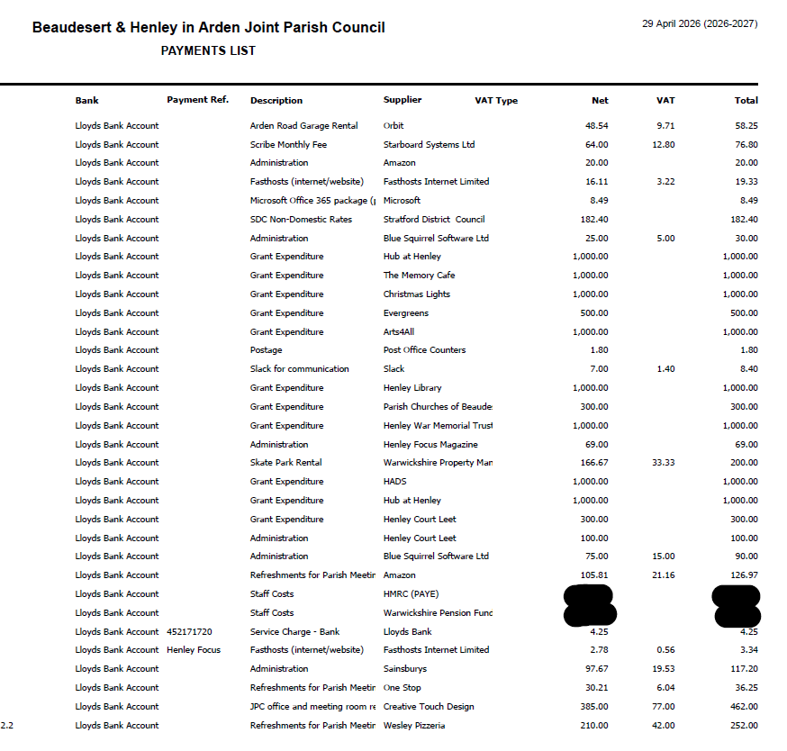
11 | Creditors payments for consideration by Members
 | NB: Any payment requests received by the Clerk after publication of this agenda MAY be presented at the meeting for consideration.
 | No payments for consideration at time of publication of agenda.
12 | Income received since last meeting
 | 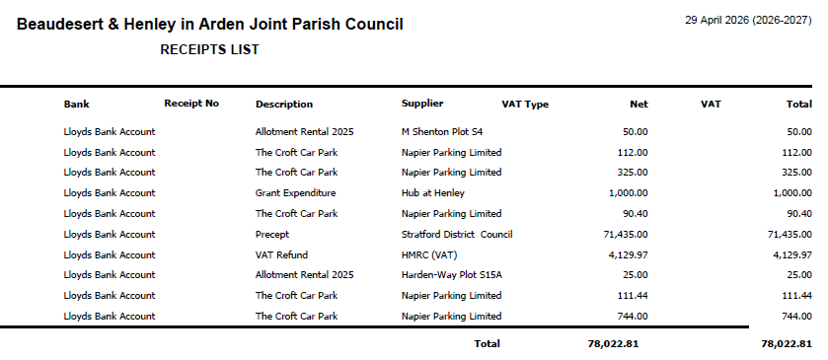
13 | Banking at 29.04.26
 | 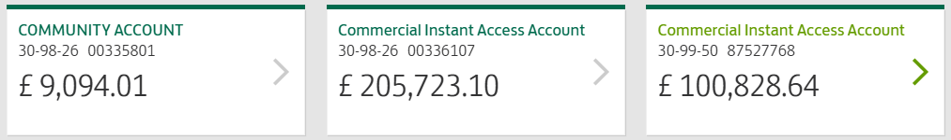
Nos. 10, 11, 12 and 13

The Vice-Chair enquired whether all members had reviewed the data for payments, receipts, and bank balances. It was RESOLVED that all members confirmed they had inspected the data and unanimously approved the content
14 | Councillors’ proposals and notes to Council – to be proposed, seconded and voted on
 | Matters concerning expenditure/income
14.1 | Commission of Pottery Business line drawing for Visit Henley website  Cllr Andrews proposed the commission of a line drawing of a new business on the High Street, The Old Bank Pottery, for the Visit Henley website at a cost of £50.00. This was seconded by Cllr Rouse and approved of unanimously by a show of hands. The clerk was instructed to send a PO to Gary Nicklin in the sum of £50.00. RESOLVED.
14.2 | Tree maintenance at Riverlands, Prince Harry Road  Cllr Andrews proposed approval of reduction of two trees, T535 and T536, which currently have branches overhanging the roof of the Medical Centre. WD Trees, our Tree Maintenance Contractor has quoted £850.00 for these works and SDC has granted planning permission. The motion to approve the cost and instruct the clerk to issue a PO in the sum of £850 to WD Trees was seconded by Cllr Rouse and approved of unanimously by a show of hands. RESOLVED.
14.3 | Rent due to National Rail Infrastructure Ltd
 | Cllr Andrews proposed the payment of the rent for water pipes under Bear Lane from National Rail at a cost of £348.53. The motion was seconded by Cllr Glaze and approved of unanimously by a show of hands. RESOLVED.
14.4 | Additional Community Notice Board [Carried forward from 8 April. No update has been received and the item remains ongoing]
 | Cllr Broadbent proposes that, in response to substantial feedback from local groups, a new centrally located noticeboard is provided for community notices. Residents highlighted that the existing boards at Beaudesert Lane and Arden Way are not sufficiently central for general use. The new community board will be positioned on the High Street.
 | MOTION: That the JPC investigates suitable suppliers and associated costs for the required works and brings the findings to the next Council meeting for consideration and ratification. Subject to approval, planning permission will then be required before any works can progress [DR], [EA]
14.5 | Payment of WALC/NALC subscription
Cllr Andrews proposed the approval of payment of the annual subscription to the Warwickshire Association of Local Councils (WALC) and the National Association of Local Councils (NALC).
WALC and NALC provide essential support to parish councils, including governance and legal guidance, training for councillors and clerks, model policies, updates on legislative changes, and access to sector-wide best practice. Membership ensures the JPC continues to operate in line with current statutory requirements and recognised standards within the local council sector. The proposal of payment of £947 was seconded by Cllr Rouse and approved of unanimously by a show of hands. RESOLVED.
14.6 | Avenue of cherry blossom trees - Littleworth
 | Cllr Andrews proposed that the members consider the suggestion from HortiHenley to plant a small avenue of cherry blossom trees in Littleworth. This would align the area with the avenues created in Jubilee and Riverlands. The proposal was seconded by Cllr Broadbent; however other members did not approve the associated cost. RESOLVED: The proposal was not approved.
15 | Councillors’ proposals and notes to Council – to be proposed, seconded and voted on
 | Business matters – updates only – no financial decisions listed
15.1 | Amendments to policies and new policies for adoption
 | Cllr Andrews proposed that the following policies, which had been reviewed by the members, be ratified.
- Standing Orders
- Specifically amends to 3g, 3h and 3i
- An addition – xvii
- Reserves Policy
- This has been updated to include information about Earmarked Reserves and s.106 and CILS payments
New policies which have been reviewed by the members to be ratified:
- Equality and Diversity Policy
- Freedom of Information Policy
- Privacy Notice
- Code of Conduct
 | The motion to ratify the policies was seconded by Cllr Glaze and approved of unanimously by a show of hands. RESOLVED.
15.4 | Henley Market – Licence Request from SDC
Cllr Andrews proposed, that following a market licence application Henley-in-Arden Market CIC made for market dates that fall within 2026, that the JPC support the application and advise SDC Licensing Dept. accordingly. The application seeks permission for up to 20 traders (market stalls) within the car park of the White Swan, Henley-in-Arden for which permission from the landowner has been obtained. The application seeks to allow traders from 9.30 – 17:30 hrs with trading to the public to take place between 10:00 – 15:00 hrs on the following dates:
7 June, 5 July, 2 August, 6 September, 4 October, 1 November
28 November (Christmas Market – will operate from 12:00 – 17:00 ). The motion to support the application and instruct the clerk to advise SDC Licensing Dept. was seconded by Cllr Rouse and approved unanimously by a show of hands. RESOLVED.

15.5 | Civic Church Service
 | Cllr Andrews proposed that Cllr Broadbent represents the council at a civic church service, on 17 May and gave her consent for Cllr Broadbent to wear the Chain of Office as there is no legislation preventing this. The motion to formally authorise Cllr Broadbent to wear the Chain of Office at the service was seconded by Cllr Rouse and approved of unanimously by a show of hands. RESOLVED.
15.6 | Working Party Review
 | Cllr Andrews proposed the updating of and appointment of new members of the council to working parties. Working parties have no decision-making powers and operate informally to support the council’s work by developing ideas, gathering information, and making recommendations for formal decision at council meetings.
 | The motion to ratify the inclusion of Cllr Glaze on to the Green Spaces working party, Cllr Field on to the Town Liaison and NDP working parties and Cllr Barlow on to the Finance and Grants working party.was seconded by Cllr Rouse and approved unanimously by a show of hands. RESOLVED.
15.7 | Review of Asset Register  Cllr Andrews proposed that, following a review of the council’s asset register by members, no changes were required and that the register be ratified as up to date. The proposal was seconded by Cllr Rouse and approved unanimously by a show of hands.  RESOLVED: That the Asset Register be ratified as up to date. The register will be maintained by the Clerk, with formal review by full council to take place at the APCM in 2027.
15.8 | Shakespeare Statues – Formal agreement between JPC and Landowner
Cllr Glaze proposed that a formal agreement between the JPC and Alderley Holdings Ltd regarding the placement of the Shakespeare statues on land owned by Alderley Holdings Ltd be signed by Cllr Andrews (Chair) and Mr Andy Robinson (Alderley Holdings Ltd).

Cllr Andrews noted that ratification of this agreement would enable the council to proceed if and when further approvals are secured, and does not constitute final approval of the project. On this basis, the proposal to ratify the agreement was seconded by Cllr Broadbent and approved unanimously by a show of hands. RESOLVED: That the agreement be ratified and signed as set out above.

15.9 | Agree schedule of meetings for 2027
 | Cllr Andrews proposed that the schedule of meetings proposed for 2027 be ratified. The motion to approve the schedule of meetings and instruct the clerk to publish the dates on the website and to advise electors/residents of the confirmed date of next year’s Annual Parish Assembly, was seconded by Cllr Broadbent and approved unanimously by a show of hands. RESOLVED.
16 | Planning
 | The below will be discussed by the planning working party and suggestions shared with members. Update will be provided at the next meeting.
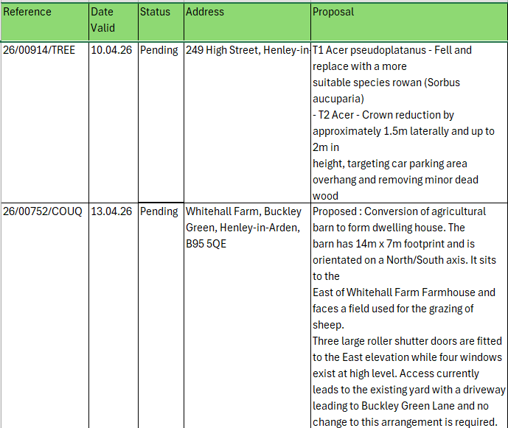
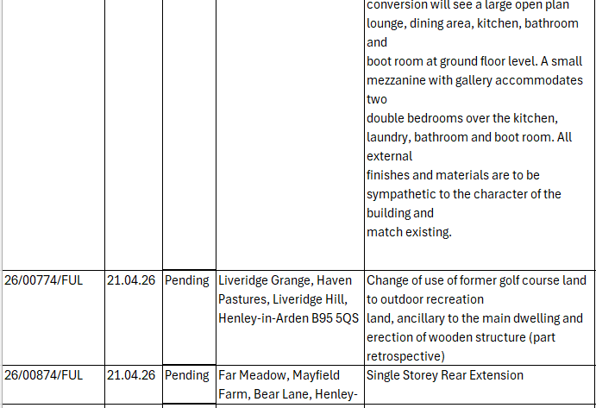

17 | Urgent Business Matters
 | Cllr Andrews enquired whether any of the members had any urgent business to report. There was no urgent business to report.
18 | Next Meeting
An Extraordinary Meeting of the JPC has been called by the Chair, in accordance with Schedule 12 of the Local Government Act 1972, to consider a proposal to submit a Community Governance Review application to Stratford District Council, which is the body responsible for determining whether a single parish and single parish council should be created. The meeting will take place at the Memorial Hall, Station Road at 6pm on Monday 11 May.

The next Ordinary Meeting of the Council will take place at the Memorial Hall, Station Road on Monday 1 June at 7pm.

.

Signed ………………………………………………………………………………….

Date……………………………………………………….

