REPORT FROM WARWICKSHIRE COUNTY COUNCILLOR
JAMES CROCKER

BEAUDESERT & HENLEY JOINT PARISH LOCAL ISSUE UPDATE
- Last Friday I walked the High Street with Cllr Jennifer Warren, the Portfolio Holder for Planning & Highways along with Cllr Cromwell and Cllr Andrews to inspect the pavements, trees, roads, lampposts etc. We will be following up with officers to suggest improvements and will also introduce Heritage Portfolio Holder Darren Cheshire to help with enhancing some of the local cultural landmarks.

NEWS FROM SHIRE HALL
Raising of threat level to severe – statement from Deputy Chief Constable Ben Smith
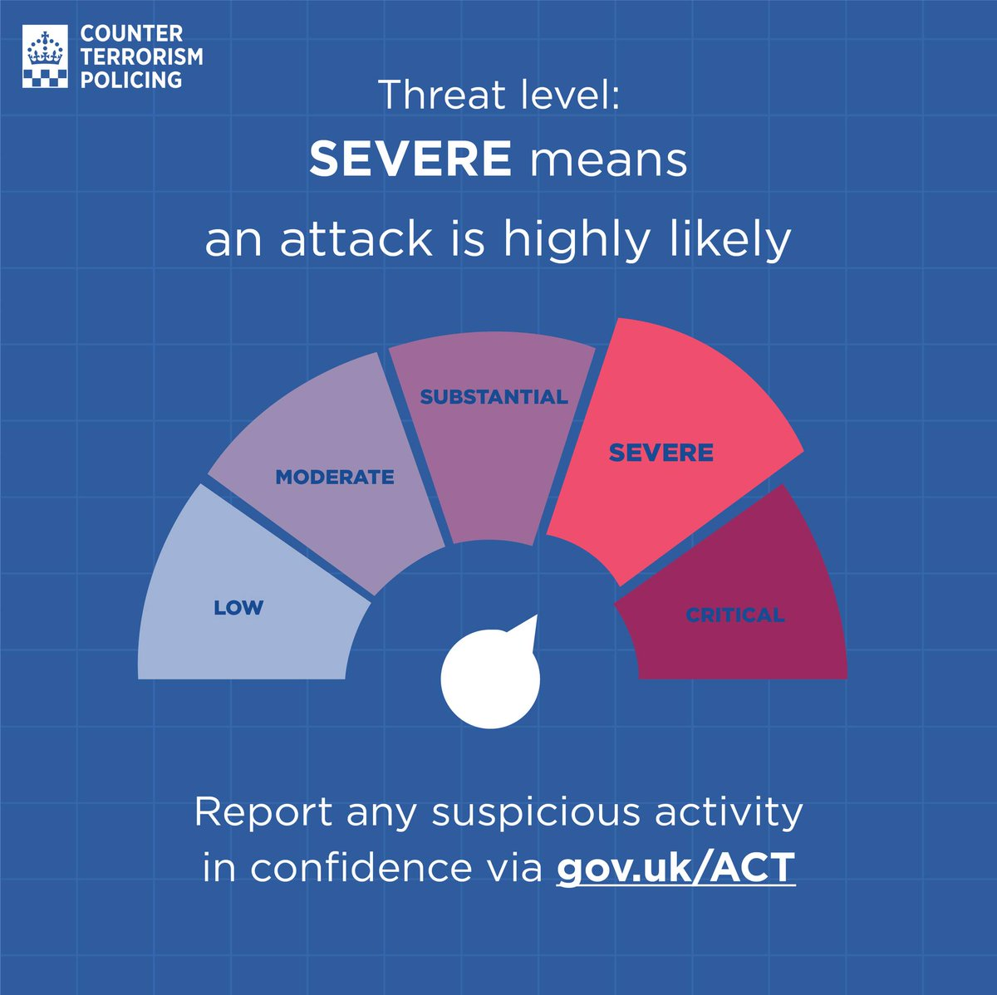
Deputy Chief Constable, Ben Smith said: “You will have seen in the news that the UK terrorism threat level has been increased from substantial to severe – meaning an attack in the UK is highly likely.
“This change comes following a series of recent incidents targeting Jewish communities in London, and our thoughts very much remain with all those impacted by these horrific attacks.
“The raise in threat level will no doubt be a cause of significant concern. I therefore wanted to give some information and reassurance about what this means for us all here in Warwickshire.
“The change in the threat status is in response to those recent events and is a precautionary measure, not based on any specific threat.
“But we do all need to be vigilant. Warwickshire Police will continue to be visible in our communities, and will be working with partner agencies, local businesses, and faith groups to share information and advice on security, what to be on the look-out for and how to report any concerns.
“Communities defeat terrorism, and we are asking you, the public to remain vigilant and report any suspicious activity to the police.
“Your support is essential, and communities across the country continue to show they stand together against anyone who tries to divide them.”
If you do see anything that doesn’t feel right, please report it via www.gov.uk/ACT. In an emergency, always call 999.
More information about what to do if you are concerned about the behaviour of someone close to you can be found on the https://actearly.uk website, including how to spot the signs of radicalisation and where to go for support.
Cost of living website: I need support now

If you are a Warwickshire resident with no other access to funds to pay for food or energy bills, you may be eligible for support through the Crisis and Resilience Fund (CRF).

https://www.warwickshire.gov.uk/crisisresiliencefund

Victim of Crime survey

Have you been a victim of crime? Make your voice heard. Complete this survey to improve the justice system for future victims.

Victim Survey for England and Wales 2026 — TONIC

New inclusion videos give Warwickshire schools practical SEND support
Warwickshire education settings can now access an expanded suite of short, practical inclusion videos designed to support everyday SEND practice in classrooms and learning environments.
Building on the video series launched in 2025, the new resources focus on real-world strategies that staff can apply immediately, helping schools meet the increasingly diverse needs of children and young people. Structured around the four areas of special educational needs and disabilities (SEND), the videos aim to bring greater consistency and confidence to inclusive practice across Warwickshire.
John Coleman, Warwickshire County Council’s Executive Director for Children and Young People, said:
“These videos provide clear, practical strategies that schools and settings can adapt to meet the needs of their pupils. By developing these resources alongside educators and families, we are supporting inclusive environments where children and young people can learn, participate and thrive.”
All videos are free to access and available on the SEND and Inclusion Resources for Schools and Settings pages on the Warwickshire Local Offer.
MY RESPONSIBILTIES AS WARWICKSHIRE COUNTY COUNCILLOR
- Deputy Leader of Warwickshire County Council, from 14th May 2026.
- Within Warwickshire County Council, other parishes in the Arden division include Wootton Wawen, Ullenhall, Claverdon, Langley, Tanworth-in-Arden (including Earlswood), Wolverton and Preston Bagot.
- Serving on both the Warwickshire Fire & Rescue Local Pension Board of the Firefighters’ Pension Scheme and the Warwickshire Pension Fund Local Pension Board.
- Member of the cross-party working group for the Bus Service Improvement Plan. I have recently received a number of requests from residents asking for service extensions to key areas such as Warwick Hospital. If you have any views or suggestions regarding local bus services, please do not hesitate to get in touch.
- Appointed to the Member Oversight Group, a cross-party body focused on WCC’s investments, trading companies and including the Warwickshire Investment Fund.
- Member of the Audit & Standards Committee, concerned with ensuring that WCC has robust systems of internal control and making sure that both councillors and officers follow high standards in the way they conduct the business of the council.
Separately, also Chair of the Reform UK branch for Stratford-on-Avon.

Getting in Touch
For any issues or ideas that would benefit Beaudesert and Henley-in-Arden, as your representative, I am always available to listen and support local priorities at Warwickshire County Council.

James Crocker
County Councillor for Arden
Warwickshire County Council Email: jamescrocker@warwickshire.gov.uk
Mobile: 07353 157962

