Here are the Minutes of the Ordinary Council Meeting of Beaudesert and Henley in Arden JPC, which took place on Monday 1 June, at 7.00pm in the Memorial Hall, Henley in Arden.

Present: Cllrs Andrews [Chair], Tomlinson, Rouse, Norris, Barlow, Field and Glaze plus Lisa Cromwell [Clerk and RFO]

In Attendance: Cllr Rice, Stratford District Council,(SDC), Cllr Crocker, Warwickshire County Council, (WCC), one member of the youth council, and 44 members of the public.

Public Session: Open Forum to provide an opportunity for members of the public to raise questions and to comment on any other items that are on the current agenda. The Chair acknowledged the presence of members of the public regarding proposed development in Henley-in-Arden and clarified that the meeting was an ordinary council meeting, not a forum for discussion on planning applications. It was noted that formal public consultations would take place separately.

CLERK’S NOTE
Planning Committee considered applications listed herein. Outcomes of these applications can be viewed on the Stratford on Avon Planning Portal click on – https://apps.stratford.gov.uk/eplanning/

Cllr Andrews [Chair] opened the meeting.

A minute’s silence was observed in memory of Carsina Goodwin and Colin Fisher, well-known and highly regarded members of the community who had recently passed away.

1 | Apologies for absence
 | Apologies were received from Cllrs McCaskie, and Broadbent.
2 | Declarations of Interest  Councillors are reminded that their actions must always be in the public interest. They must avoid giving any person an improper advantage or disadvantage, and they should not seek financial or other material benefits for themselves, their family, friends, or close associates.
 | There were no declarations of interest.
3 | Acceptance of minutes
 | The motion was proposed by Cllr Andrews and carried unanimously by all those present at the meeting. It was RESOLVED that the minutes of the meetings held on 5 May 2026 and 11 May 2026 were confirmed as a true record and signed by Cllr Andrews.
4 | District and County Reports
 | Cllrs Rice and Crocker were invited to share their reports on matters affecting Beaudesert & Henley-in-Arden. The Council noted the following community updates:
 | Cllr Mike Rice - SDC
- Provided an update regarding proposals within the South Warwickshire Local Plan (SWLP) and confirmed that the SWLP is a method for SDC and WCC to try to control the number of houses built between now and 2050.
- Advised that Mac Mic is nothing to do with the SWLP and is a speculative plan. However, there is little SDC can do to stop the likes of Mac Mic and other opportunistic developers without its Plan in place.
- Urged residents to review the SWLP, in particular page 286, and also to participate in forthcoming consultation processes.

 | Cllr James Crocker - WCC
- This week is Child Safety Week
- WCC’s Health and Wellbeing Board has approved a new Heath and Wellbeing Strategy 2026 – 2031
- WCC’s AGM on 14 May saw a new five year council plan approved. ‘Recalibrating Warwickshire’ a plan that refocuses its priorities on what matters most to residents
 | Copies of both reports can be found on the JPC website.
5 | NDP/SWLP update
- It was noted that significant time had been spent on this topic, with extended public participation and a number of questions raised following Cllr Rice’s report, accordingly, Cllr Andrews kept her update brief.
- Residents were encouraged to respond to the Mac Mic consultation.
- A proposal was made to hold a separate public consultation meeting regarding the Mac Mic development.
- A show of hands indicated unanimous support for such a meeting, and it was agreed that arrangements would be made.

6 | Youth Council Update
 | Following the half term break, just one member of the youth council attended and there was no report.
7 | Chair’s Report
 | Main Points:
- An update regarding the two recent parish meetings was given. The proposal to put forward an application for a Community Governance Review to SDC with the intention of becoming a single parish and thereafter council, whilst approved of unanimously at the Henley Parish Meeting, Beaudesert returned a majority of 5 – 4 against so we will remain as a Joint Parish Council for the foreseeable future.
- A report from Horti on the recent planting was received, noting that the majority of trees are establishing well with only limited losses or damage. It was also reported that all flowering areas have been planted and will begin to come into bloom over the coming weeks.
- The community payback team have been a great help over the last couple of weeks delivering flyers on behalf of Henley in Bloom.
 | - A report was received from a resident regarding litter at Riverlands and was referred to SDC Street Scene. The potential installation of recycling bins will be considered at a future meeting, and residents were reminded to report issues as they arise.
 | The full report can be found on the JPC’s website.
8 | Payments made since the last Ordinary Meeting.  [Consisting annual charges and subs, DD, delegated payments and/or Member voting at an Ordinary Meeting, by email, or, as determined by the JPC Financial Regulations, 5.15].  Wherever possible, all expenditure should be put on the agenda and approved at a JPC meeting. IF there is a genuine requirement for an urgent payment/purchase, individual purchases within an agreed discretionary budget for that type of expenditure may be authorised by:  - the Clerk, under delegated authority, for any items below £500 excluding VAT.  - the Clerk, in consultation with the Chair of the Council for any items below £1,000 excluding VAT.  - in respect of mini grants, all to be approved of by full council  - the council for all items over £1,000  Such authorisation will have a maximum total limit of £1,500 in a month and must be supported by a minute in the case of council or committee decisions or other auditable evidence trail.  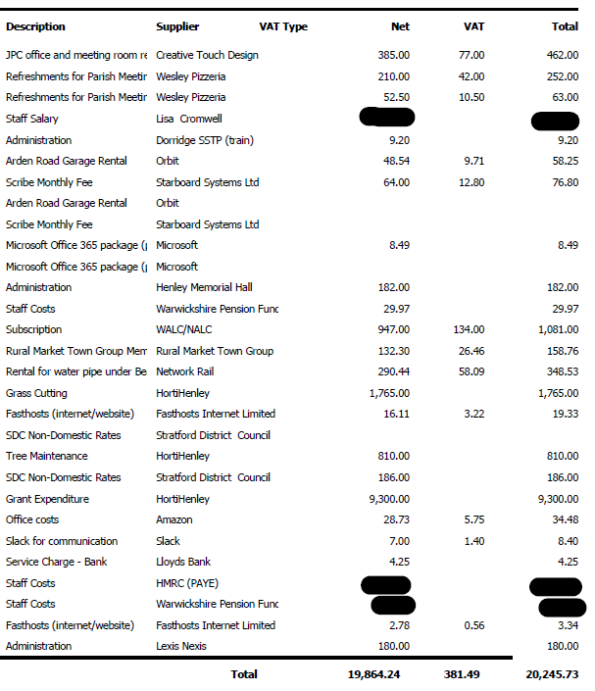
9 | Creditors payments for consideration by Members
 | NB: Any payment requests received by the Clerk after publication of this agenda MAY be presented at the meeting for consideration.
 | 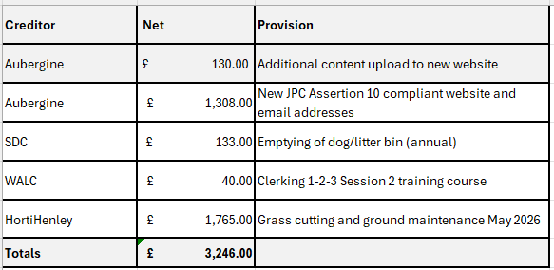
10 | Income received since last meeting
 | 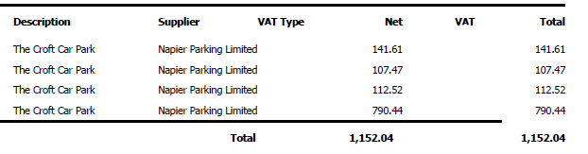
11 | Banking at 27.05.26
 | 
Nos. 8, 9, 10 and 11

The chair enquired whether all members had reviewed the data for payments, receipts, and bank balances. It was RESOLVED that all members confirmed they had inspected the data and unanimously approved the content.
12 | Councillors’ proposals and notes to Council – to be proposed, seconded and voted on
 | Matters concerning expenditure/income
12.1 | Pension Administration charges in relation to Admission and Cessation events within the Warwickshire Pension Fund
Cllr Andrews proposed that the JPC approve payment of the £825.00 invoice issued by Warwickshire Pension Fund for the preparation and provision of enhanced services relating to valuation reports for work completed in March 2026. This charge reflects the Fund’s use of external professional advisers to assess pension positions, the cost of which is now being apportioned to employers. ..

The proposal was seconded by Cllr Rouse. Following a show of hands, it was RESOLVED to approve and pay the invoice for £825.
12.2 | Allotments software
 | Cllr Andrews proposed that the Scribe Allotments module is added to the Council’s existing Scribe finance package. The module would automate communication and invoicing, integrate directly with Scribe Accounts, and provide a clear visual map of plot usage. This would reduce administrative workload, improve transparency, and strengthen oversight..
 | The proposal was seconded by Cllr Barlow. Following a show of hands, it was RESOLVED to instruct the clerk to issue a purchase order to Scribe at a cost of £386 for the first year including set up costs, and a cost of £288 per year thereafter.
12.3 | Additional Community Notice Board
 | Additional Community Notice Board
 | Update: The required information is still awaited from Cllr Broadbent. Item to remain on the agenda until the information is received.
 | Cllr Broadbent proposes that, in response to substantial feedback from local groups, a new centrally located noticeboard is provided for community notices. Residents highlighted that the existing boards at Beaudesert Lane and Arden Way are not sufficiently central for general use. The new community board will be positioned on the High Street.
 | MOTION: That the JPC investigates suitable suppliers and associated costs for the required works and brings the findings to the next Council meeting for consideration and ratification. Subject to approval, planning permission will then be required before any works can progress [CF]
12.4 | Repairs to Skate Park at the Hub
 | Cllr Andrews proposed that, following receipt of an invoice from Urban Recreation in the sum of £1,275 (net), the JPC approve the repairs to the Skate Park at Henley Hub...
 | The proposal was seconded by Cllr Field. Following a show of hands, it was RESOLVED that members approve the cost and instruct the Clerk to issue a Purchase Order for the works to commence as soon as possible.
13 | Councillors’ proposals and notes to Council – to be proposed, seconded and voted on
 | Business matters – updates only – no financial decisions listed
13.1 | Cllr Andrews proposed that the Internal Controls Statement policy, which has been reviewed by members, be ratified.
 | The proposal was seconded by Cllr Rouse. Following a show of hands, it was RESOLVED to approve and adopt the Internal Controls Statement Policy.
13.2 | Year-End Finance & Governance 2025/26  Members had reviewed the year-end governance and financial documents in advance.  - The Internal Auditor’s Report for 2025/26 was received and noted.  - It was RESOLVED to approve the Annual Governance Statement (Section 1 of the AGAR) for 2025/26. The Chair was authorised to sign.  - The Accounting Statements, having been certified and signed by the Responsible Financial Officer, were considered.  It was RESOLVED to approve the Accounting Statements (Section 2 of the AGAR) for 2025/26. The Chair was authorised to sign the statements.  - The Bank Reconciliation as at 31 March 2026 was received and noted.  - It was RESOLVED to approve the Asset Register as at 31 March 2026.  The following items were received and noted:  - Explanation of Variances for 2025/26  - Year-End Receipts and Payments Report for 2025/26  - Reserves Position as at 31 March 2026  - Budget vs Actual Report for 2025/26  It was RESOLVED that all members confirmed they had inspected the data and unanimously approved the content and authorised the clerk to submit the completed AGAR and supporting documentation to the External Auditor.
13.3 | Cllr Barlow to join the Planning Working Party
 | Cllr Andrews proposed that Cllr Barlow be appointed to the Planning Working Party in order to support the work of the group.
 | The proposal was seconded by Cllr Rouse. Following a show of hands, it was RESOLVED to appoint Cllr Barlow to the Planning Working Party.
13.4 | Shakespeare Statues – Working Party approval required
 | Cllr Glaze proposed the creation of a Shakespeare Figure Working Party to help facilitate the lawful placement of the figures around the town.
 | The proposal was seconded by Cllr Andrews. Following a show of hands, it was RESOLVED that a Working Party be appointed for the Shakespeare statues project.
13.5 | Henley for All Play Project ITT  Cllr Andrews proposed that, having successfully secured a large Community Grant from Stratford-on-Avon District Council for inclusive play equipment at Jubilee and Riverlands, the JPC approves the Invitation to Tender (ITT) for the Play Project and authorises the clerk to:  - issue the ITT to the three companies who provided initial quotations;  - publish the ITT on the JPC website;  - advertise the opportunity on Find a Tender and Contracts Finder, and  - manage the procurement process in accordance with the Council’s Financial Regulations.  The proposal was seconded by Cllr Rouse. Following a show of hands, it was RESOLVED that council approve the ITT and authorise the clerk to commence the procurement process.
13.6 | SDC Community Grant Fund – Signing of Grant Agreement
 | Cllr Andrews proposed that the council approve the SDC Community Grant Fund agreement in the sum of £43,928.65 and authorise the chair, Cllr Rouse and the clerk to sign.
 | The proposal was seconded by Cllr Barlow. Following a show of hands, it was RESOLVED to approve the agreement and authorise Cllr Andrews [Chair], Cllr Rouse and the clerk to sign the grant agreement. Two copies were duly signed.
13.7 | Urgent Submission to DCMS of amended Section 1 of the EOI for Town of Culture  Cllr Andrews proposed that the urgent submission of an amended section be ratified. Section 1 – The Bidder, required incorporating a governance clarification to confirm Stratford-on-Avon District Council as the Accountable Body, in order to meet programme requirements and mitigate financial and delivery risk. The amended submission was made under delegated authority due to the deadline of 26 May 2026 and has been shared with members.
 | The proposal was seconded by Cllr Rouse. Following a show of hands, it was RESOLVED to retrospectively ratify the submission of the amended Section 1.
14 | Planning  The below to be discussed by the planning working party and suggestions shared with members. Update will be provided at the next meeting.
 | 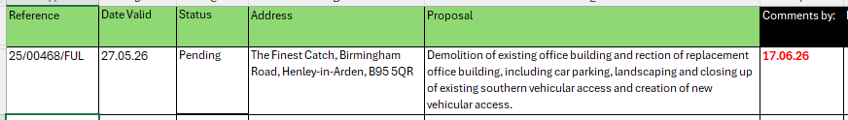
 | The items below have been discussed by the planning working party and comments shared with full members, prior to being submitted under delegated authority to SDC.
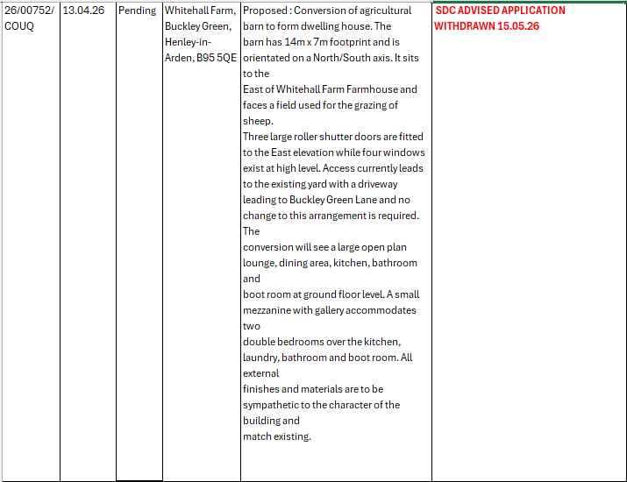
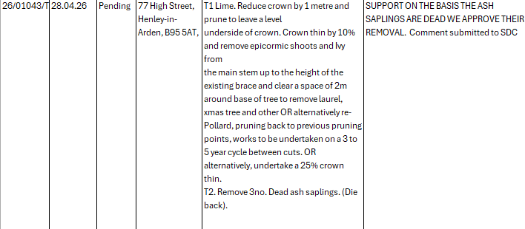
 | 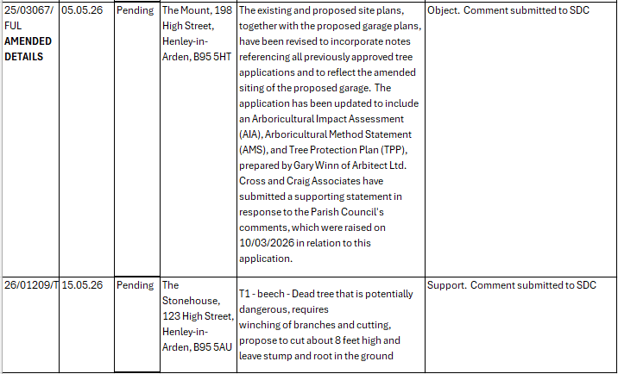
15 | Urgent Business Matters
 | There were no urgent business matters to report.
16 | Next Meeting
 | The next Ordinary Meeting of the Council will be held at the Memorial Hall, Station Road, on Monday 6 July at 7pm.

.

Signed ………………………………………………………………………………….

Date……………………………………………………….

