REPORT FROM WARWICKSHIRE COUNTY COUNCILLOR
JAMES CROCKER

BEAUDESERT & HENLEY JOINT PARISH LOCAL ISSUE UPDATE
- Crime Awareness and Prevention Programme (CAPP) for Warwickshire; £3k allocated for specific projects per division.
- Need for double yellow lines on Prince Harry Road being raised.
- Fire Station No Parking markings needed.
- Severn Trent aware of manhole cover issue.
- Jennifer Warren stepping down as Highways portfolio holder, but will be supporting the incoming Stephen Shaw.

NEWS FROM SHIRE HALL
Making prevention possible: Child safety advice for families


Child Safety Week takes place from 1 to 7 June 2026 and we are supporting the annual campaign led by the Child Accident Prevention Trust (CAPT) to help families take simple steps to keep children safe at home and out and about.
CAPT’s annual awareness week encourages thousands of safety conversations across the UK, helping families understand real risks and take simple action to prevent serious accidents and injuries.
Warwickshire County Councillor Wayne Briggs, Portfolio Holder for Children and Families, Education and SEND said:
“Child Safety Week is an important reminder about how some accidents can be prevented. By sharing practical advice and encouraging small everyday actions, we can help families feel more confident about reducing risks to keep children safe.
“As part of our child-friendly Warwickshire commitment, we want children to have the freedom to grow, learn and be independent in ways that are safe and healthy. This includes helping parents and carers know what to do, but also finding opportunities to teach children about danger, safer choices and the behaviours that protect themselves and others.”
Making prevention possible: Child safety advice for Warwickshire families - Warwickshire County Council


County Council approves bold new Council Plan to reset priorities for Warwickshire
Following the AGM on 14 May, Warwickshire County Council has approved “Recalibrating Warwickshire”, a new Council Plan that refocuses its priorities on what matters most to residents.
The Plan sets out how the Council will improve services, deliver value for money and make a real, practical difference in people’s lives.
Following public engagement and councillor scrutiny, the Plan sets out how the Council will achieve its ambition to deliver real improvement for the people of Warwickshire; making sure that Warwickshire is a place to live where business can flourish, families can thrive and where children have the best chance in life.
“Recalibrating Warwickshire” represents a shift in emphasis and direction for the Council as local government moves into a period of profound change.
https://api.warwickshire.gov.uk/documents/WCCC-1980322935-3595
View the AGM here: https://www.warwickshire.gov.uk/democracy

Strategy approved to improve the health of residents in Warwickshire
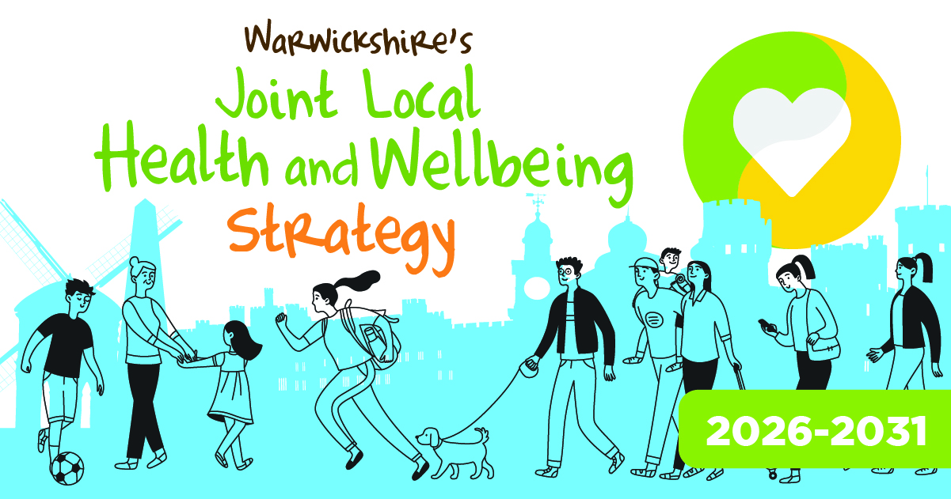
Warwickshire’s Health and Wellbeing Board (HWBB) has approved a new Health and Wellbeing Strategy 2026 – 2031.
The strategy sets out a shared vision to improve health, prevent ill health and tackle inequalities across the county so that residents can live well in Warwickshire.
The strategy recognises that wider factors such as housing, education and employment influence 80% of our health and wellbeing. It aims to help residents start well, live well and age well by addressing these “building blocks of health” and focusing on three main priorities:
- Supporting good mental health, particularly for children and young people, by improving early detection and access to support while addressing wider pressures like family stress, poverty and social isolation.
- Tackling poverty and health inequalities by embedding a “Health in All Policies” approach so that decisions about housing, transport, planning, jobs and the environment all take account of their impact on health. Families also experiencing child poverty will get better support such as improving access to good work and training opportunities.
- Encouraging physical activity and healthy eating, making it easier for people to move more and maintain a healthy weight through community programmes, improved local spaces and active travel routes.
https://api.warwickshire.gov.uk/documents/WCCC-1350011118-3558

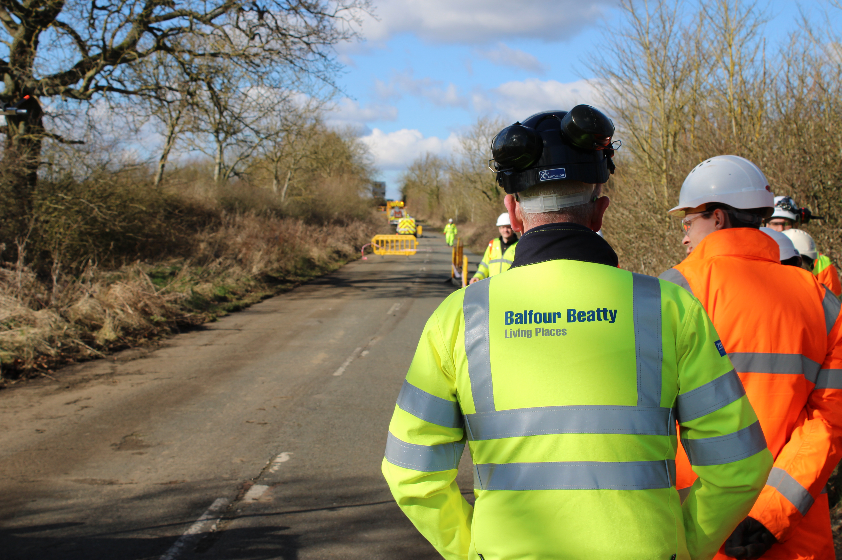
Groundbreaking highways contract goes live
Warwickshire County Council and partners at Coventry City Council and Solihull Metropolitan Borough Council awarded the contract for their highways maintenance to Balfour Beatty Living Places.
The seven-year contract, will run until May 2033 with an option to extend by a further three years based on performance and was awarded after a competitive selection process to achieve the best value service on offer in the market. The contract will maintain and improve highway networks, including roads, footways, structures and associated assets such as gulleys and culverts.
Innovation is at the heart of the delivery with innovative use of AI being used to thoroughly and efficiently review the state of roads and to diagnose what work needs to be done. This will mean that the data that drives the programme of repairs and sets priorities is fully informed and up to date. The information hub where the data is analysed can then triage repair crews to where they are most needed.

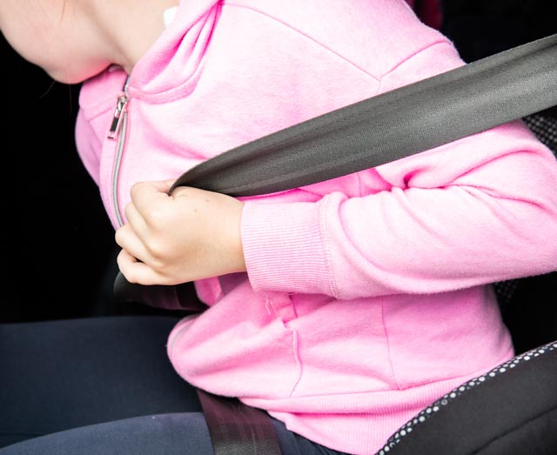
Free child car seat check events returning across Warwickshire
Find a child car seat check event near you in May and June.
Warwickshire Road Safety Partners are urging families to check that children are travelling both legally and safely on every journey, as a new series of free child car seat check events takes place across the county over the coming weeks. Tuesday 16 June – Tesco Warwick, Emscote Road, Warwick, CV34 5QJ. https://warksroadsafety.org/child-seat-check-events/


Are you struggling with the increasing cost of living?
Warwickshire services are working together to help people find the information they need to manage increased household costs. This is a difficult time for many people and finding direct support can be hard.
https://www.costoflivingwarwickshire.co.uk/

MY RESPONSIBILTIES AS WARWICKSHIRE COUNTY COUNCILLOR
- Within Warwickshire County Council, other parishes in the Arden division include Wootton Wawen, Ullenhall, Claverdon, Langley, Preston Bagot, Tanworth-in-Arden (including Earlswood) and Wolverton.
- Deputy Leader of Warwickshire County Council, Portfolio Holder for Finance & Property.
- Serving on both the Warwickshire Fire & Rescue Local Pension Board of the Firefighters’ Pension Scheme and the Warwickshire Pension Fund Local Pension Board.
- Member of the cross-party working group for the Bus Service Improvement Plan. I have recently received a number of requests from residents asking for service extensions to key areas such as Warwick Hospital. If you have any views or suggestions regarding local bus services, please do not hesitate to get in touch.
- Appointed to the Member Oversight Group, a cross-party body focused on WCC’s investments, trading companies and including the Warwickshire Investment Fund.
Chair of the Reform UK branch for Stratford-on-Avon.

Getting in Touch
For any issues or ideas that would benefit Beaudesert and Henley-in-Arden, as your representative, I am always available to listen and support local priorities at Warwickshire County Council.

James Crocker
County Councillor for Arden
Warwickshire County Council Email: jamescrocker@warwickshire.gov.uk
Mobile: 07353 157962

